Vector Network Analyzer N5222B
In this system, samples are excited by 532 nm Nd: YAG laser. Raman system enables chemical identification of elements and compounds with a spatial resolution of ~ 200 nm. Laser spot size is ~ 1µm and spectral resolution is < 0,5 cm-1 (FWHM). The signal can be measured with 100cm-1 of the laser wavelength. The spectrometer is also equipped with an eclipse filter notch for low-frequency Raman identification below 15 cm-1 both for Stokes and anti-Stokes - for 532nm laser. Confocal measurements and 2-dimensional mapping (single wavelength and full spectrum) are also possible. The system configuration allows for qualitative analyzes of a wide range of materials, including 2D materials such as graphene, MoS2, RaS2, MoSe2, WSe2, photovoltaic cells, semiconductors, carbon materials, polymers as well as biological samples (cells, tissues). The system allows performing SERS and SEIRA measurements.

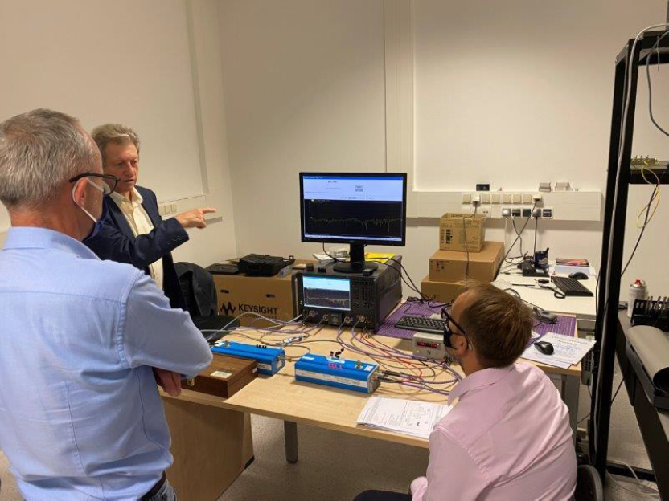
Vector Network Analyser (VNA) Keysight PNA N5222B.

