Time Domain Spectroscopy
Time Domain Spectroscopy (TDS) has recently become generally acknowledged and successful spectroscopic technique in terahertz (THz) domain. Its principle of operation relays on measuring the time-profile of the picosecond duration reference pulse (typically in vacuum or inert gas e.g. nitrogen) and its subsequent comparison with the time profile of the same pulse transmitted through the sample. The temporal differences of the shapes after the Fourier transform reveals valuable spectral information about material properties.
The TDS-THz system of the CENTERA Labs (TOPTICA Photonics AG) combines the state-of-the-art InGaAs photoconductive switches technology with well-established all-fiber, dispersion compensated femtosecond laser technology. The photoconductive emitter employs a high-mobility InAlAs/InGaAs multilayer heterostructure. The receiver is based on an LT-grown Beryllium doped InAlAs/InGaAs with short carrier lifetime. A strip-line antenna geometry with a 100 µm photoconductive gap is chosen for the emitter, and a dipole geometry with 10 µm gap for the receiver. The photoconductive switches of the emitter and receiver are fed with a robust, all-fiber-based femtosecond laser system. By using Erbium doping in the optical fiber, the laser radiation is cantered at 1.56 µm, the repetition rate is 100 MHz with the pulse width of typically 80 femtoseconds. The laser provides approx. 80 mW power at the polarization-maintaining fiber output. To account for dispersion effects in the fiber delivery, the laser includes dispersion-compensating fibers which are spliced into the fiber-optic beam path.
The system is capable to perform measurements of THz transmission or reflection in both focused or collimated beam geometries. It is equipped with the 2D scanner, the so called imaging extension. The Imaging extension utilizes two precise linear stages to scan a sample through the focus of the terahertz beam. The translational movement is synchronized with the voice-coil delay of the system resulting in a high measurement speed of up to 16 pixels per second. The positioning accuracy is better than 200 µm over a 15 x 15 cm scanning area.
CENTERA’s THz-TDS can also be used in the so called pump-probe configuration with both tunable Infra-Red (IR) and tunable MID Infra-Red (MIR) femtosecond lasers. In this mode the seed beam of the Erbium laser is divided in three parts to feeds the IR laser, the MIR laser and the photoconductive switches of the THz-TDS system. An optical delivery setup encompassing four off-axis paraboloid mirrors from which one has a central bore combines infra-red and THz radiation in one common focal spot located on the sample. The IR pulses are delayed with respect to the THz pulses by means of external optical delay line. The maximum delay time of the line is 666 picoseconds with the minimum delay shift of 3.3 femtoseconds.
System specifications:
THz-TDS
Terahertz emitter: InGaAs/InP photoconductive switch with 100 μm strip-line antenna
Terahertz receiver: InGaAs/InP photoconductive switch with 25 μm dipole antenna
Antenna package: cylindrical, Ø=25 mm, integrated Si lens and SM/PM fiber pigtail
THz pulse duration: ~2 ps
Repetition rate: 100 MHz
Temporal scan range: adjustable 5 ps @ 166 traces/s)– 200 ps @ 6 traces/s
Spectral range: 0.3 – 6 THz (typ.) 0.1 – 7 THz (max.), in < 20 s (1000 pulses average)
Average terahertz power: typ. 30 μW
Spectral peak dynamic range: 95 dB (typ.), 102 dB (max.), in < 20 s (1000 pulses average)
Useable terahertz path length: 15 – 110 cm, stationary delay
Frequency resolution @ max. scan range: < 5 GHz

Pump-probe setup
IR Laser
Pulse duration: 80-100 fs (wavelength dependent)
Average power: 200 – 1000 mW (wavelength dependent)
Repetition rate: 100 MHz
Spectral range: 0.8– 2.0 µm (Raman shifter of 1.56 µm + SHG)
MIR Laser
Pulse duration: 80-100 fs (wavelength dependent)
Average power: 0.2 – 2 mW (wavelength dependent)
Repetition rate: 100 MHz
Spectral range: 5.0 – 15.0 µm (FWM SCIR+1,56 µm)

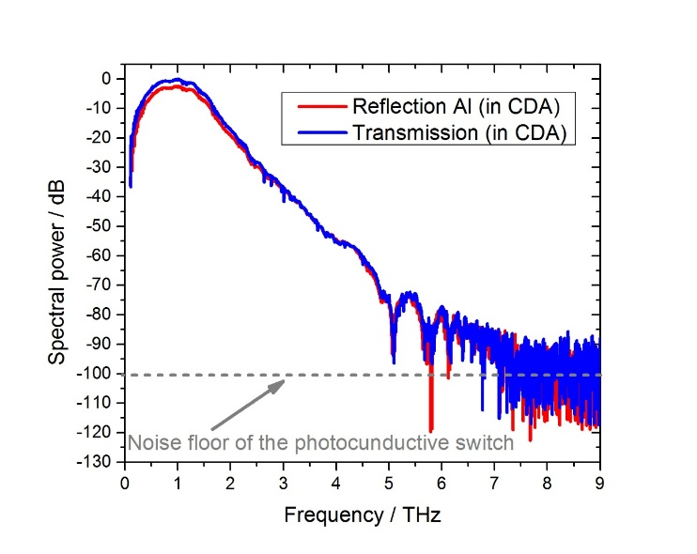
Transmission and aluminum (Al) reflection spectrum of THz-TDS system
pulse registered in Clean Dry Air (CDA)

