**Prof. W. Knap Main Scientific CV (activities 1979 – 2020)**

**Introduction**

My research activity was concentrated on Solid State Physics. I studied transport and optical (from visible till far-infrared/THz) properties of semiconductors using high pressure and/or high magnetic fields extreme conditions. Important part of my scientific experience comes from the fact that I was working in many different laboratories and research centres.

1979-1990 : Institute of Physics – Solid State Group, University of Warsaw (Poland).

1985-1986 : Innsbruck and Leoben groups of Semiconductor Physics (Austria).

1987-1990 : Centre National Researche Scientifique - Montpellier and Grenoble (France)

1991-1992 : Pulsed Magnetic Field Laboratory Toulouse (France).

1992-2020: Centre National Rsearche Scientifique - Montpellier (France)

2000-2020 : Institute of High Pressure Physics – Polish Academy of Sciences, Warsaw (Poland).

1999-2001 : Terahertz Center of Rensellaer Polytechnic Inst., Troy-New York (USA).

2007-2019 : Research. Inst. of Electr. Comm. – RIEC Tohoku University, Sendai (Japan).

This mobility was one of the important factors stimulating research in various domains of solid state physics and use of a variety of experimental techniques. The simplified list of the important research subjects with short comments is given below:

1) **Thermomagnetic and galvanomagnetic phenomena in narrow/zero gap semiconductors**.

Investigation of the interaction of the narrow gap semiconductors (HgTe and InSb) with Far Infrared Radiation was the main subject of my Master and PhD dissertations. My PhD thesis completed at University of Warsaw under supervision of Prof. M. Grynberg in 1985 was entitled “Thermomagnetic and galvanomagnetic effects induced by Far Infrared Radiation in HgTe and InSb in high magnetic fields”.

2) **Resonant impurity states in zero gap semiconductors.**

This work was done in collaboration with Prof. G. Bauer, Leoben (Austria). The subject was related to Fourier spectroscopy far infrared transmission studies of extremely thin HgTe samples with differing doping. We have shown an existence of optical singularities related to impurity states, resonant with the conduction band of n-type HgTe.

3) **Nonlinear transport and routes to chaotic oscillations in semi-insulating GaAs.**

This research crossed the border between physics and advanced mathematics. It was based on experiments showing clear “period doubling route to chaos” (Warsaw and Montpellier).

4) **Hot electrons in high magnetic fields – Landau level emission.**

This project was realised under supervision of Prof. E. Gornik (Innsbruck, Austria and Munich, Germany).

I continued this research in Warsaw and Montpellier constructing two cyclotron resonance spectrometers.

5) **Paramagnetic resonance in high magnetic fields: spin relaxation mechanism.**

My work in this field was a participation in the construction of a high field EPR spectrometer in Grenoble High Magnetic Field Laboratory (Grenoble). Important results on spin relaxation in the Si:P, and heavily doped Silicon were obtained. Spin relaxation rates as a function of temperature and magnetic field were determined and a new relaxation mechanism specific to high magnetic fields were identified.

6) **Blocked Impurity Band Detectors of Infrared Radiation (BIBs).**

These studies were related to the construction of a new type of Far Infrared detectors, insensitive to ionizing radiation. I have also installed a Fourier Spectrometer-based optical test system. Laboratory of Pulsed Magnetic Fields, Toulouse.

7) **Cyclotron Emission from two-dimensional electron systems.**

This was the continuation of the project started in Innsbruck and Warsaw (Montpellier). It was the development of 2DEG systems and the introduction of the high pressure cell. I have obtained first results on the 2DEG effective mass change with hydrostatic pressure.

8) **Quantum Transport - Weak localisation and antilocalization.**

Important research project – stimulated by theoretical support of Russian scientists from St. Petersburg and Moscow – allowed for the discovery of a universal weak localization and identification of major spin splitting/relaxation mechanisms responsible for weak anti-localisation phenomenon. Part of the work leads to a common PhD thesis between Montpellier and Warsaw Universities.

9) **Semiconductor based gas detectors.**

This work was made in collaboration with Schlumberger Industries. First important project with direct applications for industry, PhD thesis of H. Alause and an international Patent were linked to this field of research.

10) **Cyclotron Resonance and Infrared reflectivity studies of GaN and SiC wide gap semiconductors and their heterojunctions.**

Using infrared reflectivity and transport methods, we have determined effective masses and other band parameters of wide band semiconductors GaN and SiC. We then studied the details of the conduction band of 2DEG in GaN/AlGaN heterostructures. This work was done in collaboration with IHPP PAS (Warsaw), HMFL in Grenoble, le Service des Champs Pulsés de Toulouse, High Magnetic Field Laboratory – Tallahassee (USA), RPI –Troy-New York (USA), and APA Optics (USA).

11) **Diamond Anvils investigation of High pressure induced metal semiconductor transition in bulk GaN.**

The aim of this research was to understand the mechanism of doping which underlies the fact that GaN bulk synthesized under high pressure always turns out to be n-type. Organization of fruitful collaboration Montpellier (Micro Luminescence and Raman system) IHPP PAS, Warsaw (GaN bulk crystals) and Laboratoire de Physique des Milieux Condensés Paris VI (Diamond anvils – high pressure system).

12) **Plasma wave Terahertz oscillations in nanometre size semiconductors.**

This project was realized in its first phase during my stay in USA – RPI – Troy – NY, then in Montpellier, Sendai (Japan) and again in Montpellier. It is continued until now as the major research project (more detailed description is given below).

As can be seen from the list above, I have worked on many subjects related to optical and transport properties of solids. The fact that I used different tools or approached the subject with different methods specific for different laboratories, allowed me to get important results recognized by scientific community via invited and tutorial papers and multiple citations (H~50).

To present in more details my scientific activity I have divided my works on two domains : A) Basic Solid State Physics and B) Applied Physics. In each of these domains I have chosen three subjects that I consider as most important - because I had a leading/key role in their initialization and realisation and because they brought progress in understanding of some basic phenomena in solid state physics and/or were important for applications.

***A) Basic Physics***

Looking from the basic physics point of view one can choose at least three main subjects of studies:

***A1. Quantum phenomena in transport: weak localisation, anti-localisation and ballistic behaviour in low dimensional systems.***

***A2. Wide gap nitrides and their heterojunctions: metal non-metal transition and two-dimensional gas in GaN/AlGaN heterojunctions.***

***A3. Terahertz plasma excitations in low dimensional systems: Terahertz radiation rectification and generation by plasma confined in nanometre field effect transistors.***

The main results (“the firsts”) concerning these themes/axes are briefly presented below:

***Ad-A1.* Quantum phenomena in transport: weak localisation, anti-localisation and ballistic behaviour in low dimensional systems.**

The main results concerning this activity are:

i) The first observation of the **universal behaviour of the weak localisation**. Universality of the weak localization means that for ***all two-dimensional systems******– independently of carrier mass, scattering rates, doping levels. etc…. the quantum interference conductivity corrections should behave in the same way. More precisely they have the same functional dependence versus renormalized magnetic field.***

ii) The first complete analysis of the antilocalisation behaviour. It was shown that the observed antilocalisation appearing due to the quantum interference, is controlled in unexpectedly important way by the spin splitting of electron spectra. A theory was developed taking into account both linear and cubic wave-vector terms in spin splitting. Also it was shown that additional linear terms appear when the quantum well itself is asymmetric (Rashba term). ***The results obtained allowed determination of dominating spin-relaxation mechanisms and to improve the accuracy of determination of spin-splitting parameters in A3B5 crystals and their two-dimensional structures.***

***Ad-A2) Wide gap nitrides and their heterojunctions: metal non-metal transition and two-dimensional gas in GaN/AlGaN heterojunctions.***

This research was performed to answer the basic **nitrides-relatedquestions such as: value of the electron effective mass and g-factor, limits of the doping, possibility of hydrostatic pressure induced metal-non metal transition and force of electron-phonons interactions.**:

Employing:

i) far - infrared and Infrared Reflectivity under pressure

ii) diamond anvils high pressure Raman

iii) diamond anvils luminescence experiments

we were able to answer most of these questions. Effective mass was determined and shown that it changes with carrier densities due to nonparabolicity. The polaron effect related to optical phonon free carrier’s interaction was evidenced as well as the pressure induced metal – non-metal transition in highly doped n-GaN bulk crystals.

The GaN bulk studies were followed by more challenging subject related to properties of two-dimensional electron gas in GaN/AlGaN heterojunctions. In collaboration with groups from USA, Poland and France  
I performed the high field experiments that lead to the:

i) **The first demonstration of the existence of 2DEG gas in GaN/AlGaN heterojunctions.** **The first observation of the Shubnikov-de-Hass as well as Quantum Hall Effects in GaN/AlGaN heterojunctions**. These experiments made in tilted magnetic fields clearly demonstrated the existence of 2DEG gas.

ii) **The first Far Infrared Cyclotron Resonance absorption and emission that are referenced as the first published data**.

iii) **The first determination of the 2DEG effective mass**. This mass was different from the bulk value because of the strong polaron and non-parabolicity effects. It has been shown that the effective mass can increase almost by 10% with the carrier density varying between 1012/cm2 and 1013/cm2.

By tilting magnetic fields, we were able to register the change of the pattern (phase and amplitude) of the Shubnikov-de-Haas oscillations - related to spin and cyclotron splitting and observe their anticrossing behaviour. This led to:

**iv)** **The first determination of the effective g factor for 2DEG GaN/Al**GaN. The value g*~2.1 was found very close to the bulk value. Contrary to observations for GaAs/AlGaAs systems, absence of any anomalous enhancements of the spin splitting was confirmed.

**v) The first Quantum Hall Effect activation measurements** were performed showing unusual behaviour of the quantum transport gaps and an effect of many body interactions on gap renormalization. Complete theoretical analysis of the data was performed in collaboration with V. Falco – Landau Institute – Tchernogolovka Russia. It was shown that because of the higher g* factor and higher effective mass, the spin splitting and cyclotron resonance splitting becomes comparable. This makes GaN/AlGaN system very interesting from the point of view of many body interactions.

***Ad-A3) Terahertz plasma excitations in low dimensional systems: terahertz radiation rectification and generation by plasma confined in nanometer field effect transistors.***

This part of my research activity started in 1997 as a result of the collaboration with world class theoreticians Prof. M. Dyakonov and Prof. M. Shur who predicted that constant current flow in the transistor channel with special boundary conditions can lead to the new type of instability leading to the generation of high amplitude plasma waves and Terahertz emission. They have also shown that nonlinearities related to two-dimensional plasma can lead to rectification and detection of THz radiation. Intrigued by these new mechanisms of THz detection and emission I started the experimental research using high sensitivity cyclotron resonance detection system for emission (built in Montpellier) and Gunn diodes based experimental system for detection (constructed during my sabbatical at RPI, Troy, New York, (USA).

Main results of these studies are:

i) The first observation of the resonant THz detection by 2D plasmons in nanometre GaAs FETs.

ii) The first observation of the plasma instability-related emission from InGaAs /InP HEMTS.

iii) The first room temperature broadband THz detection by nanometre Si – MOSFETs.

iv) The first room temperature THz emission from GaN/AlGaN transistor.

The most interesting basic physics problems approached in these studies concern:

i) Influence of the current on the plasma wave-related detection – enhancement of the effect and narrowing of the resonances.

ii) Influence of the geometry of the channel – determination of the role of gated and ungated parts of the channel (interaction of gated and ungated 2-dimensional plasmons.

iii) Damping of Shubnikov-de-Hass oscillations at the Cyclotron and plasma resonances energy crossing in high magnetic fields.

In 2018 I initiated CENTERA project – related to the THz science and technology. Results obtained in the frame of this project are the first demonstration of THz amplification by plasmons in grating gate nano-structures.

We demonstrated gate voltage-tuneable resonant plasmon absorption, that with an increase of the current, turns to THz radiation amplification with a gain approaching 10%. The results were interpreted using a dissipative plasmonics crystal model, which captures the main trends and basic physics of the amplification phenomena. Specifically, the model predicts that increasing current drives the system into an amplification regime, wherein the plasma waves may transfer energy to the incoming electromagnetic waves.

All results were obtained at room temperature. Therefore, they pave the way towards a future THz plasmonic technology with a new generation of all-electronic, resonant, voltage-controlled THz amplifiers. This work is result of a long lasting collaboration with Tohoku University – Sendai (Japan). It was published in highly ranked journal, publishing only seminal works: Physical Review X May 2020.

**Concluding** the part concerning Basic Physics one may say that my research lead to important contributions:

***1) Quantum phenomena in transport – universality and influence of spin relaxation effects on weak localisation.***

***2) Wide gap nitrides and their heterojunctions – first band structure parameters and pressure induced phase transitions.***

***3) Terahertz plasma excitations in low dimensional systems - first demonstration of the THz plasma oscillations in nanometre FETs.***

**B) Applied Physics**

Independently of my interest in the basic physics, I also pursued activities related to applications. This led to many collaborations/contacts with industrial partners. The three most important subjects related to this part of my research activity were:

***B1) Optical sensors: Quantum well-based infrared sensors for gas detection – with Schlumberger.***

This was my first contact with industrial partner – **Schlumberger** – that wanted to develop the semiconductor based sensor that could allow for measurements of the quality of the gas delivered to the customers. Towards this end, one should determine the ratio of the methane, ethane and other gases. Using our knowledge of the physics of GaAs/AlGaAs quantum wells we proposed, fabricated and tested the semiconductor based sensors – working as the electrically modulated notch filters. This project was realized in the frame of the industry supported PhD thesis and was finalized by an international patent.

***B2) Nanotransistors- physical/versus technological limits with STMicroelectronics, APA-Optics (USA) TopGaN (Poland), III-V Labs – Thales (France).***

Pushing the transistor to higher power and higher frequency operation leads the industry to search of the new materials (like Nitrides) and/or ultimate miniaturization. Physicists have an important role in discrimination between the physical and technological limits. Two examples of collaboration can be given. They concern high power GaN based HEMTS and ultimately short Si – MOSFETs.

The basic physics research on the GaN/AlGaN heterojunctions mentioned above was followed by the studies of the High Electron Mobility transistors. By comparing of the technology based on the Sapphire, SiC and bulk GaN substrates – we were able to determine the role of the dislocations in the high and cryogenic temperatures. We were also able to establish, for example, that for dislocation density below 108/cm2 the dislocations do not influence the room temperature transistor parameters. The research on GaN/AlGaN heterojunctions involved industrial partners **APA – Optics and SET Companies from South Caroline (USA), TopGaN, Warsaw (Poland) and III-V Labs –Thales, Paris (France).**

Another example of applied physics research concerns the ultimately short Si nanotransistors. For such extremely short nanotransistors the traditional methods of carrier mobility determination do not work. We proposed mobility determination based on the geometrical magnetoresistance method. In fact, its the geometry of the transistor – very wide and short channel – thst leads to transistor channel magnetoresistance changing like (µB)2. For relatively small mobility like in Si-CMOS high magnetic fields are necessary.

By measuring magnetoresistance in magnetic fields up to 12T , we were able to examine (with our Industrial partner **STMicroelectronics)** various technologies of nanotransistors and to determine relative role of the doping, strain effects in final transistor performances.

***This research led also to the first demonstration of the ballistic limitations of the Si nanotransistors of sub100nm technology***. By the high field magnetoresistance measurements complemented by theoretical analysis we have shown that ballistic effects play an important role for modern Si transistors shorter than 100nm and are responsible for at least 50 percent “mobility reduction” in the case of 30nm channel length – technology node. This project allowed to give better understanding of the physics of ballistic effects and determine the physical limits of performance of nanometer MOSFETs.

***B3) Terahertz detection and imaging by Field Effect transistors – with TERAKALIS (France), ORTEH – (Poland), STMicroelectronics (France), NTT (Italy) , CANON (Japan/France), SAFRAN (France).***

Research on the Terahertz detection related to plasma effects in GaAs, GaN and Silicon nanotransistors leads us to discovery that these transistors can efficiently work at THz frequencies even at room temperature and that there have responsivity that is one of the highest between all existing room temperature detectors. Together with industrial partner **STMicroelectronics, CEA-LETI, and NTT (Italy)** we studied the possibilities to make an array of detectors that can be used as focal plane arrays for future Terahertz cameras working in 0.3-1.0 Terahertz range. With CANON we have studied potential applications of these detectors in wireless communication at THz frequencies.

Also GaN/AlGaN transistors are considered as potential THz detectors operating in elevated temperatures and harsh environments– this work was continued in collaboration with III-V Labs – Thales (France) and SAFRAN- France DGA project IMPAD (2014-2017).

**Detailed description of scientific activities**

**A. Research in the Basic Physics**

Concerning Basic Physics, three main themes/axes can be defined as:

***A.1 Quantum phenomena in transport: weak localisation, anti-localisation and ballistic behaviour in low dimensional systems.***

***A.2 Wide gap nitrides and their heterojunctions: metal non-metal transition and two-dimensional gas in GaN/AlGaN heterojunctions.***

***A.3 Terahertz plasma excitations in low dimensional systems: Terahertz radiation rectification and generation by plasma confined in nanometre field effect transistors.***

The main results concerning all these themes/axes are described below.

***A.1. Quantum phenomena in transport: weak localisation, anti-localisation and ballistic behaviour in low dimensional systems.***

The main results concerning this activity are:

i) The first observation of the **universal behaviour of the weak localisation**.

Universality of the weak localization means that for ***all two-dimensional systems******– independently of carrier mass, scattering rates, doping levels. etc…. the quantum interference conductivity corrections should behave in the same way.***

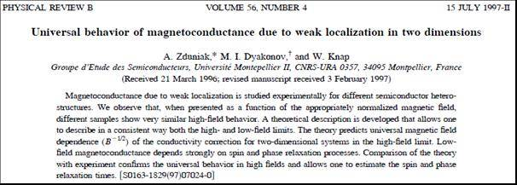

The experimental study of universality of the weak localization behaviour was a subject of the Ph.D. thesis of A. Zduniak. An original system of two superconducting coils was constructed for this purpose, allowing enhancing or compensating for magnetic fields in the sample space. It allowed transport experiments in very wide range of magnetic fields – four orders of magnitudes from high (a few Tesla) to extremely week (a few Gauss) magnetic fields. This was necessary for the full determination of the main transport process/rates: quantum scattering rate, momentum scattering rate, phase scattering rate and spin scattering rate. Typical experimental traces are shown in the figure below. One can see extremely wide magnetic scale range (4 orders of magnitude) allowing to register Shubnikov de Haas (quantum scattering time), Standard Hall effect (transport scattering time), Weak localisation effect (phase scattering time) and Weak Antilocalisation effect (spin relaxation time).

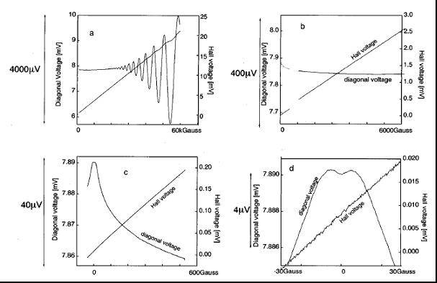

Hydrostatic pressure and illumination were used to change metastable states population and get the data as a function of carrier density. The results brought attention of the top class theoreticians from the Ioffe and Landau Institutes (Prof. M. Dyakonov & others) who improved existing weak anti-localisation theory, allowing to complete the interpretation of the experiment.

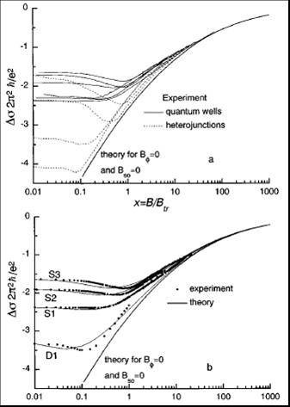 Some results are shown in Figure on the left. It shows magnetoconductivity of GaInAs quantum wells (lines) and heterojunctions (dashed lines) presented as a function of normalized magnetic field. a) presents experimental results and theoretically predicted universal asymptotic behaviour, b) shows a few experimental curves (dots) and their full theoretical fits (solid lines) together with theoretically predicted universal asymptotic behaviour. The weak anti-localisation, weak localisation and universal behaviour are correctly described.

ii) The work on weak universal weak localization was followed by another one related to influence of spin relaxation on the **weak antilocalisation** structure. The results of magnetoconductivity measurements in GaInAs quantum were analysed.

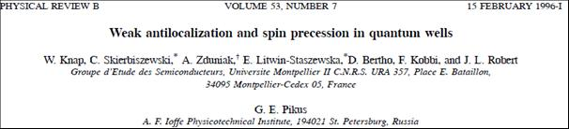

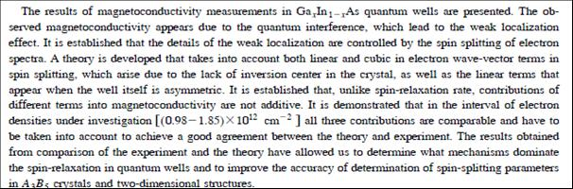

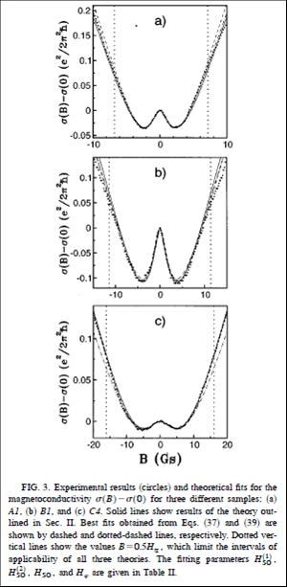

It has been shown that the observed magnetoconductivity appears due to quantum interference, which leads to the weak localisation effect, which in turn is controlled by the spin splitting of electron spectra. A theory was developed that took into account both linear and cubic (in electron wave-vector) terms in spin splitting, which arise due to the lack of inversion center in the crystal, as well as the linear terms that appear when the well itself is asymmetric (Rashba term). It was demonstrated that all three contributions are comparable and have to be taken into account to achieve a good agreement between theory and experiment. The results obtained allowed to determine the dominant spin-relaxation mechanisms and to improve the accuracy of determination of spin-splitting parameters in A3B5 crystals and their two-dimensional structures.

Some experimental curves with their theoretical fits are shown in the next figure.



Apart from many journal and conference papers, the activity in this domain has also led to the Ph.D. thesis of A. Zduniak (1998) and Rabih Tauk (2007) as well as the invited paper at 7th International Conference High Pressure in Sem. Physics, Schwabisch Gmund, Germany 1996 “Study of Quantum and Classical Scattering Times in Pseudomorphic AlGaAs/InGaAs/GaAs by Means of Pressure”.

**W. Knap**, A. Zduniak, L. H. Dmowski, M. Dyakonov, S. Contreras.

The paper on the weak antilocalisation became very important for spintronic community and achieved a large number of citations – more than 160 times.

***A.2 Wide band gap nitrides and their heterojunctions: metal non-metal transition and two-dimensional gas in GaN/AlGaN heterojunctions.***

Importance of nitrides as wide band gap semiconductors that can be used for UV/blue LEDs as well as high temperature operating transistors was discovered in early 90-ties. Together with a dynamic development of technology, it raised a number of questions about basic physical properties of Nitrides. One of the reasons for this situation was the lack of the good quality bulk GaN crystals. Together with a group of researchers from IHPP PAS in Warsaw, who synthesised first bulk GaN crystals under high pressure conditions,we started an intense research to answer the **questions about such basic parameters like value of the electron effective mass, limits of the doping, metal-non metal transition and phonon – electron interactions.**

By means of: i) Far Infrared and Infrared Reflectivity under pressure as well as by the ii) diamond anvils high pressure Raman and iii) luminescence experiments we were able to answer most of the questions. Effective mass was determined and shown that it changes with carrier densities due to non-parabolicity. The polaron effect related to optical phonon free carriers interaction was evidenced as well as the pressure induced metal –non-metal transition in highly doped n-GaN crystals.

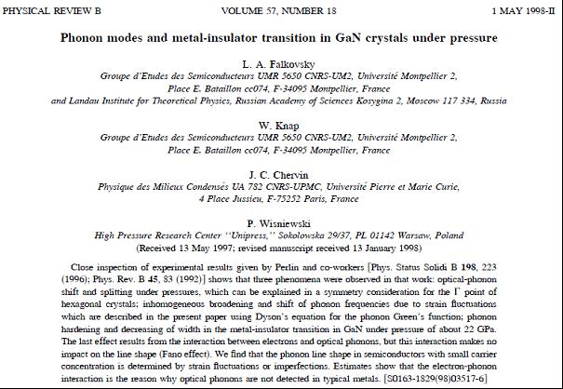

The GaN bulk studies were just an introduction to a more challenging subject related to properties of two-dimension electron gas in GaN/AlGaN heterojunctions. Although the groups of Asif Khan and M. Shur (USA) predicted the existence of 2DEG gas on the interface, no experimental data were available at that time (1999). During my sabbatical in USA I coordinated the joint efforts of IHPP PAS, CRHEA and RPI - New York and USC – South Carolina in growing the first high mobility heterojunctions. **The world record of 2DEG mobility was achieved and carefully documented by low field and high field transport experiments.**

In collaboration with these groups I proposed the high field experiments that led to the:

i) **First demonstration of the existence of 2DEG gas in GaN/AlGaN heterojunctions and measurements of the deformation potential contents.**

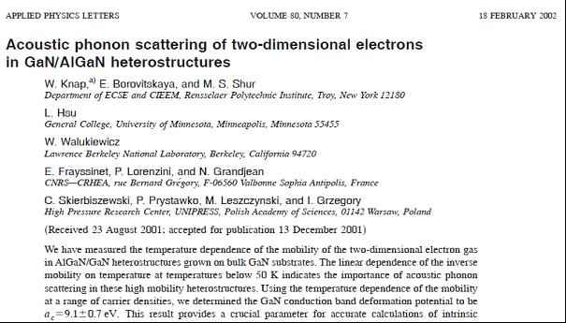

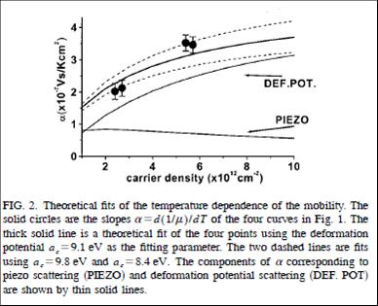

**ii)** **The first observation of the Shubnikov-de-Haas as well as Quantum Hall Effects in GaN/AlGaN heterojunctions as well as the first Cyclotron Resonance absorption and emission data.**

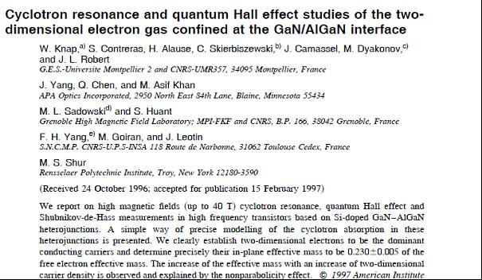

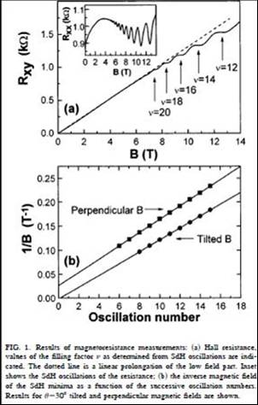(Appl. Phys. Lett. **70**, 2123 (1997)).

These experiments made in magnetic fields up to 40 T clearly demonstrated the existence of 2DEG gas. **These data are referenced as the**  **first published data on Cyclotron resonance and Quantum Hall Effect in GaN based heterojunctions.**

Cyclotron resonance, quantum Hall effect and Shubnikov-de-Haas measurements in Si-doped GaN/AlGaN heterojunctions were performed. We clearly established that two-dimensional electrons were dominant conducting carriers and determined precisely their in-plane effective mass. The increase of the effective mass with an increase of two-dimensional carrier density was observed and successfully quantitatively explained by the nonparabolicity effect.

The first work was completed by determination of the magnetic field dependence of momentum scattering rate. Mechanisms of the electron heating and cyclotron emission intensity were also carefully investigated as function of applied electric fields.

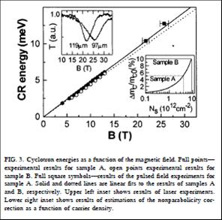

As already mentioned above, **the** **first determination of the 2DEG effective mass in GaN/AlGaN heterojunctions has already shown that the mass is different from the bulk value**. This is due to the strong corrections-related polaron and non-parabolicity effects – that are enhanced in the case of reduced dimensionality. This is because in the case of 2DEG gas in GaN/AlGaN heterojunctions the first electric level is relatively high in the conduction band and also because the reduced dimensionality leads to enhancement of the polaron interaction. It has been shown that the effective mass can increase almost by 10% with the carrier density varying between 1012/cm2 and 1013/cm2.

iii) **The first determination of the effective g factor for 2DEG GaN/AlGaN and** **the first Quantum Hall Effect activation measurements.**

To complete the information about the “Energy structure of 2DEG band in GaN/AlGaN”, it was necessary to determine the spin splitting and answer the question about the possibilities of the anomalous spin splitting behaviour, alike earlier ones observed in GaAs/AlGaAs heterojunctions. For this purpose, the high mobility heterojunctions, based on the bulk substrates, were produced and investigated in mK temperatures.

By tilting magnetic field we were able to register the change of the pattern (phase and amplitude) of the Shubnikov-de-Haas oscillations - related to spin and cyclotron splitting anticrossing behaviour.

This led to:

. 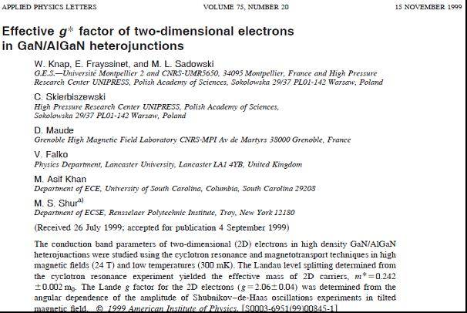

By tilting the sample placed in ultra-low temperature 40mK and high magnetic fields (Grenoble HMFL), the pattern of the Shubnikov de Haas oscillation was modified – because of modification of the ration between spin and cyclotron resonance splitting. The annulation of the Shubnikov de Haas pattern was observed around the tilting angle ~60°.

After careful analysis of the data, the value g*~2.1 was determined very close to the bulk value. Absence of any anomalous enhancements of the spin splitting was confirmed. We found that because of the higher g* factor and higher effective mass, the spin splitting and cyclotron resonance splitting become comparable (see figure below). This makes GaN/AlGaN system very interesting from the point of view of many body interactions.

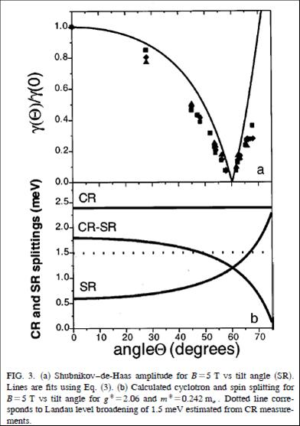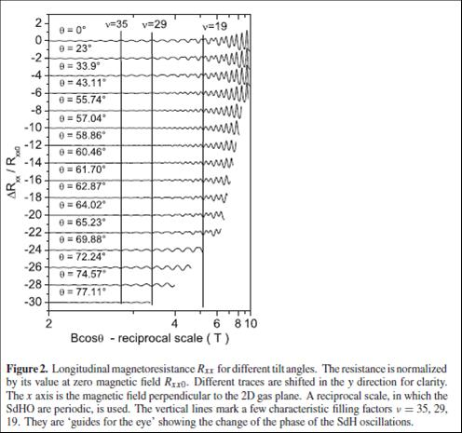

Fig. 2. Longitudinal magnetoresistance RXX for different tilt angles. The resistance is normalized by its value at zero magnetic field Rxx0. Different traces are shifted in the y direction for clarity. The x axis is the magnetic field perpendicular to the 2D gas plane. A reciprocal space, in which the SdH oscillations are periodic, is used. The vertical lines mark a few characteristic filling factors ν := 35, 29, 19. They are ‘guides for the eyes’ showing the changes of the phase of the SdH oscillations.

**First Quantum Hall Effect activation measurements** were performed, showing an unusual behaviour of the quantum transport gaps and an effect of many body interactions energy gaps renormalization. Complete theoretical analysis of the data was performed in collaboration with the V. Falco – Landau Institute. The main results were summarized in the paper in Journal of Physics: Condensed Matter.

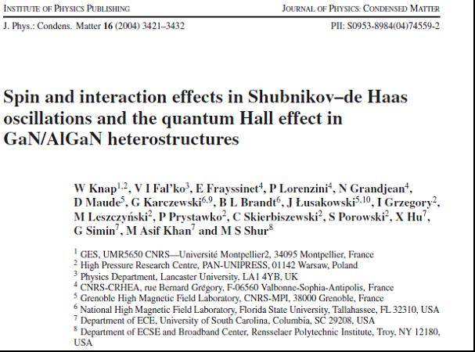

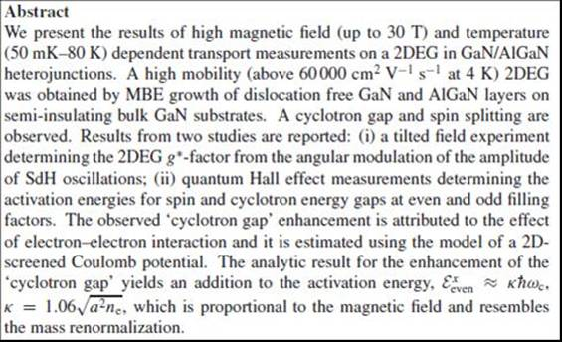

The Quantum Hall Activation measurements were performed at Tallahassee High Magnetic Field Laboratory with resistive magnetic fields up to 30T. Clear activation of the cyclotron and spin gaps were observed in wide range of temperatures.

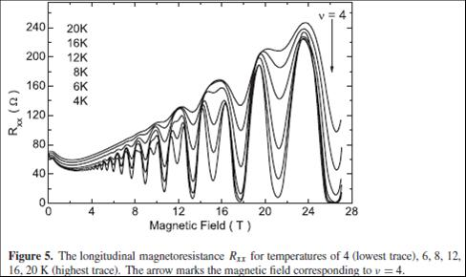

The results plotted as function of temperature are shown in the figure below. They allowed for the determination of activation energies. The observed ‘cyclotron gap’ enhancement is attributed to the effect of electron–electron interaction and is estimated using a model of a 2D-screened Coulomb potential. The analytic result for the enhancement of the ‘cyclotron gap’ yields an addition to the activation energy. Both experimental and analytic results for the enhancement of the ‘cyclotron gap’ yield an addition to the activation energy, which is proportional to the magnetic field and therefore resembles the effective mass renormalization.

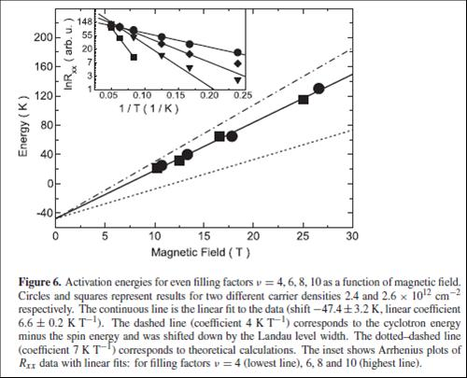

The results on the bulk nitrides and 2DEG in GaN/AlGaN have led to many publications and were recognized by several invited papers.

***A.3 Terahertz plasma excitations in low dimensional systems: Teraherz radiation rectification and generation by plasma confined in nanometre field effect transistors.***

This part of my research activity started in 1997 as a result of the collaboration with world class theoretician Prof. M. Dyakonov, who - together with Prof. M. Shur - predicted that frequencies of plasma oscillations in sub-micron/nanometer field effect transistors (FETs) can reach the Terahertz (THz) range.

They have also predicted that constant current flow in the transistor channel with special boundary conditions can lead to the new type of instability leading itself to the generation of high amplitude plasma waves and THz emission.

Also nonlinearities related to two-dimensional plasma can lead to rectification and detection of THz radiation. Interested by these new mechanisms of THz detection and emission I started the experimental research using high sensitivity cyclotron resonance detection system for emission (built in Montpellier) and Gunn based experimental system for detection (constructed during my sabbatical at RPI, Troy, NY, (USA).

The most interesting *Basic Physics* problems approached were:

i) Influence of the current on the plasma wave related detection – enhancement of the effect and narrowing of the resonances.

ii) Influence of the geometry of the channel – determination of the role of gated and ungated parts of the channel (interaction of gated and ungated two-dimensional plasmons).

iii) Coupling of cyclotron and plasma resonances with magnetic field – damping of Shubnikov-de-Haas oscillations.

**Main results of these studies are:**

i) The first observation of the resonant THz detection by 2D plasmons in GaAs FETs.

Although theoretical predictions indicated that resonant plasma modes can be excited in the channel of nanotransistors, it remained unconfirmed. Resonant modes are like an acoustic standing wave in a musical instrument. They can be excited and exist only if correct border conditions (correct cavities) are provided. In the channel of a transistor, THz frequencies requires nanometer dimensions – and the control of the borders in this scale is extremely difficult. Finally by constructing a new experimental system – sources 200 GHz and 600 GHz, cooling facility ( RPI-TROY, New York) and selecting high mobility InGaAs heterojonctions, we have managed to observe firs resonant detection.

The resonance condition quality factor above ~1 was reached thanks to the use of cryogenic temperatures and 600 GHz frequency.

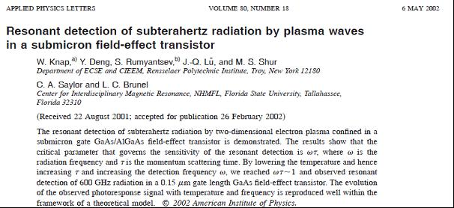

Final proof of the resonant plasma wave detection was obtained by experiments, in which we could modify the carrier density by addition of an external illumination. Using metastable properties of the 2DEG gas in InGaAs heterojunctions we could increase also a carrier mobility reaching the detection up to 1 THz. Shift of the resonant voltage/frequency with carrier density was the final proof that the plasma resonances are excited in the channel and that the plasma wave resonance mechanism is responsible for subTHz and THz detection.

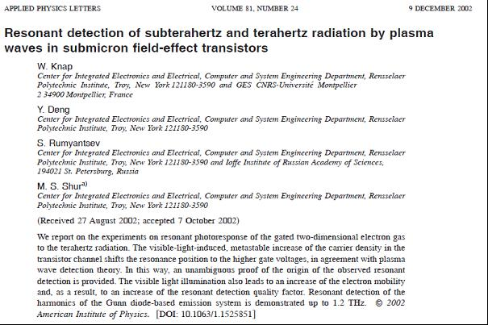

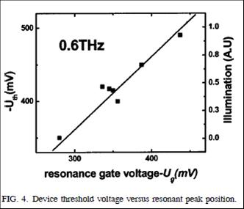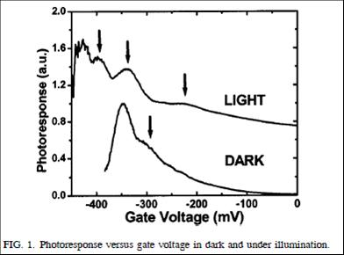

ii) First observation of the **plasma wave instability** leading to THz emission.

As already mentioned above, in early nineties Prof. M. Dyakonov together with Prof. M. Shur predicted that constant current flow in the transistor channel with special boundary conditions can lead to the new type of instability leading itself to the generation of high amplitude plasma waves and THz emission. The nanometer-size field effect InGaAs /InP HEMTS (produced by IEMN – Lille) were used in the experiments. The emission in nano-Watt range was observed with maxima shifting with applied current from 0.4 THz up to 1 THz ;:– see inset of figure below. The observation was possible thanks to the use of the previously constructed cyclotron emission/detection system – that was applied here as LHe cooled THz spectrometer. The figure below shows also the calibration results –see left upper inset in the figure- made by using InSb cyclotron emitter. Cyclotron emission is usually in low pW range.

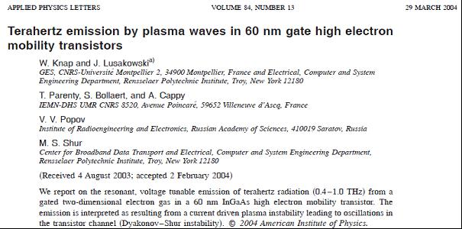



The most important from the point of view of the *Basic Physics* was verification if the emission is really due to **plasma wave instability**. This instability is a new type instability never observed in solids. It resembles a “laser like” amplification, but plasma waves are amplified not in the media but during the reflections from the channel borders. Theory predicted that once the drain current reaches certain value, a “laser like” amplification of the plasma wave amplitudes should took place in the **“Threshold Like Manner”.** The experimental proof was obtained by careful studies of the THz radiation intensity as function of the current or voltage. Clear evidence of the ***“threshold like behaviour”*** was observed – the emission signal raised by orders of magnitude once the threshold voltage/current was reached. The results are shown below – the magnetic field was used as parameter changing the threshold values – through the magnetoresistance effect.

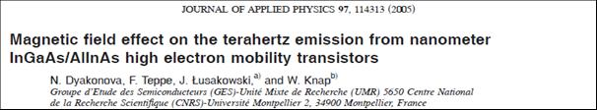

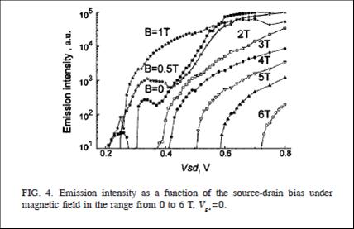

Research on high mobility HEMTS as potential Terahertz emitters brough also attention of the transistor community as documented by International Electronic Journal SPECTRUM. announcement. 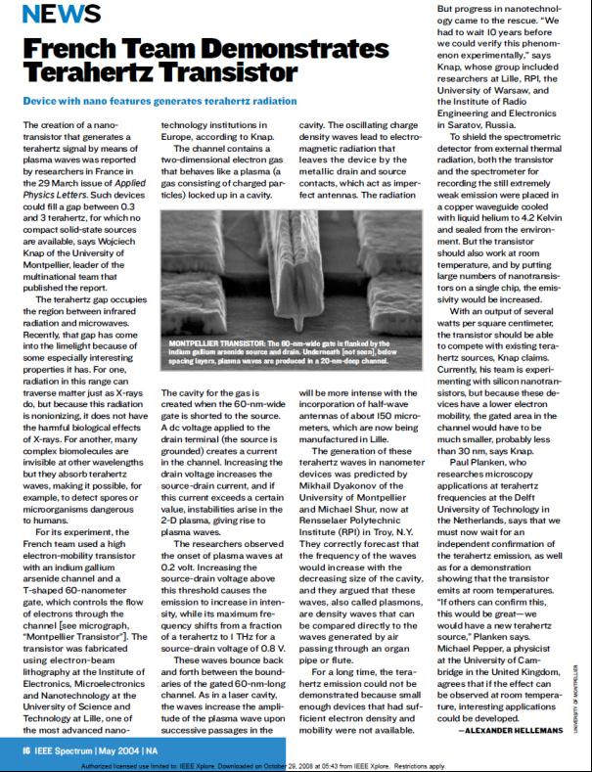

Very interesting *Basic Physics* problem - related to plasma instability - concerns an influence of the current on the plasma wave-related detection. The drain current affects the plasma relaxation rate by driving the two-dimensional plasma in the transistor channel towards the Dyakonov-Shur plasma wave instability. When FET operates as a resonant detector, the induced photoresponse is given by:



where  is the fundamental resonant plasma frequency, and  is the frequency of the incoming radiation. The resonant response in the presence of a drain current can be written as but with a replacement . Here,  is the effective scattering rate/linewidth given by:



where *v* is the electron drift velocity. With increasing current, the electron drift velocity increases, leading to the increase of  and of the quality factor. When  approaches unity, the detection becomes resonant. One was expecting an enhancement of the detectivity and narrowing of the resonances, and then an abrupt transition toward instability and emission. Narrowing and enhancement of the detection with applied drain current was observed in experiments on InGaAs transistors with multi-finger configuration (IEMN-Lille). The main results are illustrated in figure below.

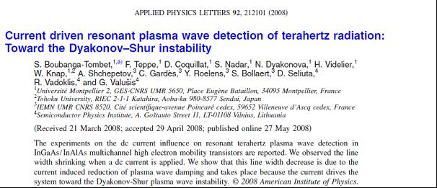

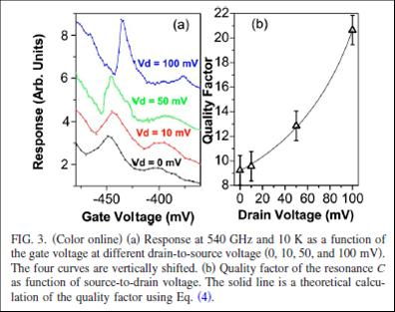

iii) Another important *Basic Physics* project related to plasma physics in two dimensional systems concerns with magnetic field influence on the plasma wave excitations.

Plasma wave propagation can be strongly modified by high magnetic fields. With increasing magnetic fields electrons will start make the cyclotron motion. Once the cyclotron resonance condition is reached, the cyclotron motion will compete with plasma density waves leading to plasma wave damping.

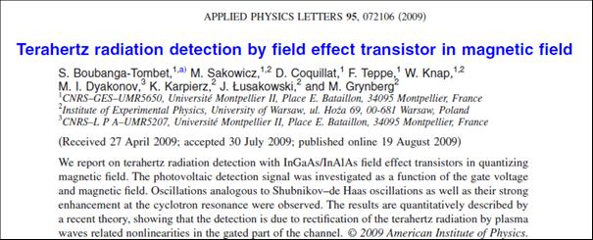

THz radiation detection using InGaAs/InAlAs FETs in quantizing magnetic field was studied. The photovoltaic detection signal was investigated as a function of the gate voltage and magnetic field. Oscillations analogous to the Shubnikov-de Haas oscillations as well as their strong enhancement at the cyclotron resonance were observed. The results were compared with a recent theory of M. Lifshits and M. Dyakonov. In this theoretical work three major effects are predicted.

First, pronounced Shubnikov-de Haas-like oscillations in the FET signal that enhanced in the vicinity of the cyclotron resonance. The second effect is the presence of a smooth component of the FET signal, unrelated to Shubnikov-de Haas oscillations. This component has also a maximum at the cyclotron resonance. Finally, they predicted also that in the gated region of the channel plasma waves can propagate only if the cyclotron resonance frequency is lower than the radiation frequency.

In the opposite case, the plasma wave vector becomes imaginary and thus plasma oscillations rapidly decay away from the source. These three effects were theoretically expected in the photoresponse under the magnetic field.

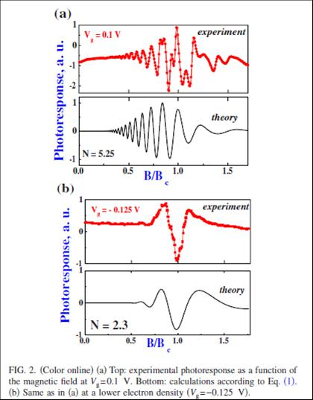

The figure above (top panels) shows FET signal as a function of the magnetic field for relatively high and low an electron density. The x scale of figures is magnetic field in unities of the cyclotron magnetic field (for 2.5 THz). The experiments show an oscillatory character of the signal. Its periodicity versus 1/*B* clearly indicates that oscillations are related to the coincidence of the Fermi level with density of states maxima of the Landau levels. The enhancement of the signal in the vicinity of the cyclotron resonance condition is also visible for the lower concentration sample. One can clearly see damping of the plasma waves above cyclotron resonance field (x>1) in agreement with a general physical picture. ***This is probably most spectacular demonstration of the plasma waves propagation and damping in two dimensional systems.***

**B. Research in the Applied Physics**

Independently of my interest in the Basic Physics, I also had an important activity concerning applications of the results of my research. This led to many collaborations and contacts with industrial partners. They can be presented in 3 groups:

1. ***Optical sensor: Quantum well based infrared sensors for gas detection – with Schlumberger.***
2. ***Nanotransistors- physical/versus technological limits.***
3. ***Terahertz detection and imaging by Field Effect Transistors.***

***B1. Optical sensors: Quantum well based infrared sensors for gas detection – with Schlumberger.***

This was my first contact with industrial partner – **Schlumberger** – that wanted to develop the semiconductor based sensor that could allow for measurements of the quality of the gas delivered to the customers. To this purpose one should determine the ratio of the methane, ethane and other gases. Using our knowledge of the physics of GaAs/AlGaAs quantum wells we proposed, fabricated and tested the semiconductor based sensors – working as the electrically modulated notch filters. This project took several years and was realized in the frame of the industry supported Ph.D. thesis of H. Alause and was finalized by an international patent.

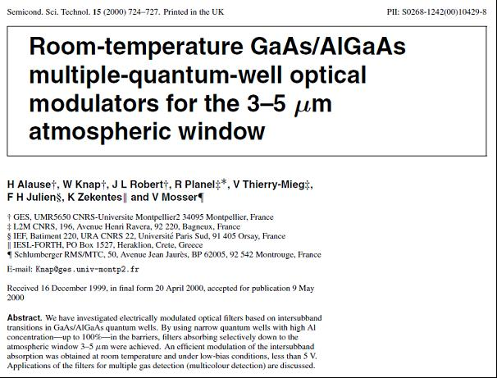

***B2. Nanotransistors - physical/versus technological limits.***

Pushing the transistor to operate at higher powers and frequencies leads the industry to search for new materials like Nitrides miniaturization. Physicists have an important role in determining what are the physical limits and which limits are only technological ones. Two examples of collaboration will be given. They concern high power GaN-based HEMTS and ultimately short Si–MOSFETs.

The *Basic Physics* research on the GaN/AlGaN heterojunctions mentioned above was followed by the studies of the High Electron Mobility transistors. By comparing the technologies based on the Sapphire, SiC and bulk GaN substrates we were able to determine the role of the dislocations in high and cryogenic temperatures.

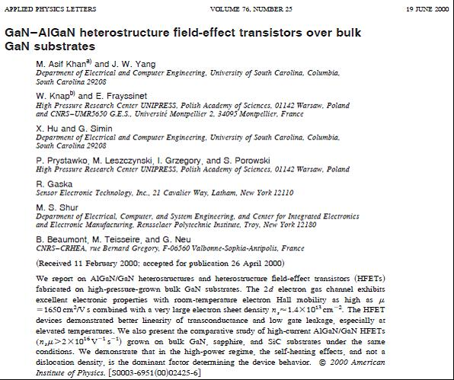

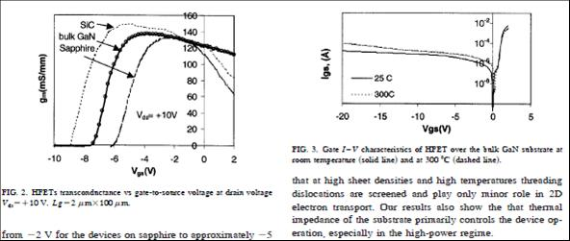

By comparing the devices on GaN bulk substrates, SiC substrates and Sapphire substrates we were able to state that for density below 108/cm2 dislocations do not influence on room temperature transistor parameters. We could also clearly show that GaN bulk-based devices, as having smallest number of dislocations, are most stable – no gate leakage current – up to elevated temperatures of ~300°C– see figure. The research on GaN/AlGaN heterojunctions involved industrial partners **APA – Optics and SET South Caroline (USA), TopGaN Warsaw (Poland) and is continued with III-V Labs.**

Another example of *Applied Physics* research concerns the ultimately short Si nanotransistors. For these extremely short nanotransistors the traditional methods of carrier mobility determination do not work correctly. We proposed a determination of mobility based on the geometrical magnetoresistance method. In fact, the geometry of the transistor – very wide and short channel – leads to magnetoresistance changing like µB squared. This way we – together with our Industrial partner **STMicroelectronics** - were able to analyse various technologies of nanotransistors and determine relative role of doping, strain and ballistic effects in the final transistor performance.

We have made the first experimental demonstration of the ballistic limitations of the Si nanotransistors of sub-100nm technology. According to the theoretical expectation in ultimately short Si MOSFETs - below 100nm - part of the electrons become ballistic even at room temperature. This phenomenon can lead to the fact that the conductivity of the channel is not increasing linearly with the decreasing of the channel length, as usually expected in the diffusive transport case, but can saturate (become channel length independent).

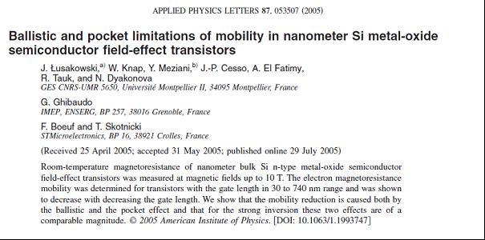

We have shown that this effect can be also seen/interpreted as a “reduction of the carrier mobility” – even if the mobility is not a well-defined value in case of ballistic motion. The so called “ballistic mobility” was introduced and validity of the Mathiessen rule (“inverse of total mobility equals to sum of inverse mobilities of all independent scattering mechanisms”) was verified experimentally. Example of the experimental results is given in the figure below. One can observe a strong reduction of mobility when the device length becomes smaller than 200 nm.

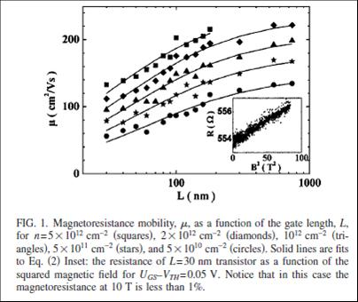

By the high field magnetoresistance measurements completed by theoretical analysis we have shown that ballistic effects play an important role for modern Si transistors shorter than 100 nm and are responsible for at least 30 percent “mobility reduction” at 30 nm channel length. We would like to mention that, from experimental point of view, mobility determination was a challenging task. The reason is that the room temperature magneto-resistance of Silicon devices changes only ~1% even in fields as high as 10 T (see inset- figure above). We used a superconducting magnet with special electrical/thermal/mechanical isolations allowing high stability room temperature measurements.

The figure below presents the relative contribution of ballistic and impurity scattering (pocket) effects for transistors of 30 nm length. One can see that the ballistic effects give the contribution that is comparable with the impurity/pocket mobility limitation.

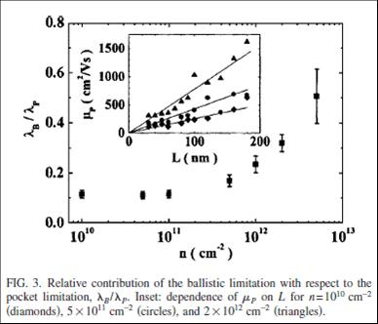

This project allowed to obtain a better understanding of the physics of ballistic effects and to determine the physical limits of performance of next generation nanometre MOSFETs.

***B3. Terahertz detection and imaging by Field Effect Transistors.***



*Fig. 1: Electromagnetic radiation spectrum from radio waves to X-rays. Symbols depict main applications of various radiation bands. The “Terahertz gap”, meaning lack of the widespread market applications and covering 100 GHz – 10 THz frequency range, is indicated. (Courtesy of Prof. T. Otsuji, Tohoku University, Japan).*

Electromagnetic radiation spectrum includes visible light (with the adjacent infrared (IR), ultraviolet (UV) and the X-ray bands) on one side and radio frequencies (with adjacent millimeter waves) on the other (see Fig.1). Both of these spectral bands are nowadays heavily utilized. In contrast, the intermediate band, grouping electromagnetic waves of frequencies from 100 GHz to 10 THz, lending itself a name of “THz gap”, remains largely unexplored (Fig. 1).

Various important basic processes and physical properties of matter can be studied with THz radiation. For example, phenomena such as a cyclotron resonance or a spin resonance, which refer to the basic energy band structure of solid-state matter, lead to an absorption of THz radiation. In addition, collective plasma excitations – plasma waves in semiconductor nanostructures – occur at THz frequencies. In medicine and biology, THz radiation may be used for detection of vibrations of large molecules that dictate physicochemical and biological properties of a living matter.

A very useful property of THz radiation is that it easily penetrates most of non-metallic materials and allows to investigate internal structure or content of objects. Also, unlike UV or X-ray, THz waves are non-ionizing and hence harmless to humans and animals, eliminating the need for safety measures. Sub-THz waves propagate through sand, fog or snow, providing vision and wireless communication possibilities difficult to obtain in other (infrared) radiation ranges.

Therefore, a multitude of potential applications for THz waves emerge in wireless communication systems (to boost the data rate), industry, agriculture and trade (for a non-destructive, non-hazardous process monitoring or quality checks), in safety (such as vision systems for difficult atmospheric conditions) and security (detection of hazards) or health (skin burns and cancerous tissue diagnostic, as well as cell dynamics).

***The enormous potential carried by both the basic science and applications identified and already partially exploited in the THz field during the last 30 years, has established a Terahertz-related science and technology as an important scientific axis, bridging the optronics and electronics and unifying efforts of a large scientific community, similarly to Quantum Computing and Spintronics.***

***Applied part of THz science and technology faces its own challenges.*** They are related to the fact that many of already demonstrated practical applications of THz technology are still not available on a mass market due to extremely high costs, unacceptably large size, limited performances or other shortcomings of former technological solutions for THz emitters and detectors. For example, available semiconductor-based THz sources like Quantum Cascade Lasers (QCLs) still require a cryogenic cooling, being therefore a laboratory equipment only. Also, ultrasensitive THz detectors, which are successfully used in astrophysics, require cryogenic cooling as well. Only at the end of the 20th century, high-quality, room-temperature-operating Schottky-diode-based THz emitters and detectors were proposed, which, however, do not allow for cost-efficient multi-pixel (arrays) and cameras.

In 1990 Dyakonov and Shur proposed theoretically to use plasma oscillations in nanometer size field effect transistors (FETs) as the candidates for THz sources and emitters. The simple physical reason for this comes from the fact that the typical velocity of plasma waves is of the order of million meters per second ( s=106 m/s). This means that the time of the round trip of plasma wave in L=500nm long device is one picosecond ( T=2L/s). Period of one picosecond correspond to oscillation frequency of 1THz. This means that the nanodevices of dimensions 500nm and smaller can serve as resonators for THz waves.

The idea of using plasma oscillations in nanometer transistors for THz applications was met with great expectations because of its compatibility with Integrated Circuits manufacturing using mainstream semiconductor technologies such as CMOS in the case of silicon or III-V HEMTs.

The research of Prof. W. Knap has provided the experimental proof that indeed, theoretical predictions of Dyakonov and Shur can be used as efficient detectors and emitters at – THz frequencies – thanks to some specific properties of electron plasma waves.

Research on the THz detection related to plasma effects in nanotransistors led us to discovery that these transistors can efficiently work at room temperature and that they have responsivity that is one of the highest among all existing room temperature detectors. One of the most important achievements was a demonstration of room temperature broadband THz detection by nanometre Si MOSFETs .

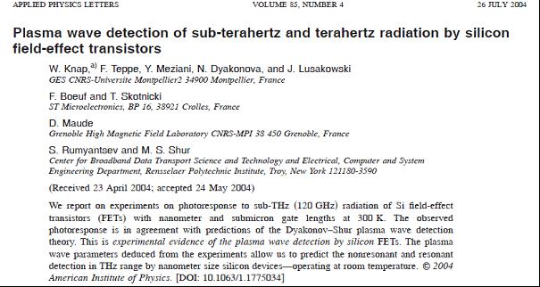

 The key parameter that determines the performance of the transistors is so called Noise equivalent power. It was found in the range of 10-10 W/Hz – this mean very close to the best room temperature THz detectors – see figure below.

Work on terahertz plasma oscillations in nanodevices appeared extremely important for development of Terahertz Science and Technology

Together with an industrial partner **STMicroelectronics, CEA-LETI, and New TeraHertz Technology- Italy,** we studied the possibilities to make an array of detectors that can be used as focal plane arrays for future THz cameras working in 0.3-1.0 THz range.

Also GaN/AlGaN transistors are considered as potential THz detectors – this work is continued in collaboration with III-V Labs and IEMN Lille – ANR project TERAGAN.

**Below there is a list of a few the most important industry related contracts:**

Schlumberger Industrie –«Capteurs de gaz a semi-conducteurs» (1995-1997).

European IP PullNano IST « PULLing the limits of NANOCmos electronics» (2006-2009).

Nano 2008 (2005-2008) and Nano 2012 ( 2009- 2012) «Terahertz nanotransistors» with STMicroelectronics.

ANR TeraGaN “Terahertz GaN transistors ”with II-V Labs (2007-2010).

Contrat Collaboration de Recherche “Terahertz FET for security applications ”Entreprise NTT, Turin, Italy (2008-2010).

CANON France – Terahertz Communication with Field Effect Transistors (2013-2016).

DGA/SAGEM/LETI – Terahertz vision with Field Effect Transistors Arrays (2014-2017).

**Very important achievement in the field of technology transfer was creation of Spin-off Company TERAKALIS.**

TERAKALIS start- up company was created in October 2014 – ( Prof. W.Knap was a co-funder and a Research and Development adviser of this company). This company already has 25 employees and gets support of most of national (OSEO) and regional agencies (Languedoc-Roussillon Region). This company uses CNRS Patents – made by CNRS group on THz detectors and sources.

Based on the internationally-recognized research and several patents, TERAKALIS aims to design and develop components, mainly terahertz sensors and sources, and measuring and imaging systems in the terahertz field.

**Another important achievement in the field of technology transfer was a development of Fast THz Mail Scanner with ORTEH-Poland (**[**http://www.orteh.pl/page/22/research-development**](http://www.orteh.pl/page/22/research-development)**)**

Below is a description of THz scanner – taken from ORTEH company WEB page.

“Fast THz Mail Scanner designed by Orteh Company (in cooperation with Institute of High Pressure Physics, ul. Sokolowska 29/37, 01-142 Warsaw, POLAND - prof. Wojciech Knap) is very fast and efficient THz postal scanning system used on the conveyor belt with simple and intuitive software.

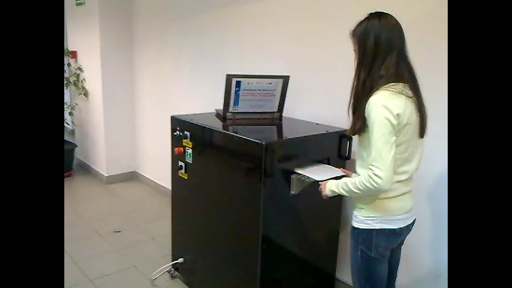Fast THz Mail Scanner system allows to verify the content of different envelopes using THz radiation. It is an extremely fast device in comparison with all other known in the world systems. It is based on the innovative combination of exceptional electronic solutions, modern optical elements and intuitive software program. The scanner itself and example of the image of the envelope with a CD disc inside are shown on the photos below.

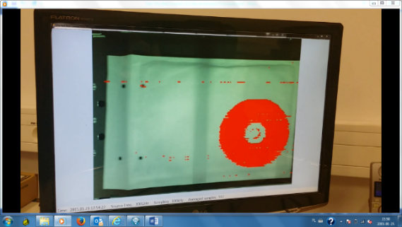

The non-ionizing character of the THz radiation makes THz scanning very powerful and eagerly developed technique. Mostly a single point-like source and single detector is used for THz imaging. Additionally, to reduce extremely long scanning time, rotating or vibrating mirrors can be used but it is still not enough for fast mail scanners.

The unique device called Fast THz Mail Scanner gives the possibility of very short scanning time due to the use of three lines of detectors and especially designed diffractive optical structure that is shaping THz beam coming from the point-like source. Extremely advanced optical element is transforming the point THz source radiation into three line segments created at particular distance behind the optical structure. Such beam is illuminating the envelope and just under it there is the matrix of detectors. The registering system consists of 3 lines of 48 single detectors each. To ensure proper functioning and data flow such matrix is divided into 4 modules (each containing 3 lines of 12 single detectors). This advanced solution allows for scanning time of one envelope about only 1 second.”

**Main Journal Publications and Invited and Tutorial Presentations List**

**Bibliometry :**

**Mendeley Data - "Updated science-wide author databases of standardized citation indicators" Published: 08-10-2020 classifies W.Knap in top 2% world scientists in the field of applied physics**

**( https://data.mendeley.com/datasets/btchxktzyw/2) .**

**Scopus –-Knap, W. (Nov 24, 2020)**

**Documents: 488**

**Citations: 10 636 total citations by 5421 documents**

**h-index: 51 ( WEB of SCIENCE 48, Google Scholar 57)**

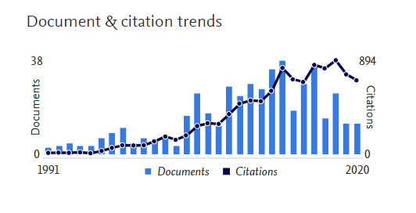

**1.1 MAIN JOURNAL PAPERS in CHRONOGICAL ORDER (273)**

**2020**

1. Vainshtein, S.; Duan, G.; Rahkonen, T.; Taylor, Z.; Zemlyakov, V.; Egorkin, V.; Smolyanskaya, O.; Skotnicki, T.; Knap, W., Self-damping of the relaxation oscillations in miniature pulsed transmitter for sub-nanosecond-precision, long-distance LIDAR. *Results in Physic***2020**, *19*, 103509.
2. Grigelionis, I.; Diakonova, N.; Knap, W.; Teppe, F.; Prystawko, P.; Kašalynas, I., Radiation from shallow oxygen impurity in AlGaN/GaN HEMT structures in magnetic field. *Solid State Communications* **2020**, *320*, 114019.
3. Boubanga-Tombet, S.; Knap, W.; Yadav, D.; Satou, A.; But, D.B.; Popov, V.V.; Gorbenko, I.V.; Kachorovskii, V.; Otsuji, T., Room-Temperature Amplification of Terahertz Radiation by Grating-Gate Graphene Structures. *Physical Review X* **2020**, *10*(3), 031004.
4. Dub, M.; Sai, P.; Przewłoka, A.; Krajewska, A.; Sakowicz, M.; Prystawko, P.; Kacperski, J.; Pasternak, I.; Cywiński, G.; But, D.; Knap, W.; Rumyantsev, S., Graphene as a schottky barrier contact to AlGaN/GaN heterostructures. *Materials* **2020**, *13*(18), 4140.
5. Mantion, S.; Avogadri, C.; Krishtopenko, S.S.; Gebert, S.; Ruffenach, S.; Consejo, C.; Morozov, S.V.; Mikhailov, N.N.; Dvoretskii, S.A.; Knap, W.; Nanot, S.; Teppe, F.; Jouault, B., Quantum Hall states in inverted HgTe quantum wells probed by transconductance fluctuations. *Physical Review B* **2020**, *102*(7), 075302.
6. Krishtopenko, S.S.; Kadykov, A.M.; Gebert, S.; Ruffenach, S.; Consejo, C.; Torres, J.; Avogadri, C.; Jouault, B.; Knap, W.; Mikhailov, N.N.; Dvoretskii, S.A.; Teppe, F., Many-particle effects in optical transitions from zero-mode Landau levels in HgTe quantum wells. *Physical Review B* **2020**, *102*(4), 041404.
7. Barani, Z.; Kargar, F.; Godziszewski, K.; Rehman, A.; Yashchyshyn, Y.; Rumyantsev, S.; Cywiński, G.; Knap, W.; Balandin, A.A., Graphene Epoxy-Based Composites as Efficient Electromagnetic Absorbers in the Extremely High-Frequency Band. *ACS Applied Materials and Interfaces* **2020**, *12*(25), 28635-28644.
8. Hubmann, S.; Budkin, G.V.; Otteneder, M.; But, D.; Sacré, D.; Yahniuk, I.; Diendorfer, K.; Bel'Kov, V.V.; Kozlov, D.A.; Mikhailov, N.N.; Dvoretsky, S.A.; Varavin, V.S.; Remesnik, V.G.; Tarasenko, S.A.; Knap, W.; Ganichev, S.D., Symmetry breaking and circular photogalvanic effect in epitaxial CdxHg1-xTe films. *Physical Review Material*s **2020**, *4*(4), 043607.
9. Otteneder, M.; Sacré, D.; Yahniuk, I.; Budkin, G.V.; Diendorfer, K.; Kozlov, D.A.; Dmitriev, I.A.; Mikhailov, N.N.; Dvoretsky, S.A.; Bel'kov, V.V.; Knap, W.; Ganichev, S.D, Terahertz Magnetospectroscopy of Cyclotron Resonances from Topological Surface States in Thick Films of CdxHg1−xTe. *Physica Status Solidi (B) Basic Research*, **2020**

**2019**

1. Krishtopenko, S.; Ruffenach, S.; González-Posada Flores, F.; Consejo, C.; Desrat, W.; Jouault, B.; Knap, W.; Fadeev, M.; Kadykov, A.; Rumyantsev, V.; Morozov, S.; Bossier, G.; Tournie, E.; Gavrilenko, V.; Teppe, F., Terahertz Spectroscopy of Two-Dimensional Semimetal in Three-Layer InAs/GaSb/InAs Quantum Well. *JETP Letters* **2019,***109* (2), 96-101.
2. Sai, P.; But, D.; Yahniuk, I.; Grabowski, M.; Sakowicz, M.; Kruszewski, P.; Prystawko, P.; Khachapuridze, A.; Nowakowski-Szkudlarek, K.; Przybytek, J.; Wiśniewski, P.; Stonio, B.; Słowikowski, M.; Rumyantsev, S.; Knap, W.; Cywiński, G., AlGaN/GaN Field Effect Transistor with Two Lateral Schottky Barrier Gates Towards Resonant Detection in Sub-mm Range. *Semiconductor Science and Technology* **2019,***34* (2), 024002.
3. Krishtopenko, S. S.; Desrat, W.; Spirin, K. E.; Consejo, C.; Ruffenach, S.; Gonzalez-Posada, F.; Jouault, B.; Knap, W.; Maremyani, K. V.; Gavrilenko, V. I.; Bossier, G.; Torres, J.; Zaknoune, M.; Tournie, E.; Teppe, F., Massless Dirac Fermions in III-V Semiconductor Quantum Wells. *Physical Review B* **2019,***99* (12), 121405.
4. Zagrajek, P.; Danilov, S. N.; Marczewski, J.; Zaborowski, M.; Kolacinski, C.; Obrebski, D.; Kopyt, P.; Salski, B.; But, D.; Knap, W.; Gaichev, S. D., Time Resolution and Dynamic Range of Field-Effect Transistor-Based Terahertz Detectors., *Journal of Infrared Millimeter and Terahertz Waves* **2019,***40* (7), 703-719.
5. Fahs, B.; Wu, K.; Aouimeur, W.; Mansha, M.W.; Gaquière, C.; Gamand, P.; Knap, W.; Hella, M.M., About 250/285 GHz push–push oscillator using differential gate equalisation in digital 65-nm CMOS., *IET Microwaves, Antennas and Propagation* **2019,***13* (12), 2073-2080.
6. Sai, P.; Jorudas, J.; Dub, M.; Sakowicz, M.; Jakstas, V.; But, D. B.; Prystawko, P.; Cywiński, G.; Kasalynas, I.; Knap, W.; Rumyantsev, S., Low frequency Noise and Trap Density in GaN/AlGaN field effect transistors. *Applied Physics Letters* **2019,***115* (18), 183501.
7. But, D. B.; Mittendorff, M.; Consejo, C.; Teppe, F.; Mikhailov, N. N.; Dvoretskii, S. A.; Faugeras, C.; Winnerl, S.; Helm, M.; Knap, W.; Potemski, M.; Orlita, M., Suppressed Auger Scattering and Tunable Light Emission of Landau-Quantized Massless Kane Electrons., *Nature Photonic* **2019,***13* (11), 783-787.
8. Yahniuk, I.; Krishtopenko, S. S.; Grabecki, G.; Jouault, B.; Consejo, C.; Desrat, W.; Majewicz, M.; Kadykov, A. M.; Spirin, K. E.; Gavrilenko, V. I.; Mikhailov, N. N.; Dvoretsky, S. A.; But, D. B.; Teppe, F.; Wróbel, J.; Cywiński, G.; Kret, S.; Dietl, T.; Knap, W., Magneto-Transport in Inverted HgTe Quantum Wells. *npj Quantum Materials* **2019,***4* (1), 13.
9. Zholudev, S. M.; Kadykov, M. A.; Fadeev, A. M.; Marcinkiewicz, M.; Ruffenach, S.; Consejo, C.; Knap, W.; Torres, J.; Morozov, S. V.; Gavrilenko, V. I.; Mikhailov, N. N.; Dvoretskii, S. A.; Teppe, F., Experimental Observation of Temperature-Driven Topological Phase Transition in HgTe/CdHgTe Quantum Wells. *Condensed Matter* **2019,***4* (1), 27.

**2018**

1. Yavorskiy, D.; Karpierz, K.; Grynberg, M.; Knap, W.; Łusakowski, J., Indium antimonide detector for spectral characterization of terahertz sources *Journal of Applied Physics* **2018,***123* (6).

2. Kadykov, A. M.; Krishtopenko, S. S.; Jouault, B.; Desrat, W.; Knap, W.; Ruffenach, S.; Consejo, C.; Torres, J.; Morozov, S. V.; Mikhailov, N. N.; Dvoretskii, S. A.; Teppe, F., Temperature-Induced Topological Phase Transition in HgTe Quantum Wells. *Physical Review Letters* **2018,***120* (8 — 23 ).

3. Cywiński, G.; Yahniuk, I.; Kruszewski, P.; Grabowski, M.; Nowakowski-Szkudlarek, K.; Prystawko, P.; Sai, P.; Knap, W.; Simin, G. S.; Rumyantsev, S. L., Electrically controlled wire-channel GaN/AlGaN transistor for terahertz plasma applications *Applied Physics Letters* **2018,***112* (13).

4. Desrat, W.; Krishtopenko, S. S.; Piot, B. A.; Orlita M; Consejo, C.; Ruffenach, S.; Knap*,* W.; Nateprov, A.; Arushanov, E.; Teppe, F., Band Splitting in Cd3As2 Measured by Magnetotransport. *Physical Review B* **2018,***97* (24), 245203.

5. Krishtopenko, S. S., Ruffenach, S.; Gonzalez-Posada, F.; Boissier, G.; Marcinkiewicz, M.; Fadeev, M. A.; Kadykov*,* A. M.; Rumyantsev, V. V.; Morozov, S. V.; Gavrilenko, V. I.; Consejo, C.; Desrat, W.; Jouault, B.; Knap, W.; Tournie, E.; Teppe, F., Temperature-Dependent Terahertz Spectroscopy of Inverted-Band Three-Layer InAs/GaSb/InAs Quantum Well. *Physical Review B* **2018**,*97* (24), 245419.

6. Zhang, B.; Wei, Y.; Li, Z.; Bai, L.; Cywinski, G.; Yahniuk, I.; Szkudlarek, K.;Skierbiszewski, C.; Przybytek, J.; But, D.; Coquillat, D.; Knap, W.; Yang, F.-H., An Effective Method for Antenna Design in Field Effect Transistor Terahertz Detectors. *Journal of infrared and milimeter waves* **2018***,37* (4), 389-392.

7. Coquillat, D., Duhant, A.; Triki, M.; Nodjiadjim, V.; Konczykowska, A.; Riet, M.; Dyakonova, N.; Strauss, O.; Knap, W., InP Double Heterojunction Bipolar Transistors for Terahertz Computed Tomography. *AIP Advances* **2018***,8* (8), 085320.

8. Bąk, M.; Yavorskiy, D.; Karpierz, K.; Łusakowski, J.; But, D.; Przybytek, J.; Yahniuk, I.; Cywiński, G.; Knap, W.; Teppe, F.; Krishtopenko, S.; Mikhailov, N. N.; Dvoretsky, S. A.; Gavrilenko, V. I., Magnetoconductivity of a mercury cadmium telluride resonant THz. *Acta Physica Polonica A* **2018***,134* (4), 973-977.

9. Marczewski, J.; Coquillat, D.; Knap, W.; Kolacinski, C.; Kopyt, P.; Kucharski, K.; Lusakowski*,* J.; Obrebski, D.; Tomaszewski, D.; Yavorskiy, D.; Zagrajek P.; Ryniec, R.; Palka, N., Thz Detectors Based on Si-CMOS Technology Field Effect Transistors – Advantages, Limitations and Perspectives for Thz Imaging and Spectroscopy. *Opto-Electronics Review* **2018***,*2*6* (4), 261-269.

10. Yavorskiy, D.; Karpierz, K.; Baj, M.; Bąk, M. M.; Mikhailov, N. N.; Dvoretsky, S. A.; Gavrilenko, V. I.; Knap, W.; Teppe, F.; Łusakowski, J., Magnetoconductivity and Terahertz Response of a HgCdTe Epitaxial Layer. *Sensors (Basel, Switzerland)* **2018***,18* (12), 4341.

**2017**

4. Ruffenach, S.; Kadykov, A.; Rumyantsev, V. V.; Torres, J.; Coquillat, D.; But, D.; Krishtopenko, S. S.; Consejo, C.; Knap, W.; Winnerl, S.; Helm, M.; Fadeev, M. A.; Mikhailov, N. N.; Dvoretskii, S. A.; Gavrilenko, V. I.; Morozov, S. V.; Teppe, F., HgCdTe-based heterostructures for terahertz photonics. *APL Materials* **2017,***5* (3), 035503.

5. Rachon, M.; Liebert, K.; Siemion, A.; Bomba, J.; Sobczyk, A.; Knap, W.; Coquillat, D.; Suszek, J.; Sypek, M., Geometrical Aberration Suppression for Large Aperture Sub-THz Lenses. *Journal of Infrared, Millimeter, and Terahertz Waves* **2017,***38* (3), 347-355

6. Marcinkiewicz, M.; Ruffenach, S.; Krishtopenko, S. S.; Kadykov, A. M.; Consejo, C.; But, D. B.; Desrat, W.; Knap, W.; Torres, J.; Ikonnikov, A. V.; Spirin, K. E.; Morozov, S. V.; Gavrilenko, V. I.; Mikhailov, N. N.; Dvoretskii, S. A.; Teppe, F., Temperature-driven single-valley Dirac fermions in HgTe quantum wells. *Physical Review B* **2017,***96* (3), 35405-35405.

7. Liebert, K.; Rachon, M.; Siemion, A.; Suszek, J.; But, D.; Knap, W.; Sypek, M., THz Beam Shaper Realizing Fan-Out Patterns. *Journal of Infrared, Millimeter, and Terahertz Waves* **2017,***38* (8), 1019-1030

8. Krishtopenko, S. S.; Ikonnikov, A. V.; Maremyanin, K. V.; Bovkun, L. S.; Spirin, K. E.; Kadykov, A. M.; Marcinkiewicz, M.; Ruffenach, S.; Consejo, C.; Teppe, F.; Knap, W.; Semyagin, B. R.; Putyato, M. A.; Emelyanov, E. A.; Preobrazhenskii, V. V.; Gavrilenko, V. I., Cyclotron resonance of dirac fermions in InAs/GaSb/InAs quantum wells. *Semiconductors* **2017,***51* (1), 38-42

9. Auton, G.; But, D. B.; Zhang, J.; Hill, E.; Coquillat, D.; Consejo, C.; Nouvel, P.; Knap, W.; Varani, L.; Teppe, F.; Torres, J.; Song, A., Terahertz Detection and Imaging Using Graphene Ballistic Rectifiers. *Nano Letters* **2017,***17* (11), 7015-7020.

**2016**

10. Viti, L.; Hu, J.; Coquillat, D.; Politano, A.; Knap, W.; Vitiello, M. S., Efficient Terahertz detection in black-phosphorus nano-transistors with selective and controllable plasma-wave, bolometric and thermoelectric response. *Scientific Reports* **2016,***6*.

11. Viti, L.; Hu, J.; Coquillat, D.; Politano, A.; Consejo, C.; Knap, W.; Vitiello, M. S., Heterostructured hBN-BP-hBN Nanodetectors at Terahertz Frequencies. *Advanced Materials* **2016,***28* (34), 7390-7396.

12. Viti, L.; Coquillat, D.; Politano, A.; Kokh, K. A.; Aliev, Z. S.; Babanly, M. B.; Tereshchenko, O. E.; Knap, W.; Chulkov, E. V.; Vitiello, M. S., Plasma-Wave Terahertz Detection Mediated by Topological Insulators Surface States. *Nano Letters* **2016,***16* (1), 80-87

13. Teppe, F.; Marcinkiewicz, M.; Krishtopenko, S. S.; Ruffenach, S.; Consejo, C.; Kadykov, A. M.; Desrat, W.; But, D.; Knap, W.; Ludwig, J., Temperature-driven massless Kane fermions in HgCdTe crystals. *Nature communications* **2016,***7*.

14. Szkudlarek, K.; Sypek, M.; Cywiński, G.; Suszek, J.; Zagrajek, P.; Feduniewicz-Żmuda, A.; Yahniuk, I.; Yatsunenko, S.; Nowakowska-Siwińska, A.; Coquillat, D.; But, D. B.; Rachoń, M.; Węgrzyńska, K.; Skierbiszewski, C.; Knap, W., Terahertz 3D printed diffractive lens matrices for field-effect transistor detector focal plane arrays. *Optics Express* **2016,***24*  (18), 20119-20131

15. Ryzhii, V.; Otsuji, T.; Ryzhii, M.; Leiman, V. G.; Fedorov, G.; Goltzman, G. N.; Gayduchenko, I. A.; Titova, N.; Coquillat, D.; But, D.; Knap, W.; Mitin, V.; Shur, M. S., Two-dimensional plasmons in lateral carbon nanotube network structures and their effect on the terahertz radiation detection. *Journal of Applied Physics* **2016,***120* (4), 044501.

16. Nahar, S.; Shafee, M.; Blin, S.; Pénarier, A.; Nouvel, P.; Coquillat, D.; Safwa, A. M. E.; Knap, W.; Hella, M. M., Wide modulation bandwidth terahertz detection in 130 nm CMOS technology. *The European Physical Journal Applied Physics* **2016,***76* (2), 20101.

17. Krishtopenko, S. S.; Yahniuk, I.; But, D. B.; Gavrilenko, V. I.; Knap, W.; Teppe, F., Pressure- and temperature-driven phase transitions in HgTe quantum wells. *Physical Review B* **2016,***94* (24), 245402-245402.

18. Krishtopenko, S. S.; Knap, W.; Teppe, F., Phase transitions in two tunnel-coupled HgTe quantum wells: Bilayer graphene analogy and beyond. *Scientific Reports* **2016,***6*, 30755

19. Knap, W.; But, D. B.; Couquillat, D.; Dyakonova, N.; Sypek, M.; Suszek, J.; Domracheva, E.; Chernyaeva, M.; Vaks, V.; Maremyanin, K.; Gavrilenko, V.; Archier, C.; Moulin, B.; Cywinski, G.; Yahniuk, I.; Szkudlarek, K., Imaging and Gas Spectroscopy for Health Protection in Sub-THz Frequency Range. *International Journal of High Speed Electronics and Systems &***2016,***25* (49), 1640017

20. Kadykov, A. M.; Torres, J.; Krishtopenko, S. S.; Consejo, C.; Ruffenach, S.; Marcinkiewicz, M.; But, D.; Knap, W.; Morozov, S. V.; Gavrilenko, V. I.; Mikhailov, N. N.; Dvoretsky, S. A.; Teppe, F., Terahertz imaging of Landau levels in HgTe-based topological insulators. *Applied Physics Letters* **2016,***108* (26), 262102.

21. Kadykov, A. M.; Consejo, C.; Marcinkiewicz, M.; Viti, L.; Vitiello, M. S.; Krishtopenko, S. S.; Ruffenach, S.; Morozov, S. V.; Desrat, W.; Dyakonova, N.; Knap, W.; Gavrilenko, V. I.; Mikhailov, N. N.; Dvoretsky, S. A.; Teppe, F., Observation of topological phase transition by terahertz photoconductivity in HgTe-based transistors. *Physica Status Solidi C-Current Topics in Solid State Physics* **2016,***13* (7-9), 534-537.

22. Ikonnikov, A. V.; Krishtopenko, S. S.; Drachenko, O.; Goiran, M.; Zholudev, M. S.; Platonov, V. V.; Kudasov, Y. B.; Korshunov, A. S.; Maslov, D. A.; Makarov, I. V.; Surdin, O. M.; Philippov, A. V.; Marcinkiewicz, M.; Ruffenach, S.; Teppe, F.; Knap, W.; Mikhailov, N. N.; Dvoretsky, S. A.; Gavrilenko, V. I., Temperature-dependent magnetospectroscopy of HgTe quantum wells. *Physical Review B* **2016,***94* (15), 155421-155421.

23. Dyakonova, N.; Faltermeier, P.; But, D. B.; Coquillat, D.; Ganichev, S. D.; Knap, W.; Szkudlarek, K.; Cywinski, G., Saturation of photoresponse to intense THz radiation in AlGaN/GaN HEMT detector. *JOURNAL OF APPLIED PHYSICS* **2016,***120* (16), 164507.

24. Cywiński, G.; Szkudlarek, K.; Kruszewski, P.; Yahniuk, I.; Yatsunenko, S.; Muzioł, G.; Skierbiszewski, C.; Knap, W.; Rumyantsev, S. L., Low frequency noise in two-dimensional lateral GaN/AlGaN Schottky diodes. *Applied Physics Letters* **2016,***109* (3).

25. Cywiński, G.; Szkudlarek, K.; Kruszewski, P.; Yahniuk, I.; Yatsunenko, S.; Muzioł, G.; Siekacz, M.; Skierbiszewski, C.; Rumyantsev, S.; Knap, W., MBE grown GaN/AlGaN lateral Schottky barrier diodes for high frequency applications. *Journal of Vacuum Science and Technology B: Nanotechnology and Microelectronics* **2016,***34* (2).

26. Coquillat, D.; Nodjiadjim, V.; Blin, S.; Konczykowska, A.; Dyakonova, N.; Consejo, C.; Nouvel, P.; Pènarier, A.; Torres, J.; But, D.; Ruffenach, S.; Teppe, F.; Riet, M.; Muraviev, A.; Gutin, A.; Shur, M.; Knap, W., High-Speed Room Temperature Terahertz Detectors Based on InP Double Heterojunction Bipolar Transistors. *International Journal of High Speed Electronics and Systems* **2016,***25* (03n04), 1640011.

27. Coquillat, D.; Marczewski, J.; Kopyt, P.; Dyakonova, N.; Giffard, B.; Knap, W., Improvement of terahertz field effect transistor detectors by substrate thinning and radiation losses reduction. *Optics Express* **2016,***24* (1), 272-281.

28. Bovkun, L. S.; Krishtopenko, S. S.; Ikonnikov, A. V.; Aleshkin, V. Y.; Kadykov, A. M.; Ruffenach, S.; Consejo, C.; Teppe, F.; Knap, W.; Orlita, M.; Piot, B.; Potemski, M.; Mikhailov, N. N.; Dvoretskii, S. A.; Gavrilenko, V. I., Magnetospectroscopy of double HgTe/CdHgTe quantum wells. *Semiconductors* **2016,***50* (11), 1532-1538.

29. Bai, L.; Yan, W.; Li, Z.-F.; Yang, X.; Zhang, B.-W.; Tian, L.-X.; Zhang, F.; Cywinski, G.; Szkudlarek, K.; Skierbiszewski, C., Surface Leakage Currents in SiN and Al2O3 Passivated AlGaN/GaN High Electron Mobility Transistors. *Chinese Physics Letters* **2016,***33* (6).

**2015**

30. Zholudev, M.; Teppe, F.; Morozov, S.; Orlita, M.; Consejo, C.; Ruffenach, S.; Knap, W.; Gavrilenko, V.; Dvoretskii, S.; Mikhailov, N., Anticrossing of Landau levels in HgTe/CdHgTe (013) quantum wells with an inverted band structure. *JETP letters* **2015,***100* (12), 790-794.

31. Watanabe, T.; Kawasaki, T.; Satou, A.; Tombet, S. B.; Suemitsu, T.; Ducournau, G.; Coquillat, D.; Knap, W.; Minamide, H.; Ito, H.; Popov, V. V.; Meziani, Y. M.; Otsuji, T., Room-temperature zero-bias plasmonic THz detection by asymmetric dual-grating-gate HEMT. *Terahertz, Rf, Millimeter, And Submillimeter-Wave Technology And Applications* **2015,***9362*, 7.

32. Vitiello, M. S.; Viti, L.; Coquillat, D.; Knap, W.; Ercolani, D.; Sorba, L., One dimensional semiconductor nanostructures: An effective active -material for terahertz detection. *APL Materials* **2015,***3* (2).

33. Viti, L.; Hu, J.; Coquillat, D.; Knap, W.; Tredicucci, A.; Politano, A.; Vitiello, M. S., Black phosphorus terahertz photodetectors. *Advanced materials* **2015,***27* (37), 5567-5572.

34. Suszek, J.; Siemion, A.; Bieda, M. S.; Blocki, N.; Coquillat, D.; Cywinski, G.; Czerwinska, E.; Doch, M.; Kowalczyk, A.; Palka, N.; Sobczyk, A.; Zagrajek, P.; Zaremba, M.; Kolodziejczyk, A.; Knap, W.; Sypek, M., 3-D-printed flat optics for THz linear scanners. *IEEE Transactions on Terahertz Science and Technology* **2015,***5* (2), 314-316.

35. Polischuk, O. V.; Popov, V. V.; Knap, W., Ultra-broadband near-field antenna for terahertz plasmonic applications. *Semiconductors* **2015,***49* (1), 104-108.

36. Orlita, M.; Faugeras, C.; Barra, A.; Martinez, G.; Potemski, M.; Basko, D. M.; Zholudev, M. S.; Teppe, F.; Knap, W.; Gavrilenko, V. I.; Mikhailov, N. N.; Dvoretskii, S. A.; Neugebauer, P.; Berger, C.; Heer, W. A. D., Infrared magneto-spectroscopy of two-dimensional and three-dimensional massless fermions : A comparison. *Journal of Applied Physics* **2015,***117* (11), 1-5.

37. Marczewski, J.; Knap, W.; Tomaszewski, D.; Zaborowski, M.; Zagrajek, P., Silicon junctionless field effect transistors as room temperature terahertz detectors. *Journal of Applied Physics* **2015,***118* (10).

38. Krishtopenko, S. S.; Ikonnikov, A. V.; Orlita, M.; Sadofyev, Y. G.; Goiran, M.; Teppe, F.; Knap, W.; Gavrilenko, V. I., Effect of electron-electron interaction on cyclotron resonance in high-mobility InAs/AlSb quantum wells. *Journal of Applied Physics* **2015,***117* (11), 112813-112813.

39. Kadykov, A. M.; Teppe, F.; Consejo, C.; Viti, L.; Vitiello, M. S.; Krishtopenko, S. S.; Ruffenach, S.; Morozov, S. V.; Marcinkiewicz, M.; Desrat, W.; Dyakonova, N.; Knap, W.; Gavrilenko, V. I.; Mikhailov, N. N.; Dvoretsky, S. A., Terahertz detection of magnetic field-driven topological phase transition in HgTe-based transistors. *Applied Physics Letters* **2015,***107* (15), 1-5.

40. Grigelionis, I.; Białek, M.; Grynberg, M.; Czapkiewicz, M.; Kolkovskiy, V.; Wiater, M.; Wojciechowski, T.; Wróbel, J.; Wojtowicz, T.; Diakonova, N.; Knap, W.; Łusakowski, J., Terahertz magneto-spectroscopy of a point contact based on CdTe/CdMgTe quantum well. *Journal of nanophotonics* **2015,***9* (1), 93082-93088.

41. Dyakonova, N.; But, D. B.; Coquillat, D.; Knap, W.; Drexler, C.; Olbrich, P.; Karch, J.; Schafberger, M.; Ganichev, S. D.; Ducournau, G.; Gaquiere, C.; Poisson, M. A.; Delage, S.; Cywinski, G.; Skierbiszewski, C., AlGaN/GaN HEMT's photoresponse to high intensity THz radiation. *Opto-electronics Review* **2015,***23* (3), 195-199.

42. Consejo, C.; Prystawko, P.; Knap, W.; Nowakowska-Siwinska, A.; Perlin, P.; Leszczynski, M., Mechanism of Hydrogen Sensing by AlGaN/GaN Pt-Gate Field Effect Transistors: Magnetoresistance Studies. *IEEE Sensors Journal* **2015,***15* (1), 123-127.

43. Bovkun, L. S.; Krishtopenko, S. S.; Zholudev, M. S.; Ikonnikov, A. V.; Spirin, K. E.; Dvoretsky, S. A.; Mikhailov, N. N.; Teppe, F.; Knap, W.; Gavrilenko, V. I., Exchange enhancement of the electron g-factor in a two-dimensional semimetal in HgTe quantum wells. *Semiconductors* **2015,***49* (12), 1627-1633.

**2014**

44. Viti, L.; Coquillat, D.; Ercolani, D.; Sorba, L.; Knap, W.; Vitiello, M. S., Nanowire Terahertz detectors with a resonant four-leaf-clover-shaped antenna. *Optics Express* **2014,***22* (8), 8996-8996.

45. Spirito, D.; Coquillat, D.; De Bonis, S. L.; Lombardo, A.; Bruna, M.; Ferrari, A. C.; Pellegrini, V.; Tredicucci, A.; Knap, W.; Vitiello, M. S., High performance bilayer-graphene Terahertz detectors. *Applied Physics Letters* **2014,***104* (6).

46. Romeo, L.; Coquillat, D.; Husanu, E.; Ercolani, D.; Tredicucci, A.; Beltram, F.; Sorba, L.; Knap, W.; Vitiello, M. S., Terahertz photodetectors based on tapered semiconductor nanowires. *Applied Physics Letters* **2014,***105* (23).

47. Penot, A.; Torres, J.; Nouvel, P.; Varani, L.; Teppe, F.; Consejo, C.; Dyakonova, N.; Knap, W.; Cordier, Y.; Chenot, S., Generation of THz radiation due to 2D-plasma oscillations in interdigitated GaN quantum well structures at room temperature. *Lithuanian Journal of Physics* **2014,***54* (1).

48. Otsuji, T.; Watanabe, T.; Tombet, S. A. B.; Satou, A.; Ryzhii, V.; Popov, V.; Knap, W., Emission and detection of terahertz radiation using two-dimensional plasmons in semiconductor nanoheterostructures for nondestructive evaluations. *Optical Engineering* **2014,***53* (3), 031206-031206.

49. Orlita, M.; Basko, D. M.; Zholudev, M. S.; Teppe, F.; Knap, W.; Gavrilenko, V. I.; Mikhailov, N. N.; Dvoretskii, S. A.; Neugebauer, P.; Faugeras, C.; Barra, A. L.; Martinez, G.; Potemski, M., Observation of three-dimensional massless Kane fermions in a zinc-blende crystal. *Nature Physics* **2014,***10* (3), 233-238.

50. Nagatsuma, T.; Nouvel, P.; Tohmé, L.; Knap, W.; Coquillat, D.; Pénarier, A.; Blin, S.; Lampin, J. F.; Varani, L.; Hisatake, S.; Ducournau, G., Terahertz wireless communication using GaAs transistors as detectors. *Electronics Letters* **2014,***50* (4), 323-325.

51. Kurita, Y.; Ducoumau, G.; Coquillat, D.; Satou, A.; Kobayashi, K.; Tombet, S. B.; Meziani, Y. M.; Popov, V. V.; Knap, W.; Suemitsu, T.; Otsuji, T., Ultrahigh sensitive sub- Terahertz detection by InP-based asymmetric dual-grating-gate high-electron-mobility transistors and their broadband characteristics. *Applied Physics Letters* **2014,***104* (25), 0-4.

52. Kopyt, P.; Zagrajek, P.; Marczewski, J.; Kucharski, K.; Salski, B.; Lusakowski, J.; Knap, W.; Gwarek, W. K., Analysis of sub-THz radiation detector built of planar antenna integrated with MOSFET. *Microelectronics Journal* **2014,***45* (9), 1168-1176.

53. But, D. B.; Drexler, C.; Sakhno, M. V.; Dyakonova, N.; Drachenko, O.; Sizov, F. F.; Gutin, A.; Ganichev, S. D.; Knap, W., Nonlinear photoresponse of field effect transistors terahertz detectors at high irradiation intensities. *Journal of Applied Physics* **2014,***115* (16), 164514.

**2013**

54. Watanabe, T.; Boubanga-Tombet, S. A.; Tanimoto, Y.; Fateev, D.; Popov, V.; Coquillat, D.; Knap, W.; Meziani, Y. M.; Wang, Y.; Minamide, H.; Ito, H.; Otsuji, T., InP- and GaAs-Based Plasmonic High-Electron-Mobility Transistors for Room-Temperature Ultrahigh-Sensitive Terahertz Sensing and Imaging. *IEEE Sensors Journal* **2013,***13* (1), 89-99.

55. Rumyantsev, S. L.; Coquillat, D.; Ribeiro, R.; Goiran, M.; Knap, W.; Shur, M. S.; Balandin, A. A.; Levinshtein, M. E., The effect of a transverse magnetic field on 1/f noise in graphene. *Applied Physics Letters* **2013,***103* (17), 173114.

56. Romeo, L.; Coquillat, D.; Pea, M.; Ercolani, D.; Beltram, F.; Sorba, L.; Knap, W.; Tredicucci, A.; Vitiello, M. S., Nanowire-based field effect transistors for terahertz detection and imaging systems. *Nanotechnology* **2013,***24* (21), 214005.

57. Otsuji, T.; Watanabe, T.; Tombet, S. A. B.; Satou, A.; Knap, W. M.; Popov, V. V.; Ryzhii, M.; Ryzhii, V., Emission and Detection of Terahertz Radiation Using Two-Dimensional Electrons in III–V Semiconductors and Graphene. *IEEE Transactions on Terahertz Science and Technology* **2013,***3* (1), 63-71.

58. Muraviev, A. V.; Rumyantsev, S. L.; Liu, G.; Balandin, A. A.; Knap, W.; Shur, M. S., Plasmonic and bolometric terahertz detection by graphene field-effect transistor. *Applied Physics Letters* **2013,***103* (18).

59. Meziani, Y. M.; Garcìa-Garcìa, E.; Velázquez-Pérez, J. E.; Coquillat, D.; Dyakonova, N.; Knap, W.; Grigelionis, I.; Fobelets, K., Terahertz imaging using strained-Si MODFETs as sensors. *Solid-State Electronics* **2013,***83*, 113-117.

60. Knap, W.; Rumyantsev, S.; Vitiello, M. S.; Coquillat, D.; Blin, S.; Dyakonova, N.; Shur, M.; Teppe, F.; Tredicucci, A.; Nagatsuma, T., Nanometer size field effect transistors for terahertz detectors. *Nanotechnology* **2013,***24* (21).

61. Knap, W.; Dyakonov, M. I., Field effect transistors for terahertz applications. *Handbook of Terahertz Technology* **2013**, 121-155.

62. Kachorovskii, V. Y.; Rumyantsev, S. L.; Knap, W.; Shur, M., Performance limits for field effect transistors as terahertz detectors. *Applied Physics Letters* **2013,***102* (22), 223505.

63. Grabecki, G.; Wróbel, J.; Czapkiewicz, M.; Cywiński, Ł.; Gierałtowska, S.; Guziewicz, E.; Zholudev, M.; Gavrilenko, V.; Mikhailov, N. N.; Dvoretski, S. A.; Teppe, F.; Knap, W.; Dietl, T., Nonlocal resistance and its fluctuations in microstructures of band-inverted HgTe/(Hg,Cd)Te quantum wells. *Physical Review B* **2013,***88* (16).

64. Blin, S.; Tohme, L.; Coquillat, D.; Horiguchi, S.; Minamikata, Y.; Hisatake, S.; Nouvel, P.; Cohen, T.; Pénarier, A.; Cano, F.; Varani, L.; Knap, W.; Nagatsuma, T., Wireless communication at 310 GHz using GaAs high-electron-mobility transistors for detection. *Journal of Communications and Networks* **2013,***15* (6), 559-568.

**2012**

65. Zholudev, M. S.; Ikonnikov, A. V.; Teppe, F.; Orlita, M.; Maremyanin, K. V.; Spirin, K. E.; Gavrilenko, V. I.; Knap, W.; Dvoretskiy, S. A.; Mihailov, N. N., Cyclotron resonance in HgCdTe-based heterostructures in strong magnetic fields *Nanoscale Research Letters* **2012,***7* (1), 534-534.

66. Zholudev, M.; Teppe, F.; Orlita, M.; Consejo, C.; Torres, J.; Dyakonova, N.; Czapkiewicz, M.; Wróbel, J.; Grabecki, G.; Mikhailov, N.; Dvoretskii, S.; Ikonnikov, A.; Spirin, K.; Aleshkin, V.; Gavrilenko, V.; Knap, W., Magnetospectroscopy of two-dimensional HgTe-based topological insulators around the critical thickness. *Physical Review B* **2012,***86* (20), 205420.

67. Watanabe, T.; Tombet, S. B.; Tanimoto, Y.; Wang, Y.; Minamide, H.; Ito, H.; Fateev, D.; Popov, V.; Coquillat, D.; Knap, W.; Meziani, Y.; Otsuji, T., Ultrahigh sensitive plasmonic terahertz detector based on an asymmetric dual-grating gate HEMT structure. *Solid-State Electronics* **2012,***78*, 109-114.

68. Vitiello, M. S.; Coquillat, D.; Viti, L.; Ercolani, D.; Teppe, F.; Pitanti, A.; Beltram, F.; Sorba, L.; Knap, W.; Tredicucci, A., Room-Temperature Terahertz Detectors Based on Semiconductor Nanowire Field-Effect Transistors. *Nano Letters* **2012,***12* (1), 96-101.

69. Vicarelli, L.; Vitiello, M. S.; Coquillat, D.; Lombardo, A.; Ferrari, A. C.; Knap, W.; Polini, M.; Pellegrini, V.; Tredicucci, A., Graphene field-effect transistors as room-temperature terahertz detectors. *Nature materials* **2012,***11* (10), 865-871.

70. Pitanti, A.; Coquillat, D.; Ercolani, D.; Sorba, L.; Teppe, F.; Knap, W.; De Simoni, G.; Beltram, F.; Tredicucci, A.; Vitiello, M. S., Terahetz detection by heterostructed InAs/InSb nanowire based field effect transistors. *Applied Physics Letters* **2012,***101* (14).

71. Moutaouakil, A. E.; Suemitsu, T.; Otsuji, T.; Coquillat, D.; Knap, W., Nonresonant Detection of Terahertz Radiation in High-Electron-Mobility Transistor Structure Using InAlAs/InGaAs/InP Material Systems at Room Temperature. *Journal of nanoscience and nanotechnology* **2012,***12* (8), 6737-6740.

72. Klimenko, O. A.; Knap, W.; Iniguez, B.; Coquillat, D.; Mityagin, Y. A.; Teppe, F.; Dyakonova, N.; Videlier, H.; But, D.; Lime, F.; Marczewski, J.; Kucharski, K., Temperature enhancement of terahertz responsivity of plasma field effect transistors. *Journal of Applied Physics* **2012,***112* (1), 14506-14506.

73. Grigelionis, I.; Białek, M.; Grynberg, M.; Czapkiewicz, M.; Kolkovskiy, V.; Wiater, M.; Wojciechowski, T.; Wróbel, J.; Wojtowicz, T.; But, D., Terahertz Response of a Point Contact Based on CdTe/CdMgTe Quantum Well in Magnetic Field. *Acta Physica Polonica A* **2012,***122* (6), 1069-1072.

74. Drexler, C.; Dyakonova, N.; Olbrich, P.; Karch, J.; Schafberger, M.; Karpierz, K.; Mityagin, Y.; Lifshits, M. B.; Teppe, F.; Klimenko, O.; Meziani, Y. M.; Knap, W.; Ganichev, S. D., Helicity sensitive terahertz radiation detection by field effect transistors. *Journal of Applied Physics* **2012,***111* (12), 124504-124504.

75. But, D.; Dyakonova, N.; Coquillat, D.; Teppe, F.; Knap, W.; Watanabe, T.; Tanimoto, Y.; Tombet, S. B.; Otsuji, T., THz Double-Grating Gate Transistor Detectors in High Magnetic Fields. *Acta Physica Polonica A* **2012,***122* (6), 1080-1082.

76. Blin, S.; Teppe, F.; Tohme, L.; Hisatake, S.; Arakawa, K.; Nouvel, P.; Coquillat, D.; Penarier, A.; Torres, J.; Varani, L.; Knap, W.; Nagatsuma, T., Plasma-Wave Detectors for Terahertz Wireless Communication. *IEEE Electron Device Letters* **2012,***33* (10), 1354-1356.

**2011**

77. Vitiello, M. S.; Coquillat, D.; Viti, L.; Ercolani, D.; Teppe, F.; Pitanti, A.; Beltram, F.; Sorba, L.; Knap, W.; Tredicucci, A., Room-temperature terahertz detectors based on semiconductor nanowire field-effect transistors. *Nano letters* **2011,***12* (1), 96-101.

78. Videlier, H.; Dyakonova, N.; Teppe, F.; Consejo, C.; Chenaud, B.; Knap, W.; Lusakowski, J.; Tomaszewski, D.; Marczewski, J.; Grabiec, P., Terahertz Photovoltaic Response of Si-MOSFETs: Spin Related Effect. *Acta Physica Polonica A* **2011,***120* (5), 927-929.

79. Torres, J.; Varani, L.; Teppe, F.; Knap, W.; Boubanga-Tombet, S.; Otsuji, T.; Shiktorov, P.; Starikov, E.; Gružinskis, V., Investigation of 2D plasma resonances in hemts by using electro-optical sampling technique. *Lithuanian Journal of Physics* **2011,***51* (4), 324-329.

80. Schuster, F.; Knap, W.; Nguyen, V., Terahertz imaging achieved with low-cost CMOS detectors. *Laser Focus World* **2011,***47* (7), 37-+.

81. Schuster, F.; Coquillat, D.; Videlier, H.; Sakowicz, M.; Teppe, F.; Dussopt, L.; Giffard, B.; Skotnicki, T.; Knap, W., Broadband terahertz imaging with highly sensitive silicon CMOS detectors. *Optics Express* **2011,***19* (8), 7827-7832.

82. Sakowicz, M.; Lifshits, M. B.; Klimenko, O. A.; Schuster, F.; Coquillat, D.; Teppe, F.; Knap, W., Terahertz responsivity of field effect transistors versus their static channel conductivity and loading effects. *Journal of Applied Physics* **2011,***110* (5), 054512.

83. Popov, V. V.; Fateev, D. V.; Otsuji, T.; Meziani, Y. M.; Coquillat, D.; Knap, W., Plasmonic terahertz detection by a double-grating-gate field-effect transistor structure with an asymmetric unit cell. *Applied Physics Letters* **2011,***99* (24), 243504.

84. Otsuji, T.; Watanabe, T.; El Moutaouakil, A.; Karasawa, H.; Komori, T.; Satou, A.; Suemitsu, T.; Suemitsu, M.; Sano, E.; Knap, W.; Ryzhii, V., Emission of Terahertz Radiation from Two-Dimensional Electron Systems in Semiconductor Nano- and Hetero-Structures. *Journal of Infrared, Millimeter, and Terahertz Waves* **2011,***32* (5), 629-645.

85. Nogajewski, K.; Łusakowski, J.; Knap, W.; Popov, V. V.; Teppe, F.; Rumyantsev, S. L.; Shur, M. S., Localized and collective magnetoplasmon excitations in AlGaN/GaN-based grating-gate terahertz modulators. *Applied Physics Letters* **2011,***99* (21), 213501.

86. Knap, W.; Nadar, S.; Videlier, H.; Boubanga-Tombet, S.; Coquillat, D.; Dyakonova, N.; Teppe, F.; Karpierz, K.; Łusakowski, J.; Sakowicz, M.; Kasalynas, I.; Seliuta, D.; Valusis, G.; Otsuji, T.; Meziani, Y.; El Fatimy, A.; Vandenbrouk, S.; Madjour, K.; Théron, D.; Gaquière, C., Field Effect Transistors for Terahertz Detection and Emission. *Journal of Infrared, Millimeter, and Terahertz Waves* **2011,***32* (5), 618-628.

87. Ikonnikov, A. V.; Zholudev, M. S.; Spirin, K. E.; Lastovkin, A. A.; Maremyanin, K. V.; Aleshkin, V. Y.; Gavrilenko, V. I.; Drachenko, O.; Helm, M.; Wosnitza, J.; Goiran, M.; Mikhailov, N. N.; Dvoretskii, S. A.; Teppe, F.; Diakonova, N.; Consejo, C.; Chenaud, B.; Knap, W., Cyclotron resonance and interband optical transitions in HgTe/CdTe(0 1 3) quantum well heterostructures. *Semiconductor Science and Technology* **2011,***26* (12), 125011.

88. Han, R.; Zhang, Y.; Coquillat, D.; Videlier, H.; Knap, W.; Brown, E.; K. K, O., A 280-GHz Schottky Diode Detector in 130-nm Digital CMOS. *IEEE Journal of Solid-State Circuits* **2011,***46* (11), 2602-2612.

89. Dyakonova, N.; El Fatimy, A.; Meziani, Y.; Coquillat, D.; Knap, W.; Teppe, F.; Buzatu, P.; Diforte-Poisson, M. A.; Dua, C.; Piotrowicz, S.; Morvan, E.; Delage, S., THz Emission Related to Hot Plasmons and Plasma Wave Instability in Field Effect Transistors. *Acta Physica Polonica A* **2011,***120* (5), 924-926.

**2010**

90. Seok, E.; Shim, D.; Mao, C.; Han, R.; Sankaran, S.; Cao, C.; Knap, W.; K. K, O., Progress and Challenges Towards Terahertz CMOS Integrated Circuits. *IEEE JOURNAL OF SOLID-STATE CIRCUITS* **2010,***45* (8), 1554-1564.

91. Otsuji, T.; Watanabe, T.; El Moutaouakil, A.; Karasawa, H.; Komori, T.; Satou, A.; Suemitsu, T.; Suemitsu, M.; Sano, E.; Knap, W.; Ryzhii, V., Emission of Terahertz Radiation from Two-Dimensional Electron Systems in Semiconductor Nano- and Hetero-Structures. *Journal of Infrared, Millimeter, and Terahertz Waves* **2010,***32* (5), 629-645.

92. Nadar, S.; Videlier, H.; Coquillat, D.; Teppe, F.; Sakowicz, M.; Dyakonova, N.; Knap, W.; Seliuta, D.; Kašalynas, I.; Valušis, G., Room temperature imaging at 1.63 and 2.54 THz with field effect transistor detectors. *Journal of Applied Physics* **2010,***108* (5), 54508-54508.

93. Kosarev, A.; Rumyantsev, S.; Moreno, M.; Torres, A.; Boubanga, S.; Knap, W., SixGey:H-based micro-bolometers studied in the terahertz frequency range. *Solid-State Electronics* **2010,***54* (4), 417-419.

94. Knap, W.; Videlier, H.; Nadar, S.; Coquillat, D.; Dyakonova, N.; Teppe, F.; Bialek, M.; Grynberg, M.; Karpierz, K.; Lusakowski, J.; Nogajewski, K.; Seliuta, D.; Kašalynas, I.; Valušis, G., Field effect transistors for terahertz detection - silicon versus III–V material issue. *Opto-Electronics Review* **2010,***18* (3), 225-230.

95. Knap, W.; Nadar, S.; Videlier, H.; Boubanga-Tombet, S.; Coquillat, D.; Dyakonova, N.; Teppe, F.; Karpierz, K.; Łusakowski, J.; Sakowicz, M.; Kasalynas, I.; Seliuta, D.; Valusis, G.; Otsuji, T.; Meziani, Y.; El Fatimy, A.; Vandenbrouk, S.; Madjour, K.; Théron, D.; Gaquière, C., Field Effect Transistors for Terahertz Detection and Emission. *Journal of Infrared, Millimeter, and Terahertz Waves* **2010,***32* (5), 618-628.

96. Knap, W.; Coquillat, D.; Dyakonova, N.; Teppe, F.; Klimenko, O.; Videlier, H.; Nadar, S.; Łusakowski, J.; Valusis, G.; Schuster, F.; Giffard, B.; Skotnicki, T.; Gaquière, C.; El Fatimy, A., Plasma excitations in field effect transistors for terahertz detection and emission. *Comptes Rendus Physique* **2010,***11* (7), 433-443.

97. Klimenko, O. A.; Mityagin, Y. A.; Videlier, H.; Teppe, F.; Dyakonova, N. V.; Consejo, C.; Bollaert, S.; Murzin, V. N.; Knap, W., Terahertz response of InGaAs field effect transistors in quantizing magnetic fields. *Applied Physics Letters* **2010,***97* (2), 22111-22111.

98. Ikonnikov, A.; Krishtopenko, S.; Gavrilenko, V.; Sadofyev, Y.; Vasilyev, Y.; Orlita, M.; Knap, W., Splitting of Cyclotron Resonance Line in InAs/AlSb QW Heterostructures in High Magnetic Fields: Effects of Electron-Electron and Electron-Phonon Interaction. *Journal of Low Temperature Physics* **2010,***159* (1), 197-202.

99. El Fatimy, A.; Dyakonova, N.; Meziani, Y.; Otsuji, T.; Knap, W.; Vandenbrouk, S.; Madjour, K.; Théron, D.; Gaquiere, C.; Poisson, M. A.; Delage, S.; Prystawko, P.; Skierbiszewski, C., AlGaN/GaN high electron mobility transistors as a voltage-tunable room temperature terahertz sources. *Journal of Applied Physics* **2010,***107* (2), 24504-24504.

100. Coutaz, J.; Ito, H.; Komiyama, S.; Knap, W., Terahertz electronic and optoelectronic components and systems Foreword *COMPTES RENDUS PHYSIQUE* **2010,***11* (7-8), 411-412.

101. Coquillat, D.; Nadar, S.; Teppe, F.; Dyakonova, N.; Boubanga-Tombet, S.; Knap, W.; Nishimura, T.; Otsuji, T.; Meziani, Y. M.; Tsymbalov, G. M.; Popov, V. V., Room temperature detection of sub-terahertz radiation in double-grating-gate transistors. *Optics Express* **2010,***18* (6), 6024-6032.

102. Boubanga-Tombet, S.; Teppe, F.; Torres, J.; El Moutaouakil, A.; Coquillat, D.; Dyakonova, N.; Consejo, C.; Arcade, P.; Nouvel, P.; Marinchio, H.; Laurent, T.; Palermo, C.; Penarier, A.; Otsuji, T.; Varani, L.; Knap, W., Room temperature coherent and voltage tunable terahertz emission from nanometer-sized field effect transistors. *Applied Physics Letters* **2010,***97* (26), 262108-262108.

**2009**

103. Pardo, J. F. M.; Reggiani, L.; Pousset, J.; Varani, L.; Palermo, C.; Knap, W.; Mateos, J.; González, T.; Perez, S., A Monte Carlo investigation of plasmonic noise in nanometric n-In 0.53 Ga 0.47 As channels. *Journal of Statistical Mechanics: Theory and Experiment* **2009,***2009* (01), P01040-P01040.

104. Otsuji, T. N.; Nobuhiro, M.; Irina, K.; Tetsuya, S.; Wojtek, K.; Taiichi, Analysis of Fringing Effect on Resonant Plasma Frequency in Plasma Wave Devices. *Japanese Journal of Applied Physics* **2009,***48* (4S), 04C096-04C096.

105. Nadar, S.; Coquillat, D.; Sakowicz, M.; Videlier, H.; Teppe, F.; Dyakonova, N.; Knap, W.; Peiris, J. M.; Lyonnet, J.; Seliuta, D., Terahertz imaging using high electron mobility transistors as plasma wave detectors. *Physica Status Solidi C-Current Topics in Solid State Physics* **2009,***6* (12), 2855-2857.

106. Meziani, Y. M.; Nishimura, T.; Handa, H.; Tsuda, H.; Suemitsu, T.; Knap, W.; Otsuji, T.; Sano, E.; Tsymbalov, G. M.; Popov, V. V., Efficiency enhancement of emission of terahertz radiation by optical excitation from dual grating gate HEMT. *Journal of Nanophotonics,* **2009,***3*, 31911-31980.

107. Knap, W.; Valušis, G.; Łusakowski, J.; Coquillat, D.; Teppe, F.; Dyakonova, N.; Nadar, S.; Karpierz, K.; Bialek, M.; Seliuta, D., Field effect transistors for terahertz imaging. *physica status solidi (c)* **2009,***6* (12), 2828-2833.

108. Knap, W.; Dyakonov, M.; Coquillat, D.; Teppe, F.; Dyakonova, N.; Łusakowski, J.; Karpierz, K.; Sakowicz, M.; Valusis, G.; Seliuta, D.; Kasalynas, I.; El Fatimy, A.; Meziani, Y. M.; Otsuji, T., Field Effect Transistors for Terahertz Detection: Physics and First Imaging Applications. *Journal of Infrared, Millimeter, and Terahertz Waves* **2009,***30* (12), 1319-1337.

109. El Fatimy, A.; Delagnes, J. C.; Younus, A.; Nguema, E.; Teppe, F.; Knap, W.; Abraham, E.; Mounaix, P., Plasma wave field effect transistor as a resonant detector for 1 terahertz imaging applications. *Optics Communications* **2009,***282* (15), 3055-3058.

110. Caumes, J. P.; Chassagne, B.; Coquillat, D.; Teppe, F.; Knap, W., Focal-plane micro-bolometer arrays for 0.5 THz spatial room-temperature imaging. *Electronics Letters* **2009,***45* (1), 34-35.

111. Boubanga‐Tombet, S.; Teppe, F.; Dyakonova, N.; Coquillat, D.; Knap, W.; Karpierz, K.; Łusakowski, J.; Grynberg, M.; Dyakonov, M. I., Influence of Shubnikov de Haas and cyclotron resonance effect on terahertz detection by field effect transistors. *physica status solidi (c)* **2009,***6* (12), 2858-2860.

112.

113. Boubanga-Tombet, S.; Nogajewski, K.; Teppe, F.; Knap, W.; Karpierz, K.; Lusakowski, J.; Grynberg, M.; Dyakonov, M., High Magnetic Field Effects on Plasma Wave THz Detection in Field-Effect Transistors. *Acta Physica Polonica A* **2009,***116* (5), 939-940.

114. Antonov, A. V.; Gavrilenko, V. I.; Maremyanin, K. V.; Morozov, S. V.; Teppe, F.; Knap, W., Resonance detection of terahertz radiation in submicrometer field-effect GaAs/AlGaAs transistors with two-dimensional electron gas. *Semiconductors* **2009,***43* (4), 528-531.

**2008**

115. Teppe, F.; Fatimy, A. E.; Boubanga, S.; Seliuta, D.; Valusis, G.; Chenaud, B.; Knap, W., Terahertz resonant detection by plasma waves in nanometric transistors. *Acta Physica Polonica-Series A General Physics* **2008,***113* (3), 815-820.

116. Shchepetov, A.; Gardès, C.; Roelens, Y.; Cappy, A.; Bollaert, S.; Boubanga-Tombet, S.; Teppe, F.; Coquillat, D.; Nadar, S.; Dyakonova, N.; Videlier, H.; Knap, W.; Seliuta, D.; Vadoklis, R.; Valušis, G., Oblique modes effect on terahertz plasma wave resonant detection in InGaAs∕InAlAs multichannel transistors. *Applied Physics Letters* **2008,***92* (24), 242105-242105.

117. Sakowicz, M.; Łusakowski, J.; Karpierz, K.; Knap, W.; Grynberg, M.; Köhler, K.; Valusis, G.; Gołaszewska, K.; Kamińska, E.; Piotrowska, A., Terahertz Detection by the Entire Channel of High Electron Mobility Transistors. *Acta Physica Polonica A* **2008,***114* (5), 1343-1348.

118. Sakowicz, M.; Łusakowski, J.; Karpierz, K.; Grynberg, M.; Knap, W.; Köhler, K.; Valušis, G.; Gołaszewska, K.; Kamińska, E.; Piotrowska, A., Terahertz detection by two dimensional plasma field effect transistors in quantizing magnetic fields. *Applied Physics Letters* **2008,***92* (20), 203509-203509.

119. Sakowicz, M.; Łusakowski, J.; Karpierz, K.; Grynberg, M.; Knap, W.; Gwarek, W., Polarization sensitive detection of 100 GHz radiation by high mobility field-effect transistors. *Journal of Applied Physics* **2008,***104* (2), 24519-24519.

120. Popov, V. V.; Polischuk, O. V.; Knap, W.; El Fatimy, A., Broadening of the plasmon resonance due to plasmon-plasmon intermode scattering in terahertz high-electron-mobility transistors. *Applied Physics Letters* **2008,***93* (26), 263503-263503.

121. Popov, T. O.; Meziani, Y. M.; Nishimura, T.; Suemitsu, T.; Knap, W.; Sano, E.; Asano, T.; V, V., Emission of terahertz radiation from dual grating gate plasmon-resonant emitters fabricated with InGaP/InGaAs/GaAs material systems *Journal of Physics: Condensed Matter* **2008,***20* (38), 384206-384206.

122. Millithaler, J. F.; Reggiani, L.; Pousset, J.; Varani, L.; Palermo, C.; Knap, W.; Mateos, J.; González, T.; Perez, S.; Pardo, D., Monte Carlo investigation of terahertz plasma oscillations in ultrathin layers of n-type In0.53Ga0.47As. *Applied Physics Letters* **2008,***92* (4), 42113-42113.

123. Meziani, Y. M.; Handa, H.; Knap, W.; Otsuji, T.; Sano, E.; Popov, V. V.; Tsymbalov, G. M.; Coquillat, D.; Teppe, F., Room temperature terahertz emission from grating coupled two-dimensional plasmons. *Applied Physics Letters* **2008,***92* (20), 201108-201108.

124. Łusakowski, W. K.; Teppe, F.; Dyakonova, N.; Coquillat, D., Plasma wave oscillations in nanometer field effect transistors for terahertz detection and emission. *Journal of Physics: Condensed Matter* **2008,***20* (38), 384205-384205.

125. Lisauskas, A.; Spiegel, W. V.; Boubanga-Tombet, S.; Fatimy, A. E.; Coquillat, D.; Teppe, F.; Dyakonova, N.; Knap, W.; Roskos, H. G., Terahertz imaging with GaAS field-effect transistors. *Electronics Letters* **2008,***44* (6), 408-409.

126. Boubanga-Tombet, S.; Teppe, F.; Coquillat, D.; Nadar, S.; Dyakonova, N.; Videlier, H.; Knap, W.; Shchepetov, A.; Gardès, C.; Roelens, Y.; Bollaert, S.; Seliuta, D.; Vadoklis, R.; Valušis, G., Current driven resonant plasma wave detection of terahertz radiation: Toward the Dyakonov–Shur instability. *Applied Physics Letters* **2008,***92* (21), 212101-212101.

**2007**

127. Vainshtein, S.; Kostamovaara, J.; Yuferev, V.; Knap, W.; Fatimy, A.; Diakonova, N., Terahertz Emission from Collapsing Field Domains during Switching of a Gallium Arsenide Bipolar Transistor. *Physical Review Letters* **2007,***99* (17), 176601-176601.

128. Tauk, R.; Tiberj, A.; Lorenzini, P.; Bougrioua, Z.; Azize, M.; Sakowicz, M.; Karpierz, K.; Knap, W., Magnetotransport characterization of AlGaN/GaN interfaces. *physica status solidi (a)* **2007,***204* (2), 586-590.

129. Tauk, R.; Łusakowski, J.; Knap, W.; Tiberj, A.; Bougrioua, Z.; Azize, M.; Lorenzini, P.; Sakowicz, M.; Karpierz, K.; Fenouillet-Beranger, C.; Cassé, M.; Gallon, C.; Boeuf, F.; Skotnicki, T., Low electron mobility of field-effect transistor determined by modulated magnetoresistance. *Journal of Applied Physics* **2007,***102* (10), 103701-103701.

130. Siekacz, M.; Dybko, K.; Maude, D.; Potemski, M.; Knap, W.; Skierbiszewski, C., Electron-Electron Interaction Effects in Quantum Hall Regime of GaN/AlGaN Heterostructures. *Acta Physica Polonica-Series A General Physics* **2007,***112* (2), 269-274.

131. Łusakowski, J.; Martínez, M. J. M.; Rengel, R.; González, T.; Tauk, R.; Meziani, Y. M.; Knap, W.; Boeuf, F.; Skotnicki, T., Quasiballistic transport in nanometer Si metal-oxide-semiconductor field-effect transistors: Experimental and Monte Carlo analysis. *Journal of Applied Physics* **2007,***101* (11), 114511-114511.

132. Levinshtein, M. E.; Rumyantsev, S. L.; Tauk, R.; Boubanga, S.; Dyakonova, N.; Knap, W.; Shchepetov, A.; Bollaert, S.; Rollens, Y.; Shur, M. S., Low frequency noise in InAlAs/InGaAs modulation doped field effect transistors with 50-nm gate length. *Journal of Applied Physics* **2007,***102* (6), 64506-64506.

133. Knap, W.; El Fatimy, A.; Torres, J.; Teppe, F.; Orlov, M.; Gavrilenko, V., Plasma wave resonant detection of terahertz radiations by nanometric transistors. *Low Temperature Physics* **2007,***33* (2), 291-294.

134. Gavrilenko, V. I.; Demidov, E. V.; Marem’yanin, K. V.; Morozov, S. V.; Knap, W.; Lusakowski, J., Electron transport and detection of terahertz radiation in a GaN/AlGaN submicrometer field-effect transistor. *Semiconductors* **2007,***41* (2), 232-234.

**2006**

135. Veksler, D.; Teppe, F.; Dmitriev, A. P.; Kachorovskii, V. Y.; Knap, W.; Shur, M. S., Detection of terahertz radiation in gated two-dimensional structures governed by dc current. *Physical Review B* **2006,***73* (12), 125328-125328.

136. Teppe, F.; Orlov, M.; El Fatimy, A.; Tiberj, A.; Knap, W.; Torres, J.; Gavrilenko, V.; Shchepetov, A.; Roelens, Y.; Bollaert, S., Room temperature tunable detection of subterahertz radiation by plasma waves in nanometer InGaAs transistors. *Applied Physics Letters* **2006,***89* (22), 222109-222109.

137. Tauk, R.; Teppe, F.; Boubanga, S.; Coquillat, D.; Knap, W.; Meziani, Y. M.; Gallon, C.; Boeuf, F.; Skotnicki, T.; Fenouillet-Beranger, C.; Maude, D. K.; Rumyantsev, S.; Shur, M. S., Plasma wave detection of terahertz radiation by silicon field effects transistors: Responsivity and noise equivalent power. *Applied Physics Letters* **2006,***89* (25), 253511-253511.

138. Sakowicz, M.; Tauk, R.; Łusakowski, J.; Tiberj, A.; Knap, W.; Bougrioua, Z.; Azize, M.; Lorenzini, P.; Karpierz, K.; Grynberg, M., Low temperature electron mobility and concentration under the gate of AlGaN∕GaN field effect transistors. *Journal of Applied Physics* **2006,***100* (11), 113726-113726.

139. Ryzhii, V.; Satou, A.; Knap, W.; Shur, M. S., Plasma oscillations in high-electron-mobility transistors with recessed gate. *Journal of Applied Physics* **2006,***99* (8), 84507-84507.

140. Meziani, Y. M.; Dyakonova, N.; Knap, W.; Seliuta, D.; Sirmulis, E.; Devenson, J.; Valusis, G.; Boeuf, F.; Skotnicki, T., Non resonant response to terahertz radiation by submicron CMOS transistors. *IEICE transactions on electronics* **2006,***89* (7), 993-998.

141. Łusakowski, J.; Knap, W.; Meziani, Y.; Cesso, J. P.; El Fatimy, A.; Tauk, R.; Dyakonova, N.; Ghibaudo, G.; Boeuf, F.; Skotnicki, T., Electron mobility in quasi-ballistic Si MOSFETs. *Solid-State Electronics* **2006,***50* (4), 632-636.

142. Knap, W.; Teppe, F.; Dyakonova, N.; El Fatimy, A., Terahertz emission and detection by plasma waves in nanometer size field effect transistors. *IEICE transactions on electronics* **2006,***89* (7), 926-930.

143. Inushima, T.; Kato, N.; Maude, D. K.; Lu, H.; Schaff, W. J.; Tauk, R.; Meziani, Y.; Ruffenack, S.; Briot, O.; Knap, W., Superconductivity of InN with a well defined Fermi surface. *physica status solidi (b)* **2006,***243* (7), 1679-1686.

144. El Fatimy, A.; Tombet, S. B.; Teppe, F.; Knap, W.; Veksler, D. B.; Rumyantsev, S.; Shur, M. S.; Pala, N.; Gaska, R.; Fareed, Q., Terahertz detection by GaN/AlGaN transistors. *Electronics Letters* **2006,***42* (23), 1342-1344.

145. El Fatimy, A.; Teppe, F.; Dyakonova, N.; Knap, W.; Seliuta, D.; Valušis, G.; Shchepetov, A.; Roelens, Y.; Bollaert, S.; Cappy, A.; Rumyantsev, S., Resonant and voltage-tunable terahertz detection in InGaAs∕InP nanometer transistors. *Applied Physics Letters* **2006,***89* (13), 131926-131926.

146. Dyakonova, N.; El Fatimy, A.; Łusakowski, J.; Knap, W.; Dyakonov, M. I.; Poisson, M. A.; Morvan, E.; Bollaert, S.; Shchepetov, A.; Roelens, Y., Room-temperature terahertz emission from nanometer field-effect transistors. *Applied Physics Letters* **2006,***88* (14), 141906.

**2005**

147. Teppe, F.; Veksler, D.; Kachorovski, V. Y.; Dmitriev, A. P.; Xie, X.; Zhang, X. C.; Rumyantsev, S.; Knap, W.; Shur, M. S., Plasma wave resonant detection of femtosecond pulsed terahertz radiation by a nanometer field-effect transistor. *Applied Physics Letters* **2005,***87* (2), 22102-22102.

148. Teppe, F.; Knap, W.; Veksler, D.; Shur, M. S.; Dmitriev, A. P.; Kachorovskii, V. Y.; Rumyantsev, S., Room-temperature plasma waves resonant detection of sub-terahertz radiation by nanometer field-effect transistor. *Applied Physics Letters* **2005,***87* (5), 52107-52107.

149. Skierbiszewski, C.; Dybko, K.; Knap, W.; Siekacz, M.; Krupczyński, W.; Nowak, G.; Boćkowski, M.; Łusakowski, J.; Wasilewski, Z. R.; Maude, D.; Suski, T.; Porowski, S., High mobility two-dimensional electron gas in AlGaN∕GaN heterostructures grown on bulk GaN by plasma assisted molecular beam epitaxy. *Applied Physics Letters* **2005,***86* (10), 102106-102106.

150. Popov, V. V.; Tsymbalov, G. M.; Shur, M. S.; Knap, W., The resonant terahertz response of a slot diode with a two-dimensional electron channel. *Semiconductors* **2005,***39* (1), 142-146.

151. Meziani, Y. M.; Maleyre, B.; Sadowski, M. L.; Ruffenach, S.; Briot, O.; Knap, W., Terahertz investigation of high quality indium nitride epitaxial layers. *physica status solidi (a)* **2005,***202* (4), 590-592.

152. Łusakowski, J.; Teppe, F.; Dyakonova, N.; Meziani, Y. M.; Knap, W.; Parenty, T.; Bollaert, S.; Cappy, A.; Popov, V.; Shur, M. S., Terahertz generation by plasma waves in nanometer gate high electron mobility transistors. *physica status solidi (a)* **2005,***202* (4), 656-659.

153. Łusakowski, J.; Knap, W.; Meziani, Y.; Cesso, J. P.; Fatimy, A. E.; Tauk, R.; Dyakonova, N.; Ghibaudo, G.; Boeuf, F.; Skotnicki, T., Ballistic and pocket limitations of mobility in nanometer Si metal-oxide semiconductor field-effect transistors. *Applied Physics Letters* **2005,***87* (5), 53507-53507.

154. Lusakowski, J.; Knap, W.; Dyakonova, N.; Varani, L.; Mateos, J.; Gonzalez, T.; Roelens, Y.; Bollaert, S.; Cappy, A.; Karpierz, K., Voltage tuneable terahertz emission from a ballistic nanometer InGaAs∕InAlAs transistor. *Journal of Applied Physics* **2005,***97* (6), 64307-64307.

155. Lorenzini, P.; Bougrioua, Z.; Tiberj, A.; Tauk, R.; Azize, M.; Sakowicz, M.; Karpierz, K.; Knap, W., Quantum and transport lifetimes of two-dimensional electrons gas in AlGaN∕GaN heterostructures. *Applied Physics Letters* **2005,***87* (23), 232107-232107.

156. Knap, W.; Skierbiszewski, C.; Dybko, K.; Łusakowski, J.; Siekacz, M.; Grzegory, I.; Porowski, S., Influence of dislocation and ionized impurity scattering on the electron mobility in GaN/AlGaN heterostructures. *Journal of Crystal Growth* **2005,***281* (1), 194-201.

157. Dyakonova, N.; Teppe, F.; Łusakowski, J.; Knap, W.; Levinshtein, M.; Dmitriev, A. P.; Shur, M. S.; Bollaert, S.; Cappy, A., Magnetic field effect on the terahertz emission from nanometer InGaAs/AlInAs high electron mobility transistors. *Journal of Applied Physics* **2005,***97* (11), 114313-114313.

158. Dyakonova, N.; Rumyantsev, S. L.; Shur, M. S.; Meziani, Y.; Pascal, F.; Hoffmann, A.; Fareed, Q.; Hu, X.; Bilenko, Y.; Gaska, R., High magnetic field studies of 1/f noise in GaN/AlGaN heterostructure field effect transistors. *physica status solidi (a)* **2005,***202* (4), 677-679.

**2004**

159. Shur, W. K.; Fal’ko, V. I.; Frayssinet, E.; Lorenzini, P.; Grandjean, N.; Maude, D.; Karczewski, G.; Brandt, B. L.; Łusakowski, J.; Grzegory, I.; Leszczyński, M.; Prystawko, P.; Skierbiszewski, C.; Porowski, S.; Hu, X.; Simin, G.; a, M. A. K., Spin and interaction effects in Shubnikov–de Haas oscillations and the quantum Hall effect in GaN/AlGaN heterostructures. *Journal of Physics: Condensed Matter* **2004,***16* (20), 3421-3421.

160. Rumyantsev, S. L.; Shur, M. S.; Dyakonova, N.; Knap, W.; Meziani, Y.; Pascal, F.; Hoffman, A.; Hu, X.; Fareed, Q.; Bilenko, Y.; Gaska, R., 1∕f noise in GaN∕AlGaN heterostructure field-effect transistors in high magnetic fields at 300K. *Journal of Applied Physics* **2004,***96* (7), 3845-3847.

161. Meziani, Y. M.; Łusakowski, J.; Knap, W.; Dyakonova, N.; Teppe, F.; Romanjek, K.; Ferrier, M.; Clerc, R.; Ghibaudo, G.; Boeuf, F.; Skotnicki, T., Magnetoresistance characterization of nanometer Si metal-oxide-semiconductor transistors. *Journal of Applied Physics* **2004,***96* (10), 5761-5765.

162. Lusakowski, J.; Knap, W.; Dyakonova, N.; Kaminska, E.; Piotrowska, A.; Golaszewska, K.; Shur, M. S.; Smirnov, D.; Gavrilenko, V.; Antonov, A.; Morozov, S., Magnetotransport characterization of THz detectors based on plasma oscillations in submicron field-effect transistors. *PHYSICS OF THE SOLID STATE* **2004,***46* (1), 138-145.

163. Knap, W.; Teppe, F.; Meziani, Y.; Dyakonova, N.; Lusakowski, J.; Boeuf, F.; Skotnicki, T.; Maude, D.; Rumyantsev, S.; Shur, M. S., Plasma wave detection of sub-terahertz and terahertz radiation by silicon field-effect transistors. *Applied Physics Letters* **2004,***85* (4), 675-677.

164. Knap, W.; Lusakowski, J.; Parenty, T.; Bollaert, S.; Cappy, A.; Popov, V. V.; Shur, M. S., Terahertz emission by plasma waves in 60 nm gate high electron mobility transistors. *Applied Physics Letters* **2004,***84* (13), 2331-2333.

165. Antonov, A. V.; Gavrilenko, V. I.; Demidov, E. V.; Morozov, S. V.; Dubinov, A. A.; Lusakowski, J.; Knap, W.; Dyakonova, N.; Kaminska, E.; Piotrowska, A.; Golaszewska, K.; Shur, M. S., Electron transport and terahertz radiation detection in submicrometer-sized GaAs/AlGaAs field-effect transistors with two-dimensional electron gas. *Physics of the Solid State* **2004,***46* (1), 146-149.

**2003**

166. Neu, G.; Teisseire‐Doninelli, M.; Morhain, C.; Semond, F.; Grandjean, N.; Beaumont, B.; Frayssinet, E.; Knap, W.; Witowski, A. M.; Sadowski, M. L., Residual donors in wurtzite GaN homoepitaxial layers and heterostructures. *PHYSICA STATUS SOLIDI B-BASIC RESEARCH* **2003,***235* (1), 20-25.

167. Łusakowski, J.; Knap, W.; Kamińska, E.; Piotrowska, A.; Gavrilenko, V., Magnetoconductivity of GaAs Transistors as Detectors of THz Radiation. *Acta Physica Polonica A* **2003,***103* (6), 545-551.

168. Chwalisz, B.; Wysmołek, A.; Bożek, R.; Korona, K.; Stępniewski, R.; Knap, W.; Pakuła, K.; Baranowski, J.; Grandjean, N.; Massies, J.; Prystawko, P.; Grzegory, I., Localization Effects in GaN/AlGaN Quantum Well - Photoluminescence Studies. *Acta Physica Polonica A* **2003,***103* (6), 573-578.

**2002**

169. Rumyantsev, S. L.; Deng, Y.; Borovitskaya, E.; Dmitriev, A.; Knap, W.; Pala, N.; Shur, M. S.; Levinshtein, M. E.; Khan, M. A.; Simin, G.; Yang, J.; Hu, X., Low-frequency noise in GaN/AlGaN heterostructure field-effect transistors at cryogenic temperatures. *Journal of Applied Physics* **2002,***92* (8), 4726-4730.

170. Peralta, X.; Knap, W., THz DETECTION BY RESONANT 2-D PLASMONS IN FIELD EFFECT DEVICES. *International Journal of High Speed Electronics and Systems* **2002,***12* (02), 491-500.

171. Knap, W.; Kachorovskii, V.; Deng, Y.; Rumyantsev, S.; Lü, J. Q.; Gaska, R.; Shur, M. S.; Simin, G.; Hu, X.; Khan, M. A.; Saylor, C. A.; Brunel, L. C., Nonresonant detection of terahertz radiation in field effect transistors. *Journal of Applied Physics* **2002,***91* (11), 9346-9353.

172. Knap, W.; Deng, Y.; Rumyantsev, S.; Shur, M. S., Resonant detection of subterahertz and terahertz radiation by plasma waves in submicron field-effect transistors. *Applied Physics Letters* **2002,***81* (24), 4637-4639.

173. Knap, W.; Deng, Y.; Rumyantsev, S.; Lü, J. Q.; Shur, M. S.; Saylor, C. A.; Brunel, L. C., Resonant detection of subterahertz radiation by plasma waves in a submicron field-effect transistor. *Applied Physics Letters* **2002,***80* (18), 3433-3435.

174. Knap, W.; Borovitskaya, E.; Shur, M. S.; Hsu, L.; Walukiewicz, W.; Frayssinet, E.; Lorenzini, P.; Grandjean, N.; Skierbiszewski, C.; Prystawko, P.; Leszczynski, M.; Grzegory, I., Acoustic phonon scattering of two-dimensional electrons in GaN/AlGaN heterostructures. *Applied Physics Letters* **2002,***80* (7), 1228-1230.

**2001**

175. Frayssinet, E.; Knap, W.; Krukowski, S.; Perlin, P.; Wisniewski, P.; Suski, T.; Grzegory, I.; Porowski, S., Evidence of free carrier concentration gradient along the c-axis for undoped GaN single crystals. *Journal of Crystal Growth* **2001,***230* (3), 442-447.

176. Contreras, S.; Knap, W.; Frayssinet, E.; Sadowski, M. L.; Goiran, M.; Shur, M., High magnetic field studies of two-dimensional electron gas in a GaN/GaAlN heterostructure: Mechanisms of parallel conduction. *Journal of Applied Physics* **2001,***89* (2), 1251-1255.

**2000**

177. Skierbiszewski, C.; Perlin, P.; Wisniewski, P.; Knap, W.; Suski, T.; Walukiewicz, W.; Shan, W.; Yu, K. M.; Ager, J. W.; Haller, E. E., Large, nitrogen-induced increase of the electron effective mass in In y Ga 1− y N x As 1− x. *Applied Physics Letters* **2000,***76* (17), 2409-2411.

178. Neu, G.; Teisseire, M.; Frayssinet, E.; Knap, W.; Sadowski, M. L.; Witowski, A. M.; Pakula, K.; Leszczynski, M.; Prystawko, P., Far-infrared and selective photoluminescence studies of shallow donors in GaN hetero-and homoepitaxial layers. *Applied Physics Letters* **2000,***77* (9), 1348-1350.

179. Knap, W.; Borovitskaya, E.; Shur, M. S.; Gaska, R.; Karczewski, G.; Brandt, B.; Maude, D.; Frayssinet, E.; Lorenzini, P.; Grandjean, N., High magnetic field studies of AlGaN/GaN heterostructures grown on bulk GaN, SiC, and sapphire substrates. *MRS Online Proceedings Library Archive* **2000,***639*.

180. Frayssinet, E.; Prystawko, P.; Leszczynski, M.; Domagala, J.; Knap, W.; Robert, J. L., Microwave plasma etching of GaN in nitrogen atmosphere. *physica status solidi (a)* **2000,***181* (1), 151-155.

181. Frayssinet, E.; Knap, W.; Prystawko, P.; Leszczynski, M.; Grzegory, I.; Suski, T.; Beaumont, B.; Gibart, P., Infrared studies on GaN single crystals and homoepitaxial layers. *Journal of Crystal Growth* **2000,***218* (2), 161-166.

182. Frayssinet, E.; Knap, W.; Lorenzini, P.; Grandjean, N.; Massies, J.; Skierbiszewski, C.; Suski, T.; Grzegory, I.; Porowski, S.; Simin, G., High electron mobility in AlGaN/GaN heterostructures grown on bulk GaN substrates. *Applied Physics Letters* **2000,***77* (16), 2551-2553.

183. Asif Khan, M.; Yang, J. W.; Knap, W.; Frayssinet, E.; Hu, X.; Simin, G.; Prystawko, P.; Leszczynski, M.; Grzegory, I.; Porowski, S., GaN–AlGaN heterostructure field-effect transistors over bulk GaN substrates. *Applied Physics Letters* **2000,***76* (25), 3807-3809.

184. Alause, H.; Knap, W.; Robert, J. L.; Planel, R.; Thierry-Mieg, V.; Julien, F. H.; Zekentes, K.; Mosser, V., Room-temperature GaAs/AlGaAs multiple-quantum-well optical modulators for the 3-5 µm atmospheric window. *Semiconductor Science and Technology* **2000,***15* (7), 724.

**1999**

185. Leszczynski, M.; Beaumont, B.; Frayssinet, E.; Knap, W.; Prystawko, P.; Suski, T.; Grzegory, I.; Porowski, S., GaN homoepitaxial layers grown by metalorganic chemical vapor deposition. *Applied Physics Letters* **1999,***75* (9), 1276-1278.

186. Knap, W.; Frayssinet, E.; Skierbiszewski, C.; Chaubet, C.; Sadowski, M. L.; Maude, D.; Asif Khan, M.; Shur, M. S., Conduction Band Energy Spectrum of Two‐Dimensional Electrons in GaN/AlGaN Heterojunctions. *physica status solidi (b)* **1999,***216* (1), 719-725.

187. Knap, W.; Frayssinet, E.; Sadowski, M. L.; Skierbiszewski, C.; Maude, D.; Falko, V.; Khan, M. A.; Shur, M. S., Effective g* factor of two-dimensional electrons in GaN/AlGaN heterojunctions. *Applied Physics Letters* **1999,***75* (20), 3156-3158.

188. Frayssinet, E.; Knap, W.; Robert, J.; Prystawko, P.; Leszczynski, M.; Suski, T.; Wisniewski, P.; Litwin-Staszewska, E.; Porowski, S.; Beaumont, B.; Gibart, P., Infrared reflectivity and transport investigations of GaN single crystals and homoepitaxial layers *PHYSICA STATUS SOLIDI B-BASIC RESEARCH* **1999,***216* (1), 91-94.

189. Aleshkin, V. Y.; Andronov, A. A.; Antonov, A. V.; Bekin, N. A.; Gavrilenko, A. V.; Gavrilenko, V. I.; Revin, D. G.; Uskova, E. A.; Zvonkov, B. N.; Zvonkov, N. B., Far Infrared Emission and Population Inversion of Hot Holes in MQW InGaAs/GaAs Heterostructures under Real Space Transfer. *ULTRAFAST PHENOMENA IN SEMICONDUCTORS* **1999,***297*, 261-264.

190. Aleshkin, V. Y.; Andronov, A. A.; Antonov, A. V.; Bekin, N. A.; Gavrilenko, A. V.; Gavrilenko, V. I.; Revin, D. G.; Uskova, E. A.; Zvonkov, B. N.; Zvonkov, N. B., Far infrared emission and population inversion of hot holes in MQW InGaAs/GaAs heterostructures excited at lateral transport. *COMPOUND SEMICONDUCTORS 1998* **1999,** (162), 105-110.

**1998**

191. Wisniewski, P.; Knap, W.; Malzac, J. P.; Camassel, J.; Bremser, M. D.; Davis, R. F.; Suski, T., Investigation of optically active E1 transversal optic phonon modes in AlxGa1−xN layers deposited on 6H–SiC substrates using infrared reflectance. *Applied Physics Letters* **1998,***73* (13), 1760-1762.

192. Skierbiszewski, C.; Knap, W.; Dur, D.; Ivchenko, E. L.; Huant, S.; Etienne, B., Far infrared spectroscopy with high resolution cyclotron resonance filters. *Journal of Applied Physics* **1998,***84* (1), 433-438.

193. Prystawko, P.; Leszczynski, M.; Beaumont, B.; Gibart, P.; Frayssinet, E.; Knap, W.; Wisniewski, P.; Bockowski, M.; Suski, T.; Porowski, S., Doping of homoepitaxial GaN layers. *physica status solidi (b)* **1998,***210* (2), 437-443.

194. Levinshtein, M. E.; Pascal, F.; Contreras, S.; Knap, W.; Rumyantsev, S. L.; Gaska, R.; Yang, J. W.; Shur, M. S., Low-frequency noise in GaN/GaAlN heterojunctions. *Applied Physics Letters* **1998,***72* (23), 3053-3055.

195. Leszczyński, M.; Prystawko, P.; Śliwinski, A.; Suski, T.; Litwin-Staszewska, E.; Porowski, S.; Paszkiewicz, R.; Tłaczała, M.; Beaumont, B.; Gibart, P., Polarity related problems in growth of GaN homoepitaxial layers. *Acta Physica Polonica A* **1998,***94* (3), 427-430.

196. Goiran, M.; Engelbrecht, F.; Yang, F.; Knap, W.; Huant, S.; Negre, N.; Barbaste, R.; Leotin, J.; Helbig, R.; Askenazy, S., Cyclotron resonance of electrons in 6H-SiC in high magnetic fields up to 50T. *Physica B: Condensed Matter* **1998,***246-247*, 270-273.

197. Farah, W.; Dyakonov, M.; Scalbert, D.; Knap, W., Optically induced nuclear magnetic field in InP. *Physical Review B* **1998,***57* (8), 4713-4719.

198. Falkovsky, L. A.; Knap, W.; Chervin, J. C.; Wisniewski, P., Phonon modes and metal-insulator transition in GaN crystals under pressure. *Physical Review B* **1998,***57* (18), 11349-11355.

199. D’yakonova, N. V.; Levinshtein, M. E.; Contreras, S.; Knap, W.; Beaumont, B.; Gibart, P., Low-frequency noise in n-GaN. *SEMICONDUCTORS* **1998,***32* (3), 257-260.

200. Contreras, S.; Goiran, M.; Knap, W.; Yang, F.; Rakoto, H.; Barbaste, R.; Robert, J. L.; Leotin, J.; Askenazy, S.; Chen, Q.; Asif Khan, M., High magnetic field studies of quantum transport and cyclotron resonance on 2D gas in GaN/GaAlN heterojunction. *Physica B* **1998,***246-247*, 274-277.

201. Allegre, J.; Lefebvre, P.; Juillaguet, S.; Camassel, J.; Knap, W.; Chen, Q.; Khan, M., Optical properties of InGaN/GaN multiple quantum wells. *SILICON CARBIDE, III-NITRIDES AND RELATED MATERIALS, PTS 1 AND 2* **1998,***264*, 1295-1298.

202. Aleshkin, V. Y.; Andronov, A. A.; Antonov, A. V.; Bekin, N. A.; Gavrilenko, A. V.; Gavrilenko, V. I.; Revin, D. G.; Uskova, E. A.; Zvonkov, B. N.; Zvonkov, N. B.; Knap, W.; Lusakowski, J.; Skierbiszewski, C., Far Infrared Emission and Population Inversion of Hot Holes in MQW InGaAs/GaAs Heterostructures under Real Space Transfer. *Materials Science Forum* **1998,***297-298*, 261-264.

**1997**

203. Zduniak, A.; Dyakonov, M. I.; Knap, W., Universal behavior of magnetoconductance due to weak localization in two dimensions. *Physical Review B* **1997,***56* (4), 1996-2003.

204. Knap, W.; Contreras, S.; Alause, H.; Skierbiszewski, C.; Camassel, J.; Dyakonov, M.; Robert, J. L.; Yang, J.; Chen, Q.; Asif Khan, M.; Sadowski, M. L.; Huant, S.; Yang, F. H.; Goiran, M.; Leotin, J.; Shur, M. S., Cyclotron resonance and quantum Hall effect studies of the two-dimensional electron gas confined at the GaN/AlGaN interface. *Applied Physics Letters* **1997,***70* (16), 2123-2125.

205. Dmowski, L. H.; Cheremisin, M.; Skierbiszewski, C.; Knap, W., Far-infrared narrow-band photodetector based on magnetically tunable cyclotron resonance-assisted transitions in pure n-type InSb. *ACTA PHYSICA POLONICA A* **1997,***92* (4), 733-736.

206. Contreras, S.; Knap, W.; Skierbiszewski, C.; Alause, H.; Robert, J. L.; Khan, M. A., Observation of quantum Hall effect in 2D-electron gas confined in GaN/GaAlN heterostructure. *Materials Science and Engineering: B* **1997,***46* (1), 92-95.

207. Allègre, J.; Lefebvre, P.; Juillaguet, S.; Knap, W.; Camassel, J.; Chen, Q.; Khan, M. A., Time-resolved photoluminescence studies of InGaN/GaN multiple quantum wells. *MRS Internet Journal of Nitride Semiconductor Research* **1997,***2* (33-41).

208. Alause, H.; Skierbiszewski, C.; Dyakonov, M.; Knap, W.; Sadowski, M. L.; Huant, S.; Young, J.; Asif Khan, M.; Chen, Q., Contactless characterisation of 2D-electrons in GaN/AlGaN HFETs. *DIAMOND AND RELATED MATERIALS* **1997,***6* (10), 1536-1538.

209. Alause, H.; Malzac, J. P.; Grasdepot, F.; Nouaze, V.; Hermann, J.; Knap, W., Micromachined optical tunable filter for long term stability gas sensors. *IEE Proceedings-Optoelectronics* **1997,***144* (5), 350-354.

210. Alause, H.; Knap, W.; Azema, S. C.; Bluet, J. M.; Sadowski, M. L.; Huant, S.; Young, J.; Khan, M. A.; Chen, Q.; Shur, M., Optical and electrical properties of 2-dimensional electron gas in GaN/AlGaN heterostructures. *Materials Science and Engineering: B* **1997,***46* (1), 79-83.

211. Alause, H.; Grasdepot, F.; Malzac, J. P.; Knap, W.; Hermann, J., Micromachined optical tunable filter for domestic gas sensors. *Sensors and Actuators B: Chemical* **1997,***43* (1), 18-23.

**1996**

212. Perlin, P.; Litwin‐Staszewska, E.; Suchanek, B.; Knap, W.; Camassel, J.; Suski, T.; Piotrzkowski, R.; Grzegory, I.; Porowski, S.; Kaminska, E.; Chervin, J. C., Determination of the effective mass of GaN from infrared reflectivity and Hall effect. *Applied Physics Letters* **1996,***68* (8), 1114-1116.

213. Perlin, P.; Knap, W.; Taliercio, T.; Camassel, J.; Robert, J. L.; Suski, T.; Grzegory, I.; Jun, J.; Porowski, S.; Chervin, J. C., Optical characterization of the free electron gas in bulk single crystals of GaN by means of Raman scattering and infrared reflectivity: evidence of phonon-plasmon coupled modes. *Institute of Physics Conference Series* **1996,***142*, 951-954.

214. Perlin, P.; Knap, W.; Camassel, J.; Polian, A.; Chervin, J. C.; Suski, T.; Grzegory, I.; Porowski, S., Metal‐Insulator Transition in GaN Crystals. *physica status solidi (b)* **1996,***198* (1), 223-233.

215. Knap, W.; Skierbiszewski, C.; Zduniak, A.; Litwin-Staszewska, E.; Bertho, D.; Kobbi, F.; Robert, J. L.; Pikus, G. E.; Pikus, F. G.; Iordanskii, S. V.; Mosser, V.; Zekentes, K.; Lyanda-Geller, Y. B., Weak antilocalization and spin precession in quantum wells. *Physical Review B* **1996,***53* (7), 3912-3924.

216. Knap, W.; Alause, H.; Bluet, J. M.; Camassel, J.; Young, J.; Asif Khan, M.; Chen, Q.; Huant, S.; Shur, M., The cyclotron resonance effective mass of two-dimensional electrons confined at the GaN/AlGaN interface. *Solid State Communications* **1996,***99* (3), 195-199.

217. Grasdepot, F.; Alause, H.; Knap, W.; Malzac, J. P.; Suski, J., Domestic gas sensor with micromachined optical tunable filter. *Sensors and Actuators B: Chemical* **1996,***36* (1), 377-380.

218. Dmowski, L. H.; Zduniak, A.; Litwin‐Staszewska, E.; Contreras, S.; Knap, W.; Robert, J. L., Study of quantum and classical scatterIng times In pseudomorphic AlGaAs/InGaAs/GaAs by means of pressure. *physica status solidi (b)* **1996,***198* (1), 283-288.

**1995**

219. Perlin, P.; Camassel, J.; Knap, W.; Taliercio, T.; Chervin, J. C.; Suski, T.; Grzegory, I.; Porowski, S., Investigation of longitudinal‐optical phonon‐plasmon coupled modes in highly conducting bulk GaN. *Applied Physics Letters* **1995,***67* (17), 2524-2526.

220. Lancefield, D.; Adams, A. R.; Meney, A. T.; Knap, W.; Litwin-Staszewska, E.; Skierbiszewski, C.; Robert, J. L., The light-hole mass in a strained InGaAs/GaAs single quantum well and its pressure dependence. *Journal of Physics and Chemistry of Solids* **1995,***56* (3), 469-473.

221. Knap, W.; Skierbiszewski, C.; Litwin-Staszewska, E.; Kobbi, F.; Zduniak, A.; Robert, J. L.; Pikus, G. E.; Iordanskii, S. V.; Mosser, V.; Zekentes, K., Weak Antilocalization in Quantum Wells. *Acta Physica Polonica-Series A General Physics* **1995,***87* (2), 427-432.

222. Essaleh, L.; Galibert, J.; Rincón, C.; Wasim, S. M.; Knap, W.; Leotin, J., Infrared Reflectivity and Electrical Parameters of Zn‐Doped Degenerate CuInSe2. *physica status solidi (b)* **1995,***189* (1).

**1994**

223. Stȩpniewski, R.; Potemski, M.; Buhmann, H.; Toet, D.; Maan, J. C.; Martinez, G.; Knap, W.; Raymond, A.; Etienne, B., Magneto-optical spectroscopy of free- and bound-electron-hole excitations in the presence of a two-dimensional electron gas. *Physical Review B* **1994,***50* (16), 11895-11901.

224. Raymond, W. Z.; Chaubet, C.; Dur, D.; Knap, W., Cyclotron emission study of electron masses in GaAs-GaAlAs heterostructures. *Semiconductor Science and Technology* **1994,***9* (3), 320-320.

225. Litwin-Staszewska, E.; Kobbi, F.; Kamal-Saadi, M.; Dur, D.; Skierbiszewski, C.; Sibari, H.; Zekentes, K.; Mosser, V.; Raymond, A.; Knap, W.; Robert, J. L., Determination of the basic parameters of pseudomorphic GaInAs quantum wells by means of simultaneous transport and optical investigations. *SOLID-STATE ELECTRONICS* **1994,***37* (4), 665-667.

**1993**

226. Vicente, P.; Kavokin, A. V.; Raymond, A.; Lyapin, S. G.; Zekentes, K.; Dur, D.; Knap, W., Oscillator strength of the E1HH1 excitonic transition as a function of magnetic field in modulation doped GaAlAs/GaAs quantum well. *JOURNAL DE PHYSIQUE IV* **1993,***3* (C5), C5-323.

227. Smirnov, D. V. M., D. V.; Safonchik, M. O.; Roznovan, Yu. V.; Leotin, J.; Knap, W., Magnetophonon resonance and infrared lattice reflection. *Semiconductors* **1993,***27* (10), 901-905.

**1992**

228. Knap, W.; Lusakowski, J.; Karpierz, K.; Orsal, B.; Robert, J. L., Improved performance of magnetically tunable GaAs and InP far‐infrared detectors. *Journal of Applied Physics* **1992,***72* (2), 680-683.

229. Knap, W.; Dur, D.; Raymond, A.; Meny, C.; Leotin, J.; Huant, S.; Etienne, B., A far‐infrared spectrometer based on cyclotron resonance emission sources. *Review of Scientific Instruments* **1992,***63* (6), 3293-3297.

230. Gregorkiewicz, T.; Knap, W.; Bekman, H. H. P. T.; Brunel, L. C.; Ammerlaan, C. A. J.; Martinez, G., High-field EPR spectroscopy of thermal donors in silicon. *Physica B: Condensed Matter* **1992,***177* (1), 476-480.

231. Gregorkiewicz, T.; Bekman, H. H. P. T.; Ammerlaan, C. A. J.; Knap, W.; Brunel, L. C.; Martinez, G., High-resolution EPR spectroscopy of the Si-NL10 thermal donor. *Physical Review B* **1992,***45* (11), 5873-5878.

**1991**

232. Rau, U.; Peinke, J.; Parisi, J.; Karpierz, K.; Łusakowski, J.; Knap, W., Reconstruction of traveling waves in semi-insulating GaAs. *Physics Letters A* **1991,***152* (7), 356-360.

233. Andre, C. C.; Raymond, A.; Knap, W.; Mulot, J. Y.; Baj, M.; J, P., Pressure dependence of the cyclotron mass in n-GaAs-GaAlAs heterojunctions by FIR emission and transport experiments. *Semiconductor Science and Technology* **1991,***6* (3), 160-160.

**1990**

234. Stȩpniewski, R.; Knap, W.; Raymond, A.; Martinez, G.; Maan, J. C.; Etienne, B.; Ploog, K., Exciton-one-component plasma interaction in high magnetic fields. *Surface Science* **1990,***229* (1), 519-521.

235. Knap, W.; Huant, S.; Chaubet, C.; Etienne, B., Magneto-emission from shallow donors in quantum wells. *Superlattices and Microstructures* **1990,***8* (3), 313-316.

**1989**

236. Karpierz, K., J. Lusakowski, and W. Knap, ACTIVATION OF LOW-FREQUENCY OSCILLATIONS IN SI GAAS. *Acta Physica Polonica A* **1989,***75* (2), 207-210

**1988**

237. Slupinski, T. a. W. K., DETECTION OF THE OPTICAL-TRANSITIONS BETWEEN LANDAU SUBLEVELS IN HGTE BASED ON OPTICALLY INDUCED NERNST-ETTINGHAUSEN EFFECT. . *Acta Physica Polonica A* **1988,***73* (3), 389-394

238. Lusakowski, J., M. Jezewski, W. Knap, and W. Kuszko, LOW-FREQUENCY OSCILLATIONS AND CHAOS IN SEMIINSULATING GAAS. *Acta Physica Polonica A* **1988,***73* (2), 183-187

239. Knap, W.; Jeżewski, M.; Lusakowski, J.; Kuszko, W., Low frequency and chaotic current oscillations in semiinsulating GaAs. *solid-state Electronics* **1988,***31* (3-4), 813-816.

240. Kaminska, E., A. Piotrowska, W. Knap, and P. Trautman, OHMIC CONTACTS TO SEMI-INSULATING GAAS. *Acta Physica Polonica A* **1988,***73* (3), 501-503

241. Etienne, S. H.; Knap, W.; Martinez, G., Quasi-Two-Dimensional Resonant Bound Polarons. *EPL (Europhysics Letters)* **1988,***7* (2), 159-159.

**1986**

242. Dybko, K.; Knap, W.; Gornik, E., Application of Landau emission for far infrared spectroscopy of shallow donors in InP. *Acta Physica Polonica, Series A* **1986,***69* (5), 765-768.

**1985**

243. Knap, W.; Stȩpniewski, R.; Fantner, E., Optically Induced Nernst‐Ettinghausen Effect in the Far Infrared and Strong Magnetic Fields in HgTe and InSb. *physica status solidi (b)* **1985,***132* (1), 133-140.

244. Helm, M.; Knap, W.; Seidenbusch, W.; Lassnig, R.; Gornik, E.; Triboulet, R.; Taylor, L. L., POLARON CYCLOTRON RESONANCE IN n-CdTe AND n-InP *Solid State Communications* **1985,***53* (6), 547-550.

**1984**

245. Knap, W.; Kossut, J.; Mycielski, J., Photoelectromagnetic effect and photoconductivity in quantizing magnetic fields. *physica status solidi (b)* **1984,***122* (2), 761-773.

246. Górska, M.; Wojtowicz, T.; Knap, W., Cyclotron resonance in Pb1−xMnxTe. *Solid State Communications* **1984,***51* (2), 115-118.

**1980**

247. Wittlin, A.; Knap, W.; Wilamowski, Z.; Grynberg, M., Evidence for the spin-dependent scattering of conduction electrons on Mn2+ ions in Hg1− xMnxTe and Cd1− xMnxSe mixed crystals. *Solid State Communications* **1980,***36* (3), 233-236.

**1.2 INVITED and TUTORIAL CONFERENCE PRESENTATIONS (117)**

117. *(tutorial)* **W. Knap**, et al, **"Transistors based THz detectors - from basic physics to first real world applications."**, European Solid Deuce Research Conference, Cracow, Poland, 22–26 September 2019

116. *(tutorial)* **W. Knap**, et al, **"Terahertz Plasma Oscillations in Field Effect Transistors: from Basic Physics to Applications (>25 Years History)."**, 8th Russia-Japan-USA-Europe Symposium on Fundamental & Applied Problems of Terahertz Devices & Technologies & GDR-I FIR-LAB Workshop Nizhny Novgorod, Nizhny Novgorod, Russia, 8 August 2019

115. *(invited)* **W. Knap**, et al, **"THz cyclotron emission from bulk HgCdRe alloys."**, 29th International Travelling Summer School (ITSS) on Microwaves and Lightwaves, Frankfurt, Germany, 13–19 July 2019

114. *(invited)* **W. Knap**, et al, **"THz cyclotron emission from Dirac-like fermions in bulk HgCdTe."**, International Workshop of FIR-LAB network, Nizhny Novgorod, Russia, 7 July 2019

113. *(tutorial)* **W. Knap**, et al, **"Tutorial Terahertz plasma oscillations in Nanotransistors-Basic Science and Applications."**, XXIII International Symposium "Nanophysics & Nanoelectronics" Nizhny Novgorod, Nizhny Novgorod, Russia, 10–14 March 2019

112. *(invited)* **W. Knap**, et al, **"Field Effect Transistors Based Terahertz Detectors 25 Years History, State of the Art and Future Directions."**, 43rd International Conference on Infrared, Milimeter and Terahertz Waves, Nagoya, Japan, 9–14 September 2018

111. *(invited)* **W. Knap**, et al, **"New GaN FETs and Silicon Junctionless Field Effect Transistor Terahertz Detectors."**, Frontiers of photonics, plasmonics and electronics with 2D nanosystems, Erice, Italy, 14–20 July 2018

110. *(invited)* **W. Knap**, et al, **"New GaN and Silicon Junctionless Field Effect Transistor Terahertz Detectors."**, 9th International Conference Materials Science and Condensed Matter Physics, Chisinau, Republic of Moldova, 25–28 September 2018

109. *(invited)* **W. Knap**, et al, **"Topological Phases of HgTe Quantum Wells for QHE resistance standard applications."**, 7th Russia-Japan-USA-Europe Symposium on Fundamental & Applied Problems of Terahertz Devices & Technologies & 4th TERAMIR International Laboratory Workshop, Warsaw, Poland, 17–21 September 2018

108. *(invited)* **W. Knap**, et al, **"EdgeFET Based on AlGaN/GaN with Two Lateral Schottky Barrier Gates Towards Resonant Terahertz Detection."**, 7th Russia-Japan-USA-Europe Symposium on Fundamental & Applied Problems of Terahertz Devices & Technologies & 4th TERAMIR International Laboratory Workshop, Warsaw, Poland, 17–21 September 2018

107. *(invited)* **W. Knap**, et al, **"Terahertz Vision Using Field Effect Transistors Detectors Arrays."**, 22nd International Microwave and Radar Conference (MIKON 2018), Poznan, Poland, 15–17 May 2018

106. *(invited)* **W. Knap**, et al, **"Terahertz imaging and wireless communication with nanometer field effect transistor arrays."**, International Symposium on Photonics and Optical Communications (ISPOC 2017) Katahira - Sendai - Japan, November 2017

105. *(invited)* **W. Knap**, et al, **“Terahertz Imaging With GaAs and GaN Plasma Field Effect Transistors Detectors Arrays”**, 4th International Symposium on Microwave and Terahertz Science and Applications 2017, Okayama- Japan, November 19-23, 2017

**104. (PLENARY)W. Knap**, et al, **“Terahertz Imaging and Wireless Communication with Nanometer Field Effect Transistor Arrays”**, 17 th International Conference on Emerging Technologies ETMOS , Warsaw, May 28 - 30, 2017

103. *(invited)* **W. Knap**, D. But, F. Teppe J. Suszek, A. M. Siemion, M. Sypek, G. Cywinski, **“Terahertz Plasma Field Effect Transistors: From Basic Physics to First Postal Scanners Imaging Applications”**, 46rd European Microwave Conference 2016, London, October 3-7 2016

102. **(PLENARY)W. Knap**, et al **“PLASMA FIELD EFFECT TRANSISTOR ARRAYS FOR IMAGING IN SUB-THZ ATMOSPHERIC WINDOWS”**, 5th Russia-Japan-USA-Europe Symposium on Fundamental and Applied Problems of Terahertz Devices and Technologiers RJUSE TeraTech 2016, Sendai- Japan , Oct31-Nov1 June 2016

101. **(PLENARY)W. Knap** et al., **“Terahertz Plasma FETs - First Imaging Applications”**, Emerging Technologies 2016 Conference, Montreal, May 25 – 27, 2016

100. **(PLENARY)W. Knap** et al., **“Terahertz Plasma Field Effect Transistors: From Basic Physics to First Imaging Applications”,** International Workshop on "Terahertz Science, Nanotechnologies and Applications" – Erice (Sicily), Italy - July 16-22, 2016

99. *( invited)* **W. Knap**, N. Dyakonova, D. But, F. Teppe J. Suszek, A. M. Siemion, M. Sypek, G. Cywinski, K. Szkudlarek, I. Yahniuk, **“Terahertz Imaging With GaAs and GaN Plasma Field Effect Transistors Detectors Arrays”**, 23rd International Conference Mixed Design of Integrated Circuits and Systems MIXDES 2016, Lodz, 23-25 June 2016

98. **(PLENARY)W. Knap**, B. Moulin, M. Sypek, D. Coquillat, G. Cywinski, J. Suszek, M. Triki, D. But, A.Siemion, K. Szkudlarek, C. Archier, N. Dyakonova, T. Antonini, F. Teppe **“Plasma Field Effect Transistors Arrays for Amplitude and Polarization Imaging in THz Range”**, 8th International Conference on Materials Science and Condensed Matter Physics, September 12-16, 2016, Chisinau, Moldova

97. **(invited) W. Knap**, D. But, D. Coquillat, N. Dyakonova, F. Teppe, **“Terahertz Imaging by Field Effect Transistors”,** Conference 21st International Conference on Microwave, Radar and Wireless Communications, MIKON 2016, May 9-11, Krakow 2016

96. **W. Knap**, N. Dyakonova, D. But, F. Teppe, M. Sypek, J. Suszek, A. Wolos, G. Cywinski, K.Szkudlarek, I.Yahniuk, **“Physics and Applications of Field Effect Transistors for Terahertz Imaging”,** Energy Materials Nanotechnology Meeting on Terahertz 2016 San Sebastian Spain May 14-18 2016

95. **W. Knap**, M. Sypek, D. B. But, N. Dyakonova, D. Coquillat, F. Teppe, E. Kling, **“Terahertz Imaging with Nanometer Field Effect Transistors for Security Screening”,** Paris –OPTRO 7th International Symposium on Optronics in Defense and Security, Paris 2-4 February 2016

94. **W. Knap** et al., **“Terahertz science and technology - achievements and future perspectives of French-Polish collaborative projects”,** French-Polish Forum of Research and Innovations, Krakow, 8 June 2016.

93. **W. Knap**, D. B. But, N. Dyakonova, D. Coquillat, F. Teppe, M. Vitiello, S. D. Ganichev, M. Sypek, **“Terahertz Detectors Based on Plasma Oscillations in Nanometer Field Effect Transistors”,** 9th Workshop on Frontiers in Electronics (WOFE-2015) will be held on December 15-18, 2015, in the Caribe Hilton Hotel, San Juan, Puerto Rico, USA.

92. **W. Knap**, J. Suszek, D. Coquillat, G. Cywinski, N. Dyakonova, F. Teppe, M. Sypek, **“Terahertz Plasma FETs from Basic Physics to First Fast Terahertz Scanners for Detection of Explosives and CBRN”,**

NATO ARW on THz Diagnostics of CBRN effects and Detection of Explosives & CBRN, Izmir, Turkey 3-6 November 2015

91. **W. Knap**, and M. Sypek **“Terahertz Imaging with Field Effect Transistors”**

European Microwave Week EuMW 2015: Paris September 6-11, 2015

90. **(PLENARY)** W.Knap 2nd “Terahertz Imaging and Broadband Wireless Communication Using

Plasma Oscillations in Nanometer Field Effect Transistors” (Pleanary) International Conference on Applied Science and Environmental Technology Bangkok Thailand August 2015

89. **(PLENARY)**W .Knap et al “ From Basic Physics to Applications of THz Nanotransistors” 4th Russian-Japan-USA Symposium (RJUS-2015) on Fundamental & Applied Problems of Terahertz Devices & Technologies "RJUS TeraTech-2015", Chernogolovka Russia June 9-12, 2015

88. **(PLENARY)** W.Knap “ Terahertz Excitations in Terahertz Nanotransistors” (Plenary) 19th Symposium on Nanophysics an Nanotechnology Nizny Novgorod Russia March 10-14 2015

87. W.Knap et al “Plasma Oscillations in Field Effect Transistors for Room Temperature Terahertz Imaging Applications” 3rd International Symposium on Microwave/THz Science and Technology MTSA 15 Okinawa, Japan June 2015

86. W.Knap et al “ Terahertz Detection by Plasma Waves Nonlinearities – in semiconductors and topological insulator systems” Russian Conference on Semiconductor Photonic Problems Novosibirsk Russia October 12-16 2015

85. W.Knap et al “ Terahertz Communication with Nanometer Field Effect Transistors – project WITH” 11th Japan-French Workshop on Nanomaterials Rennes France 27-30 May 2015

84. W.Knap “Physics of Terahertz Field Effect Transistor Detectors” European Optical Society (EOS) organizes the 4th topical meeting on Terahertz Science & Technology in Camogli (Italy), 11–14 May 2014

83. W.Knap, D.But, N.Diakonova, F.Teppe, D.Coquillat, “Terahertz FETs for Laser Aplications”

International Conf. on Advanced Laser Technologies Cassis France October 2014

82. (Plenary) W.Knap , N.Diakonova et al “THz plasma oscillations in semiconductor nanostructures: physics and applications”, ”7th International Conference on Materials Science and Condensed Matter Physics (MSCMP 2014), Kishiniev, Moldavia Sept 16-19 2014

81. W.Knap et al “Physics of THz excitation in Nanometric Semiconductor Structures” International Training School in Terahertz, Infrared and Millimetre-Wave technology and its Application to Sensing and Imaging

School of Electronic and Electrical Engineering, University of Leeds, UK 14 - 16 July 2014 –

80. W.Knap, D.But, N.Diakonova, F.Teppe, D.Coquillat “Physical Limits of Terahertz Plasma Transistors” 5th Int. Symposium on Terahertz Nanoscience, Martinique, December 2014

79. W. Knap, D.But, A. El Fatimy, P.Buzatu, O. Klimenko, N. Diakonova, ”Temperature limitations of THz plasma detectors” European Microwave Week Rome Italy October 2014

78. W.Knap et al “Nanotransistor based THz plasma detectors: low temperatures, graphene, linearity, and circular polarization studies” SPIE –San Diego USA August 2013

77. W.Knap “THz imaging with Field Effect transistors – limits of temperature improvements” European Microwave Week Nurnberg Germany 6-11 October 2013

76. W.Knap, S.Rumyantcev “Physical limitations of Terahertz Detectors based on FETs”, International Workshop on Terahertz Science and Technology OTST Kyoto Japan April 2013

75. Knap “Overview on physical limits of Terahertz Field Effect Transistors”, 38th Int. Conf. on Infrared, Millimeter and THz Waves Mainz –Germany Sept 1-6 2013

74. W.Knap “Natrasistors for THz imaging and communication” 21 Int. Conf on Applied Electromagnetics &Communication ICECom Dubrownik Croatia, October 14-16 2013

73. KnapW et al “Limits of Broadband THz Detectors Based on Plasma Oscillations in Field Effect Transistors” SMMO&COST Conference Warsaw Poland April 2013

72. Knap, W. But1, S.Rumyantsev1,3, M.S. Vitiello et al " Recent Developments in THz Rectification by Plasma Nanotransistors : Helicity, Temperature and Power Dependence Studies ", International Workshop on Frontiers in Electronics WOFE December 17 - 20 2013, San Juan, Puerto Rico

71. Knap, W. "Silicon nanotransistors for Terahertz detection", , International workshop on advanced process and device integration in nanoelectronics, Kiev (UA), 9-11 April 2013.

70. Knap, W. "Terahertz plasma oscillations in semiconductor nanostructures: basic physics and applications", , TERA-MIR radiation: Materials, Generation, Detection and Applications, Cortona (IT), 20-24 May 2013.

69. Knap, W. "THz detection and imaging with silicon nanotransistors", , Thz NATO advanced Research Workshop on THz and security applications, Kiev (UA), 26-29 May 2013.

68. Knap, W. "Terahertz plasma instabilities in nanometer size semiconductor structures", , International conference on physics of semiconductors, Wisla (PL), 23-28 June 2013.

67. Knap, W. "THz Plasma Nonlinearities in Field Effect Transistors", , 2-nd InternationalConference on Terahertz and Microwave radiations, Moscow (RU), 20-22 (2012)

66. Knap, W. "Physics and Applications of Plasma Excitations in nanometer Field Effect Transistors", The International Winter School on Semiconductor Physics, St. Petersburg (RU), 24 – 27, 2012.

65. Knap, W. "Field Effect Transistors for THz imaging and wireless communication applications", 19th International Conference on Microwaves, Radar and Wireless Communications, Warsaw, (PL), May 21-23,2012.

64. Knap, W. "Plasma wave generation in Field Effect Transistors", , National Electronic Symposium, Darlowek (PL), June 11-14, 2012.

63. Knap, W. "Terahertz Generation , Detection & Imaging by Nanometer Field Effect Transistors", International Microwave Symposium, Montreal (CA), June 17 -22, 2012.

62. Knap, W. "THz Plasma Nonlinearities in Field Effect Transistors", , MRS Symposium on Group IV Photonics for Sensing and Imaging, San Francisco, California, (US), April 9-13, 2012.

61. Knap, W. "Field Effect Transistors for Terahertz Applications", International Workshop on Future Trends in Microelectronics June 25-29, 2012, Corsica, (FR), 2012.

60. Knap,W. "Terahertz detection and emission by field-effect transistors", SPIE, TERAHERTZ EMITTERS, RECEIVERS, AND APPLICATIONS III, San Diego, California (US), 12 - 16 August 2012.

59. Coquillat, D., Diakonova, N., Poumirol, J., Goiran, M., Escoffier, W., Raquet, B., Teppe, F., Dyakonov, M. and Knap, W. "Terahertz radiation rectification as a probe of universal conductance fluctuations in graphene, Teranano 2011, Extended Abstract 1(1) 25I-N-10 (2011).", International TeraNano &GDR-I THz Workshop, Osaka (JP), November 24-29, 2011.

58. Knap, W. "Generation and Detection of Terahertz Radiation by Field Effect Transistors", PIERS 2011 Progress In Electromagnetics Research Symposium, Marrakesh (MA), March 20-23, 2011.

57. Knap, W. "Silicon Field Effect Transistors for Terahertz Detection and Imaging", , European Conference on Antennas and Propagation, Roma (IT), April 11-15 , 2011.

56. Knap, W. "Terahertz Detection and Emission by Field effect Transistors", 3rd International Workshop on THz Radiation : Basic Research &Applications, Kharkov (UA), September 4-8, 2011.

55. Knap, W. "Nanotransistors for Terahertz Detection and Imaging.", The 8th Spanish Conference on Electron Devices (CDE 2011), Palma de Mallorca (ES), Feb. 8-11, 2011.

54. Knap, W. "Terahertz Detection and Emission by Field Effect Transistors", 10th Russian Conference on Physics of Semiconductors, N. Novgorod (RU), September 19-23 2011.

Knap, W. "Teraherz Emitters based on GaN Field Effect Transistors", , International School and Conference on the Physics of Semiconductors, Krynica (PL), June27-July1st 2011.

53. Knap, W. "Plasma waves in Field Effect Transistors for THZ detection and generation", 6th International Optoelectronics and Photonics Winter School, Trento (IT), February 20-27 2011.

52. Knap, W. "Plasma Excitations in Field Effect Transistors: Physics and Aplications", , International School and Conference on the Physics of Semiconductors, Krynica (PL), June27-July1st 2010

51. Knap, W., Diakonova, N., Videlier, H., Boubanga Tombet, S., Coquillat, D., Teppe, F., Karpierz, K. and Lusakowski, J. "Field Effect Transistors for Terahertz Detection", , The XIV Nanophysics and Nanoelectronics Symposium, Niznij Novgorod (RU), March 15 to March 19, 2010.

50. W. Knap, D. Coquillat, N. Dyakonova, F. Teppe, K. Karpierz , J. Łusakowski, S. Monfray and T.Skotnicki ,

“Field Effect Transistors For Terahertz Detection and Imaging”

International Conference on Semiconductor Mid-IR Materials and Optics SMMO 2010, October 21th - 23th , 2010. Warsaw, Poland

49. W. Knap, D. Coquillat, N. Dyakonova, F. Teppe

Silicon versus III-V semiconductor material choice for terahertz imaging with nanometerfield effect transistors based detectors

5th Int. Conference on Materials Science and Condensed Matter Physics MSCMP 2010 September 13-17, 2010, CHISINAU , MOLDOVIA

48. W. Knap, O.Klimenko, F. Schuster, N. Dyakonova, D. Coquillat, F. Teppe, B. Gifard

Field Effect Transistors for Terahertz Detection and Emission

20th International Conference on Applied Electromagnetics and Communications

20 – 23 September 2010 Dubrovnik, CROATIA

47. W. Knap. D. Coquillat. F. Teppe.N. Dyakonova,

“Terahertz Detection and Emission by Field Effect Transistors: influence of transistor geometry and high magnetic fields”,

Invited key note Paper, Int.Conference on Infrared Millimeter and Terahertz Waves (IRMMW) 2010 Rome, Italy 5-10 Sept 2010

46. W. Knap, S. Nadar, H. Videlier, S. Boubanga-Tombet, D. Coquillat, N. Dyakonova, F. Teppe, D. Seliuta, I. Kasalynas, G. Valušis, K. Karpierz , J. Łusakowski, M. Sakowicz, S. Monfray and T. Skotnicki,

Field Effect Transistors for Fast Terahertz Detection and Imaging,

Invited –Pleanary paper 18th International Conference on Microwaves, Radar and Wireless Communications (MIKON-2010), Vilnius Lithuania June 14-18 2010.

45. Taiichi Otsuji, Tsuneyoshi Komori, Takayuki Watanabe, Tetsuya Suemitsu, Dominique Coquillat, and Wojciech Knap, “Plasmon-resonant microchip emitters and detectors for terahertz sensing and spectroscopic applications”, Invited Paper, Proc. SPIE 7671, 767102 (2010)

44. W. Knap, H. Videlier, S. Boubanga-Tombet , F. Teppe, D. Coquillat, N. Dyakonova, J. Łusakowski, K. Karpierz, “Influence of High Magnetic Field and Gate Length on Terahertz Detection by Field Effect Transistors”, NATO Vilnius 3&4 May2010, Invited Paper, SET159 Specialists Meeting on Terahertz and Other Electromagnetic Wave Techniques for Defence and Security", 3-4 May 2010, Lithuania.

43. W. Knap, S. Nadar, H. Videlier, S. Boubanga-Tombet, M. Sakowicz, D. Coquillat, N. Dyakonova, F. Teppe, A. El Fatimy, T. Otsuji, Y. M. Meziani, K. Karpierz, J. Lusakowski, D. Seliuta, I. Kasalynas, G. Valusis, G. M. Tsymbalov, and V. V. Popov “Field Effect Transistors for Terahertz Detection” Invited paper TeraTech'09: The Int. Workshop on Terahertz Technology 2009, Osaka, Japan, Nov. 30-Dec. 3, 2009.

42. W. Knap, S. Nadar, H. Videlier, S. Boubanga-Tombet, M. Sakowicz, D. Coquillat, N. Dyakonova, F. Teppe, A. El Fatimy, T. Otsuji, Y. M. Meziani, K. Karpierz, J. Lusakowski, D. Seliuta, I. Kasalynas, G. Valusis, G. M. Tsymbalov, and V. V. Popov “Field Effect Transistors for Terahertz Detection” Invited paper TeraTech'09: The Int. Workshop on Terahertz Technology 2009, Osaka, Japan, Nov. 30-Dec. 3, 2009.

41. W. Knap, J.Lusakowski

Comparison of silicon versus III-V semiconductor material choice for terahertz imaging with fast field effect transistors based detectors

2009 E-MRS Fall Meeting, Warsaw,Poland September 2009

40. W. Knap

6th International Workshop on Bulk Semiconductors “Bulk nitrides based heterojunctions for Terahertz detection and emission” Galindia, Poland, August 2009

39. Knap W., Popov V.

Terahertz Nanotransistors

15th Int. Symposium,on Nano Structures Physics, Novosibirsk, Russia 25-29 June 2007

38. W. Knap

Nanotransistors for Plasmonics

Tutorial - International Conf on Physics of Semiconductors Jaszowiec Poland June 2009

37. W. Knap

Field Effect Transistors for Terahertz Imaging

15th Semiconducting and Insulating Materials Conference, June 15-19, 2009, Vilnius, Lithuania.

36. K. K. Oh, M. F. Chang, M. Shur, W. Knap

"Sub-Millimeter Wave Signal Generation and Detection in CMOS" International Microwave Symposium 2009 (IMS 2009) Boston, Massachusetts, June 2009

35. D. Shim, C. Mao, R. Han, S. Sankaran, E. Seok, C. Cao, W. Knap,

Paths to Terahertz CMOS Integrated Circuits

2009 IEEE Custom Integrated Circuits Conference -CICC 2009 San Jose, USA September 2009

34. W. Knap

Plasma waves in nanotransistors working as terahertz detectors and emitters,

International Workshop on Semiconductor and Carbon based nanostructures in magnetic fields Grenoble – November 2008

33. W. Knap, T.Otsuji

“Terahertz detector and sources based on nanotransitors and multigrating structures”

The International Conference on Lasers and Electro-Optics (CLEO) San José, 4-8 may 2008

32. W. Knap, T.Otsuji, Y.Mezziani

Nanotransistors for Terahertz Integrated Sources and Detctors

Int. Conf on Integrated Quantum Electronics (RCIQE), Hokkaido University Sapporo Japan March 2008.

31. W. Knap

Review on Terahertz nanotransistors

International Workshop of Semiconductor Ekaterinburg Russia 2006

30. W. Knap

Nitrides based nanotransistors for Terahertz applications

European Conf. on III-Nitride Semiconductor Materials and Devices Crete Grece 2006

29. W. Knap

Nanostructures for Terahertz emission and imaging

16th International Conference on Microwaves, Radar and Wireless Communications (MIKON-2006) Krakow Poland May 2006

28. KNAP W

Plasma oscillations in submicron field effect transistors for THz detection

International Conf. on Nanophotonics-2003, Nizhny Novgorod, Russia, 17-20 March, 2003

27. KNAP W, SHUR.M

Terahertz plasma wave electronics

SPIE-East Meeting,Philadelphia,Octobre 25-29, 2004.

26. KNAP W.

Terahertz generation and detection by plasma waves in nanometer gate high electron mobility transistors

12th International Symposium on Ultrafast Phenomena in Semiconductors, Vilnius, Lithuania, August, 22-25, 2004.

25. LUSAKOWSKI J., KNAP W

Semiconductor nanometric transistors for terahertz oscillations

The 7-th International Conference-School on Advanced Materials and Thechnologies, August 27-31, 2005, Palanga, Lithuania

24. KNAP W., LUSAKOWSKI J., TEPPE F., DYAKONOVA N.

Terahertz emission by plasma waves in high electron mobility transistors

Topical Workshop on Heterostructure Microelectronics ,Hyogo,Japon August 22-25, 2005

23. KNAP W.

Terahertz Nanotransistors

14th International Conference on Nonequilibrium Carrier Dynamics in Semiconductors (HCIS 14), Chicago, July 24-29, 2005

22. LUSAKOWSKI J., KNAP W., DYAKONOVA N.

Nanometer Transistors for Emission and Detection of THz Radiation

3rd International Conference on Materials for Advanced Thechnologies (ICMAT 2005) and 9th International Conference on Advanced Materials (ICAM 2005), 3-8 July 2005, Singapore

21. W. Knap

Terahertz nanotransistors: plasma oscillations and ballistic effects

Russian-French Workshop on Nanosciences and Nanotechnolgies, Lille, august 2005

20. W. Knap

Nanometer Silicon MOSFET Transistors for Terahertz detection

MRS Boston November 2006 USA.

19. W. KNAP

Terahertz Emission and detection from Nanotransistors

Keynote International Conference on Infrared and Millimetre Waves Shanghai China September 2006.

18. KNAP W. SKIERBISZEWSKI C.

Plasma oscillations in 2 DEG in GaN /AlGaN heterojunctions

International Conference on bulk III-N Semiconductors – Brasil, July 2007.

17. W. Knap

Influence of dislocation and ionized impurity scattering on the electron mobility in GaN/AlGaN heterostructures

2002 E-MRS Fall Meeting and 5th International Workshop on Molecular Beam Epitaxy & Vapor Phase Epitaxy Growth Physics and Technology, Warsaw, Poland, 15-19 Septembre, 2002.

16. W. Knap

French-Russian Seminars on Nanotechnologies,

Nanometre scale silicon FETs- Physical versus technological limits Moscow, June 2004

15. W. Knap

High magnetic field studies of GaN/AlGaN heterostructures on bulk substrates

International Conf. on bulk III-N Semiconductors – Zakopane, Poland, September 2004

14. W. Knap

Workshop ST-CNRS on Micro and Nanotechnologies, Crolles, December 2003.

Magneto-transport Characterization of the nanometer silicon MOSFETs.

13. KNAP W. , SKIERBISZEWSKI C., DYBKO K., LUSAKOWSKI J., SIEKACZ M., GRZEGORY I., POROWSKI S.

Influence of dislocation and ionized impurity scattering on the electron mobility in GaN/AlGaN heterostructures

International Workshop on Bulk Nitride Semiconductors – Amazonas, Brazil, 18-23/05/2002

12. W. Knap

Conduction band Energy Spectrum of Two Dimensional Electrons in GaN/AlGaN Heterojunctions

The Third International Conference on Nitride Semiconductors ICNS3, Montpellier France, July 1999.

11. W. Knap

Cyclotron resonance emission and absorption in 2D gas in GaN/GaAlN heterostructures - nonparabolicity and polaron effects;

INTERNATIONAL WORKSHOP ON NANOFOTONICS, Nizhny Novgorod Russia 15-18 March 1999

10. W. Knap, E. Borovitskaya, M. Shur, and R. Gaska G. Karczewski B. Brandt et al

HIGH MAGNETIC FIELD STUDIES OF AlGaN/GaN HETEROSTRUCTURES GROWN ON BULK GaN, SiC, AND SAPPHIRE SUBSTRATES. Material Research Society Meeting MRS Boston - Novembre 2000

9. P. Perlin, W. Knap, A. Polian, J.L. Chervin, J. Camassel et al

Metal - Insulator Transition in GaN crystals.

7th Int.Conf.on High Pressure in Sem. Physics,Schwabisch Gmund, Germany 1996)

8. W. Knap, A. Zduniak, L.H. Dmowski, M. Dyakonov, S. Contreras

7th Int.Conf.on High Pressure in Sem. Physics, Schwabisch Gmund, Germany 1996 “Study of Quantum and Classical Scattering Times in Pseudomorphic AlGaAs/InGaAs/GaAs by Means of Pressure”

7. W. Knap. C. Skierbiszewski,C. Chaubet,M. Goiron, J. Leotin

Cyclotron resonance emission and absorption in 2D gas in GaN/GaAlN heterostructures - nonparabolicity and polaron effects;

International Workshop on NANOFOTONICS Nizhny Novgorod Russia 15-18 March 1999

6. W. Knap, G.E. Pikus, A.L. Barra, G. Martinez

Dynamic Nuclear Polarisation in High Field EPR in Si:P

International Workshop on High-Field Electron Paramagnetic Resonance Aussois (Savoie), April 11-13, 1996

5. E. Gornik, M. Witzany, K. Unterrainer, W. Knap,

FIR emission spectroscopy: history, state of the art and future aspects"

14th International Conference on Infrared and Millimeter Waves -Wurzburg, germany (1989),

4. S. Huant, S.P. Najda, W. Knap, G. Martinez, B. Etienne,

Impurity States and Phenomena in Quantum Wells: Two Dimensional D centers and Tunable Resonant Polaron Strenght

20 th Inernational Conference on the Physics of Semiconductors Thesaloniki Grece (1990) ,

3. A. Raymond, C. Chauvet, D. Dur, W. Knap,W. Zawadzki

Far infrared properties of GaAs GaAlAs heterojunctions controlled by metastable states under pressure

V Int.Conf.on High Pressure in Semiconductor Physics,HPSP, Kyoto, Japon (1992)

2. J. Leotin, W. Knap, G. Sirmain, C. Meny, P. Etieve

Far infrared photoconductors for spaceborn experiments

Int. Conf. on Millimeter Wawes and Far Infrared Technology Beijing, Chine (1992)

1. W. Knap, D. Dur, A. Raymond

Far infrared spectroscopy based on magnetically tunable emitters, filters and detectors.

18-th Int.Conf. on Infrared and Millimeter Waves Colchester, Great Britain (1992)