**A. Research in the Basic Physics**

Concerning Basic Physics, three main themes/axes can be defined as:

***A.1 Quantum phenomena in transport: weak localisation, anti-localisation and ballistic behaviour in low dimensional systems.***

***A.2 Wide gap nitrides and their heterojunctions: metal non-metal transition and two-dimensional gas in GaN/AlGaN heterojunctions.***

***A.3 Terahertz plasma excitations in low dimensional systems: Terahertz radiation rectification and generation by plasma confined in nanometre field effect transistors.***

The main results concerning all these themes/axes are described below.

***A.1. Quantum phenomena in transport: weak localisation, anti-localisation and ballistic behaviour in low dimensional systems.***

The main results concerning this activity are:

i) The first observation of the **universal behaviour of the weak localisation**.

Universality of the weak localization means that for ***all two-dimensional systems******– independently of carrier mass, scattering rates, doping levels. etc…. the quantum interference conductivity corrections should behave in the same way.***

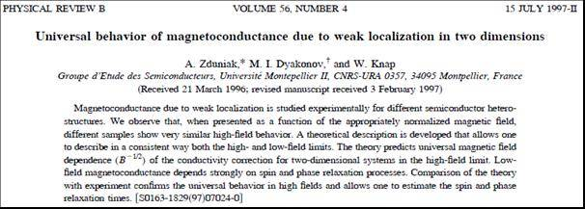

The experimental study of universality of the weak localization behaviour was a subject of the Ph.D. thesis of A. Zduniak. Original two superconducting coil system was constructed to this purpose allowing enhancing or compensating magnetic fields in the sample space. It allowed transport experiments in very wide range of magnetic fields – four orders of magnitudes from high (a few Tesla) to extremely week (a few Gauss) magnetic fields. This was necessary for full determination of the main transport process/rates: quantum scattering rate, momentum scattering rate, phase scattering rate and spin scattering rate. Typical experimental traces are shown in figure below. One can see extremely wide magnetic scale range (4 orders of magnitude) allowing to register Shubnikov de Haas (quantum scattering time), Standard Hall effect (transport scattering time), Weak localisation effect (phase scattering time) and Weak Antilocalisation effect (spin relaxation time).

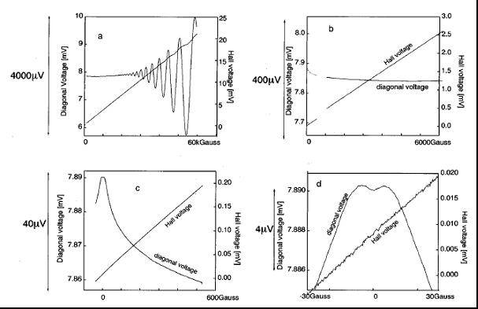

Hydrostatic pressure and illumination were used to change metastable states population and get the data as a function of carrier density. The results brought attention of the highest world - class theoreticians from the Ioffe and Landau Institutes (Prof. M. Dyakonov & others) who improved existing weak anti-localisation theory allowed to complete interpretation of the experiment.

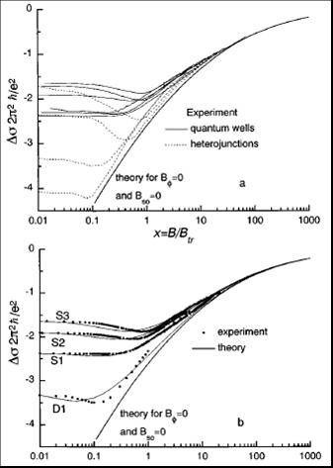 Some results are shown in Figure on the left. It shows magnetoconductivity of GaInAs quantum wells (lines) and heterojunctions (dashed lines) presented as a function of normalized magnetic field. a) presents experimental results and theoretically predicted universal asymptotic behaviour, b) shows a few experimental curves (dots) and their full theoretical fits (solid lines) together with theoretically predicted universal asymptotic behaviour. The weak anti-localisation, weak localisation and universal behaviour are correctly described.

ii) The work on weak universal weak localization was followed by another one related to influence of spin relaxation on the **weak antilocalisation** structure. The results of magnetoconductivity measurements in GaInAs quantum were analysed.

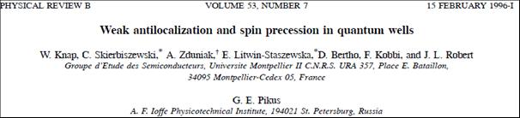

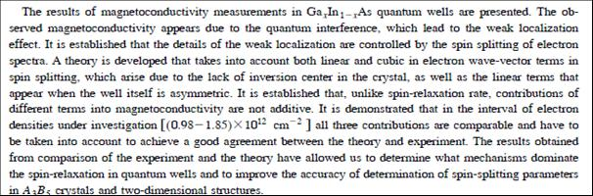

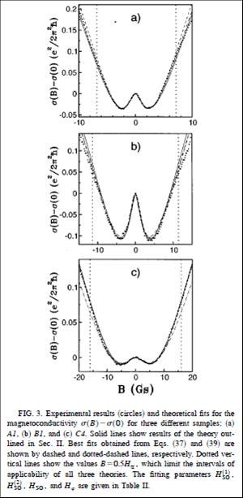

It has been shown that the observed magnetoconductivity appears due to the quantum interference, which lead to the weak localisation effect which in its turn is controlled by the spin splitting of electron spectra. A theory was developed that took into account both linear and cubic in electron wave-vector terms in spin splitting, which arise due to the lack of inversion center in the crystal, as well as the linear terms that appear when the well itself is asymmetric (Rashba term). It was demonstrated that all three contributions are comparable and have to be taken into account to achieve a good agreement between the theory and experiment. The results obtained allowed determination of dominating spin-relaxation mechanisms and to improve the accuracy of determination of spin-splitting parameters in A3B5 crystals and their two-dimensional structures.

Some experimental curves with their theoretical fits are shown in the next figure.



Except many journal and conference papers the activity in this domain led to the Ph.D. thesis of A. Zduniak (1998) and Rabih Tauk (2007) as well as the invited paper at 7th International Conference High Pressure in Sem. Physics, Schwabisch Gmund, Germany 1996 “Study of Quantum and Classical Scattering Times in Pseudomorphic AlGaAs/InGaAs/GaAs by Means of Pressure”.

**W. Knap**, A. Zduniak, L. H. Dmowski, M. Dyakonov, S. Contreras.

The paper on the weak antilocalisation became very important for spintronic community and have great number of citations – more than 160 times.

***A.2 Wide band gap nitrides and their heterojunctions: metal non-metal transition and two-dimensional gas in GaN/AlGaN heterojunctions.***

Importance of nitrides as wide band gap semiconductors that can be used for UV/blue LEDs as well as for high temperature operating transistors was discovered in early 90-ties. Together with dynamic development of technology raised a number of questions about basic physical properties of Nitrides. One of the reasons for this situation was the lack of the good quality bulk GaN crystals. Together with a group of researchers from IHPP PAS in Warsaw who synthesised first bulk GaN crystals – under high pressure conditions – we started intense research to answer the **questions about such basic parameters like value of the electron effective mass, limits of the doping, metal-non metal transition and phonon – electron interactions.**

By the experiments: i) Far Infrared and Infrared Reflectivity under pressure as well as by the ii) diamond anvils high pressure Raman and iii) luminescence experiments we were able to answer most of the questions. Effective mass was determined and shown that it changes with carrier densities due to non-parabolicity. The polaron effect related to optical phonon free carriers interaction was evidenced as well as the pressure induced metal –non-metal transition in highly doped n-GaN crystals.

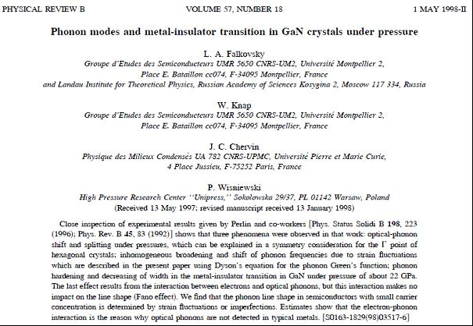

The GaN bulk studies were just introduction to more challenging subject related to properties of two-dimension electron gas in GaN/AlGaN heterojunctions. Although the groups of Asif Khan and M. Shur (USA) predicted existence of 2DEG gas on the interface no experimental data were available at that time (1999). During my sabbatical in USA – I coordinated the common efforts of IHPP PAS, CRHEA and RPI- New York and USC – South Carolina in growing the first high mobility heterojunctions. **The world record of 2DEG mobility was achieved and carefully documented by low field and high field transport experiments.**

In collaboration with these groups I proposed the high field experiments that led to the:

i) **First demonstration of the existence of 2DEG gas in GaN/AlGaN heterojunctions and measurements of the deformation potential contents.**

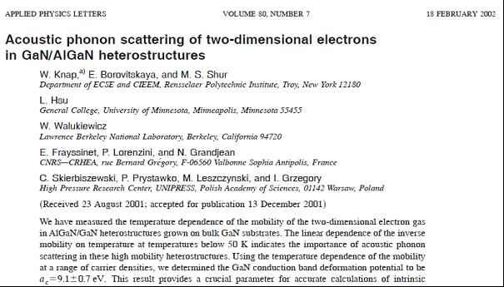

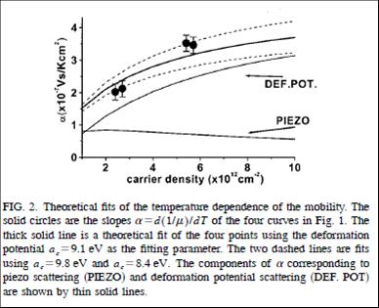

**ii)** **The first observation of the Shubnikov-de-Haas as well as Quantum Hall Effects in GaN/AlGaN heterojunctions as well as the first Cyclotron Resonance absorption and emission data.**

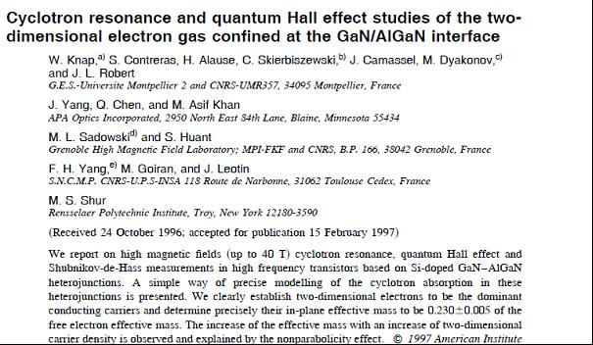

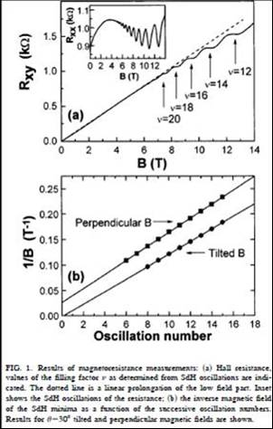(Appl. Phys. Lett. **70**, 2123 (1997)).

These experiments made in magnetic fields up to 40 T clearly demonstrated the existence of 2DEG gas. **These data are referenced as the**  **first published data on Cyclotron resonance and Quantum Hall Effect in GaN based heterojunctions.**

Cyclotron resonance, quantum Hall effect and Shubnikov-de-Haas measurements in Si-doped GaN/AlGaN heterojunctions were performed. We clearly established that two-dimensional electrons were dominant conducting carriers and determined precisely their in-plane effective mass. The increase of the effective mass with an increase of two-dimensional carrier density was observed and successfully quantitatively explained by the nonparabolicity effect.

The first work was completed by determination of the magnetic field dependence of momentum scattering rate. Mechanisms of the electron heating and cyclotron emission intensity were also carefully investigated as function of applied electric fields.

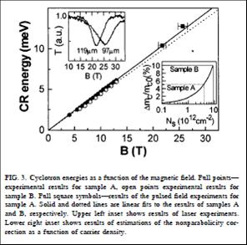

As mentioned already above **the** **first determination of the 2DEG effective mass in GaN/AlGaN heterojunctions has already shown that the mass is different from the bulk value**. This is due to the strong corrections related polaron and non-parabolicity effects – that are enhanced in the case of reduced dimensionality. This is because in the case of 2DEG gas in GaN/AlGaN heterojunctions the first electric level is relatively high in the conduction band and also because the reduced dimensionality leads to enhancement of the polaron interaction. It has been shown that the effective mass can increase almost by 10% with the carrier density varying between 1012/cm2 and 1013/cm2.

iii) **The first determination of the effective g factor for 2DEG GaN/AlGaN and** **the first Quantum Hall Effect activation measurements.**

To complete the information about the “Energy structure of 2DEG band in GaN/AlGaN”, it was necessary to determine the spin splitting and answer the question about the possibilities of the anomalous spin splitting behaviour like earlier observed in GaAs/AlGaAs heterojunctions. For this purpose the high mobility heterojunctions, based on the bulk substrates, were produced and investigated in mK temperatures.

By tilting magnetic field we were able to register the change of the pattern (phase and amplitude) of the Shubnikov-de-Haas oscillations - related to spin and cyclotron splitting anticrossing behaviour.

This led to:

. 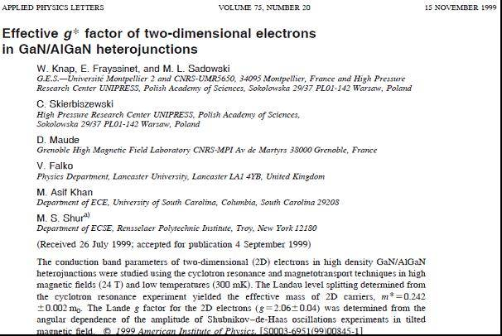

By tilting the sample placed in ultra-low temperature 40mK and high magnetic fields (Grenoble HMFL) – the pattern of the Shubnikov de Haas oscillation was modified – because of modification of the ration between spin and cyclotron resonance splitting. The annulation of the Shubnikov de Haas pattern was observed around the tilting angle ~60°.

By careful analysis of the data the value g*~2.1 was determined very close to the bulk value. Absence of any anomalous enhancements of the spin splitting was confirmed. We found that because of the higher g* factor and higher effective mass, the spin splitting and cyclotron resonance splitting becomes comparable (see figure below). This makes GaN/AlGaN system very interesting from the point of view of many body interactions.

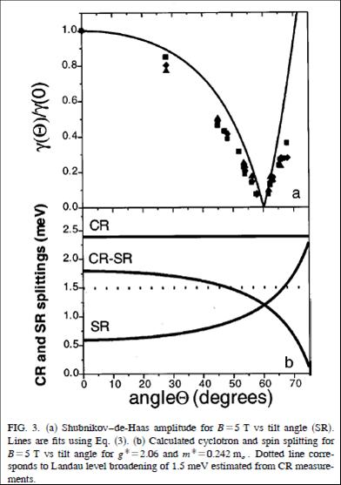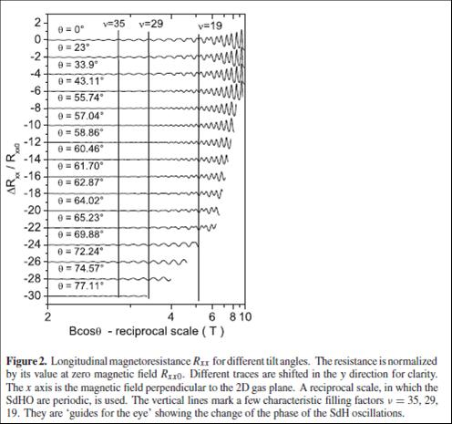

Fig. 2. Longitudinal magnetoresistance RXX for different tilt angles. The resistance is normalized by its value at zero magnetic field Rxx0. Different traces are shifted in the y direction for clarity. The x axis is the magnetic field perpendicular to the 2D gas plane. A reciprocal space, in which the SdH oscillations are periodic, is used. The vertical lines mark a few characteristic filling factors ν := 35, 29, 19. They are ‘guides for the eyes’ showing the changes of the phase of the SdH oscillations.

**First Quantum Hall Effect activation measurements** were performed showing unusual behaviour of the quantum transport gaps and an effect of many body interactions energy gaps renormalization. Complete theoretical analysis of the data was performed in collaboration with the V. Falco – Landau Institute. The main results were summarized in the paper in Journal of Physics: Condensed Matter.

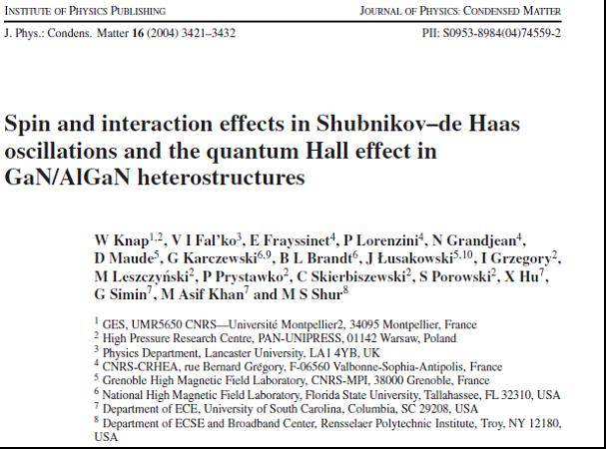

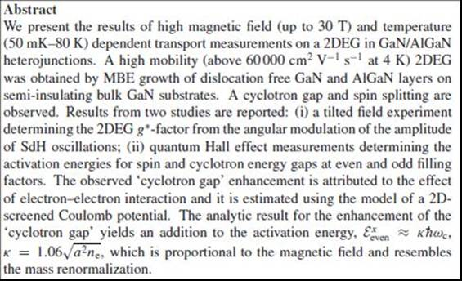

The Quantum Hall Activation measurements were performed at Tallahassee High Magnetic Field Laboratory with resistive magnetic fields up to 30T. Clear activation of the cyclotron and spin gaps were observed in wide range of temperatures.

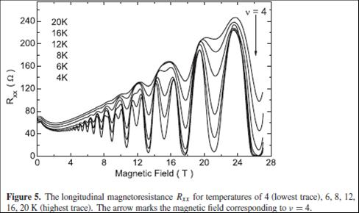

The results plotted as function of temperature are shown in figure below. They allowed the determination of the activation energies. The observed ‘cyclotron gap’ enhancement is attributed to the effect of electron–electron interaction and is estimated using the model of a 2D-screened Coulomb potential. The analytic result for the enhancement of the ‘cyclotron gap’ yields an addition to the activation energy. Both experimental and analytic results for the enhancement of the ‘cyclotron gap’ yield an addition to the activation energy, which is proportional to the magnetic field and therefore resembles the effective mass renormalization.

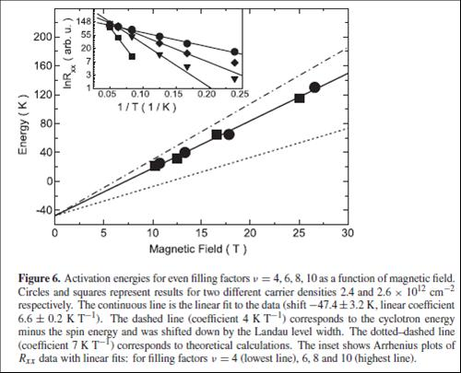

The results on the bulk nitrides and 2DEG in GaN/AlGaN lead to many publications and were recognized by few invited papers:

1) P. Perlin, **W. Knap**, A. Polian, J. L. Chervin, J. Camassel et al

Metal - Insulator Transition in GaN crystals.

7th Int. Conf. on High Pressure in Sem. Physics, Schwabisch Gmund, Germany 1996.

2) **W. Knap**, E. Borovitskaya, M. Shur, and R. Gaska G. Karczewski B. Brandt et al

HIGH MAGNETIC FIELD STUDIES OF AlGaN/GaN HETEROSTRUCTURES GROWN ON BULK GaN, SiC, AND SAPPHIRE SUBSTRATES. Material Research Society Meeting MRS Boston, November 2000.

3) **W. Knap**

Cyclotron resonance emission and absorption in 2D gas in GaN/GaAlN heterostructures - nonparabolicity and polaron effects;

International Workshop on NANOFOTONICS.

Nizhny Novgorod, Russia, 15-18 March 1999.

4) **W. Knap**

Conduction band Energy Spectrum of Two Dimensional Electrons in GaN/AlGaN Heterojunctions

# The Third International Conference on Nitride Semiconductors ICNS3.

Montpellier, France, July 1999.

5) **Knap W.** , Skierbiszewski C., Dybko K., Lusakowski J., Siekacz M., Grzegory I., Porowski S.

Influence of dislocation and ionized impurity scattering on the electron mobility in GaN/AlGaN heterostructures.

International Workshop on Bulk Nitride Semiconductors – Amazonas, Brazil, 18-23 May 2002.

6) **W. Knap**

Record mobility of two-dimensional electrons in GaN/AlGaN heterostructures on bulk substrates.

International Workshop on bulk III-N Semiconductors – Zakopane, Poland, May 2004.

7) **W. Knap**

Influence of dislocation and ionized impurity scattering on the electron mobility in GaN/AlGaN heterostructures.

5th International Workshop on Molecular Beam Epitaxy & Vapor Phase Epitaxy Growth Physics and Technology, Warsaw, Poland, 15-19 September 2002.

8) **Knap W.** Skierbiszewski C.

Plasma oscillations in 2 DEG in GaN /AlGaN heterojunctions.

International Conference on bulk III-N Semiconductors – Brasil, July 2007.

***A.3 Terahertz plasma excitations in low dimensional systems: Teraherz radiation rectification and generation by plasma confined in nanometre field effect transistors.***

This part of my research activity started in 1997 as a result of the collaboration with world class theoretician Prof. M. Dyakonov who, together with Prof. M. Shur predicted that frequencies of plasma oscillations in sub-micron/nanometer field effect transistors (FETs) can reach the Terahertz (THz) range. They have also predicted that constant current flow in the transistor channel with special boundary conditions can lead to the new type of instability leading itself to the generation of high amplitude plasma waves and THz emission. Also nonlinearities related to two-dimensional plasma can lead to rectification and detection of THz radiation. Interested by these new mechanisms of THz detection and emission I started the experimental research using high sensitivity cyclotron resonance detection system for emission (built in Montpellier) and Gunn based experimental system for detection (constructed during my sabbatical at RPI, Troy, NY, (USA).

The most interesting *Basic Physics* problems treated were:

i) Influence of the current on the plasma wave related detection – enhancement of the effect and narrowing of the resonances.

ii) Influence of the geometry of the channel – determination of the role of gated and ungated parts of the channel (interaction of gated and ungated two-dimensional plasmons).

iii) Coupling of cyclotron and plasma resonances with magnetic field – Damping of Shubnikov-de-Haas oscillations.

**Main results of these studies are:**

i) The first observation of the resonant THz detection by 2D plasmons in GaAs FETs.

Although predicted theoretically it was not sure if the resonant plasma modes can be excited in the channel of nanotransistors. Resonant modes are like a sound standing wave in musical instruments. They can be excited and exist only if correct border conditions (correct cavities) are provided. In the channel of a transistor, THz frequencies requires nanometer dimensions – and the control of the borders in this scale is extremely difficult. Finally by constructing a new experimental system – sources 200 GHz and 600 GHz, cooling facility ( RPI-TROY, New York) – and selecting high mobility InGaAs heterojonctions, we have managed to observe firs resonant detection.

The resonance condition – quality factor above ~1 was reached thanks to use cryogenic temperatures and 600 GHz frequency.

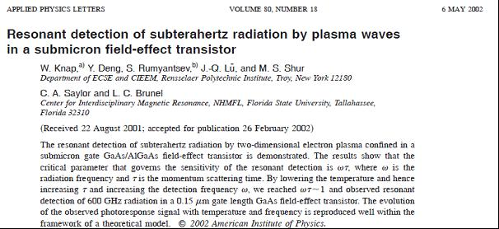

Final proof of the resonant plasma wave detection was obtained by experiments in which we could modify the carrier density by addition external illumination. Using metastable properties of the 2DEG gas in InGaAs heterojunctions we could increase also a carrier mobility reaching the detection up to 1 THz. Shift of the resonant voltage/frequency with carrier density was the final proof that the plasma resonances are excited in the channel and that the plasma wave resonance mechanism is responsible for subTHz and THz detection.

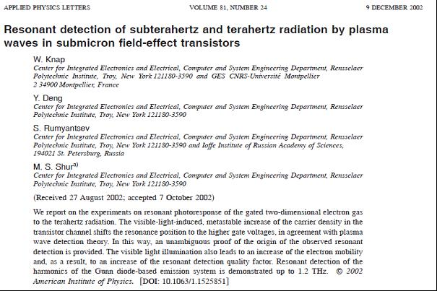

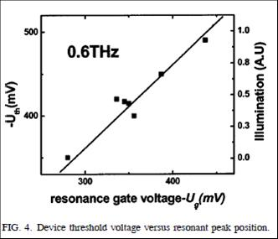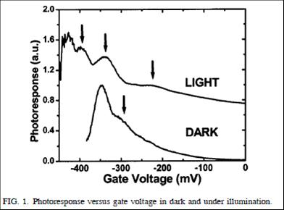

ii) First observation of the **plasma wave instability** leading to THz emission.

As mentioned already above – in early nineties Prof. M. Dyakonov together with Prof. M. Shur predicted that constant current flow in the transistor channel with special boundary conditions can lead to the new type of instability leading itself to the generation of high amplitude plasma waves and THz emission. The nanometer size field effect InGaAs /InP HEMTS (produced by IEMN – Lille) were used in the experiments. The emission in nano-Watt range was observed with maxima shifting with applied current from 0.4 THz up to 1 THz ;:– see inset of figure below. The observation was possible thanks to use early constructed cyclotron emission/detection system – that was applied here as LHe cooled THz spectrometer. The figure below shows also the calibration results –see left upper inset in the figure- made by using InSb cyclotron emitter. Cyclotron emission is usually in low pW range.

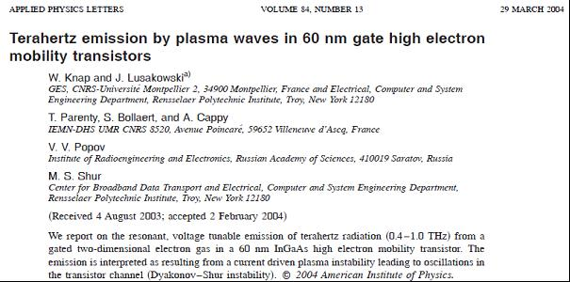



The most important from the point of view of the *Basic Physics* was verification if the emission is really due to **plasma wave instability**. This instability is a new type instability never observed in solids. It resembles a “laser like” amplification but the plasma waves are amplified not in the media but during the reflections from the channel borders. Theory predicted that once the drain current reaches certain value – “laser like” amplification of the plasma wave amplitudes should took place in the **“Threshold Like Manner”.** The experimental proof was obtained by careful studies of the THz radiation intensity as function of the current or voltage. Clear evidence of the ***“threshold like behaviour”*** was observed – the emission signal raised by orders of magnitude once the threshold voltage/current was reached. The results are shown below – the magnetic field was used as parameter changing the threshold values – through the magnetoresistance effect.

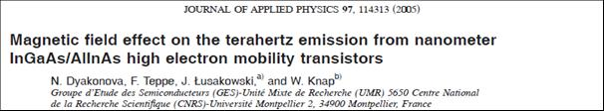

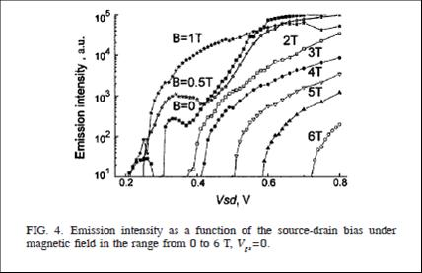

Research on high mobility HEMTS as potential Terahertz emitters brough also attention of the transistor community as documented by International Electronic Journal SPECTRUM. announcement. 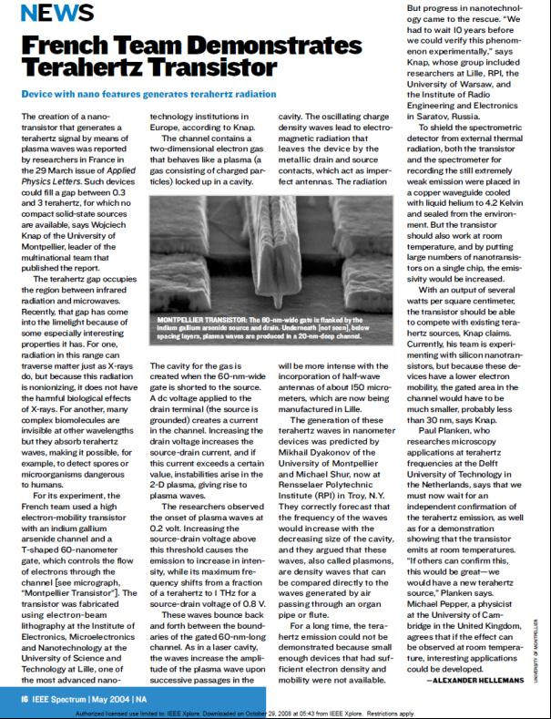

Very interesting *Basic Physics* problem- related to plasma instability- concerns influence of the current on the plasma wave related detection. The drain current affects the plasma relaxation rate by driving the two-dimensional plasma in the transistor channel towards the Dyakonov-Shur plasma wave instability. When FET operates as a resonant detector the induced photoresponse is given by:



where  is the fundamental resonant plasma frequency, and  is the frequency of the incoming radiation. The resonant response in the presence of a drain current can be written as but with a replacement . Here,  is the effective scattering rate/linewidth given by:



where *v* is the electron drift velocity. With increasing current, the electron drift velocity increases, leading to the increase of  and of the quality factor. When  approaches unity, the detection becomes resonant. One was expecting enhancement of the detectivity and narrowing of the resonances, and then abrupt transition toward instability and emission. Narrowing and enhancement of the detection with applied drain current was observed in experiments on InGaAs transistors with multi-finger configuration (IEMN-Lille). The main results are illustrated in figure below.

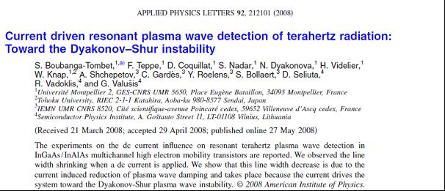

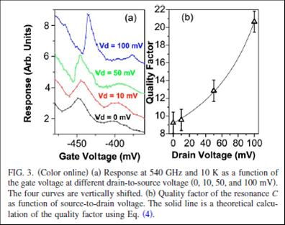

iii) Another important *Basic Physics* project related to plasma physics in two dimensional systems concerns with magnetic field influence on the plasma wave excitations.

Plasma wave propagation can be strongly modified by high magnetic fields. With increasing magnetic fields electrons will start make the cyclotron motion. Once the cyclotron resonance condition is reached, the cyclotron motion will compete with plasma density waves leading to plasma wave damping.

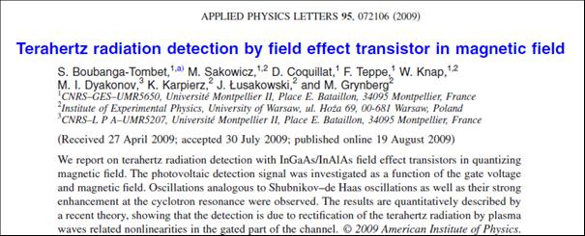

THz radiation detection using InGaAs/InAlAs FETs in quantizing magnetic field was studied. The photovoltaic detection signal was investigated as a function of the gate voltage and magnetic field. Oscillations analogous to the Shubnikov-de Haas oscillations as well as their strong enhancement at the cyclotron resonance were observed. The results were compared with a recent theory of M. Lifshits and M. Dyakonov. In this theoretical work three major effects are predicted. First, pronounced Shubnikov-de Haas like oscillations, in the FET signal that enhanced in the vicinity of the cyclotron resonance. The second effect is the presence of a smooth component of the FET signal, unrelated to Shubnikov-de Haas oscillations. This component has also a maximum at the cyclotron resonance. Finally, they predicted also that in the gated region of the channel plasma waves can propagate only if the cyclotron resonance frequency is lower than the radiation frequency.

In the opposite case the plasma wave vector becomes imaginary and thus plasma oscillations rapidly decay away from the source. These three effects were theoretically expected in the photoresponse under the magnetic field.

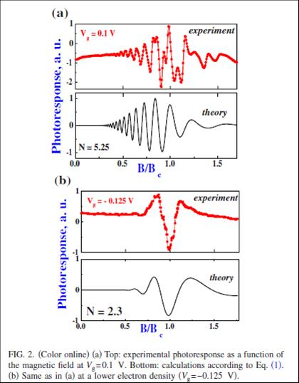

Figure above (top panels) shows FET signal as a function of the magnetic field for relatively high and low electron density. The x scale of figures is magnetic field in unities of the cyclotron magnetic field (for 2.5 THz). The experiments show an oscillatory character of the signal. Its periodicity versus 1/*B* clearly indicates that oscillations are related to the coincidence of the Fermi level with density of states maxima of the Landau levels. The enhancement of the signal in the vicinity of the cyclotron resonance condition is also visible for the lower concentration sample. One can clearly see damping of the plasma waves above cyclotron resonance field (x>1) in agreement with a general physical picture. ***This is probably most spectacular demonstration of the plasma waves propagation and damping in two dimensional systems.***

However…… lower panels show calculations of the FET signal, **using theory artificially limited only to the oscillating part**!!!. Such simplified theory describes correctly an influence of Shubnikov-de Haas effects on the photoresponse as well as the plasma wave damping in the post cyclotron resonance region.

**3.3. Research in the Applied Physics**

Independently of my interest in the Basic Physics – I had also an important activity concerning applications of the results of my research. This led to many collaborations and contacts with industrial partners. They can be presented in 3 groups:

1. ***Optical sensor: Quantum well based infrared sensors for gas detection – with Schlumberger.***
2. ***Nanotransistors- physical/versus technological limits.***
3. ***Terahertz detection and imaging by Field Effect Transistors.***

***3.3.1. Optical sensors: Quantum well based infrared sensors for gas detection – with Schlumberger.***

This was my first contact with industrial partner – **Schlumberger** – that wanted to develop the semiconductor based sensor that could allow for measurements of the quality of the gas delivered to the customers. To this purpose one should determine the ration of the methane, ethane and other gases. Using our knowledge of the physics of GaAs/AlGaAs quantum wells we proposed, fabricated and tested the semiconductor based sensors – working as the electrically modulated notch filters. This a few years project was realized in the frame of the industry supported Ph.D. thesis of H. Alause and was finalized by an international patent.

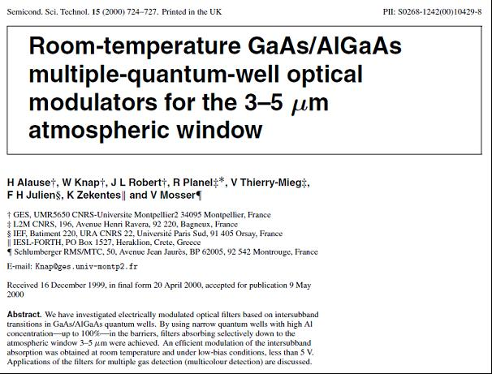

***3.3.2. Nanotransistors- physical/versus technological limits.***

Pushing the transistor to the higher power and higher frequency operation leads the industry to search of the new materials like Nitrides miniaturization. Physicists have an important role in determination what are the physical and what are only technological limits. Two examples of collaboration can be given. They concern high power GaN based HEMTS and ultimately short Si – MOSFETs.

The *Basic Physics* research on the GaN/AlGaN heterojunctions mentioned above was followed by the studies of the High Electron Mobility transistors. By comparing of the technology based on the Sapphire, SiC and bulk GaN substrates – we were able to determine the role of the dislocations in the high and cryogenic temperatures.

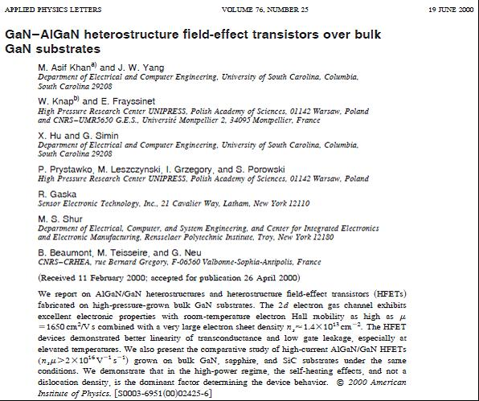

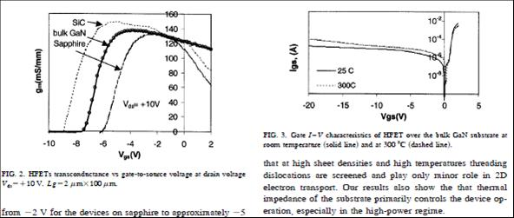

By comparing the devices on GaN bulk substrates, SiC substrates and Sapphire substrates we were able to state that that for density below 108/cm2 the dislocations do not influence the room temperature transistor parameters. We could also clearly show that GaN bulk based devices as having smallest number of dislocations are most stable – no gate leakage current – up to elevated temperatures ~300°C– see figure. The research on GaN/AlGaN heterojunctions involved industrial partners **APA – Optics and SET South Caroline (USA), TopGaN Warsaw (Poland) and is continued with III-V Labs.**

Another example of *Applied Physics* research concerns the ultimately short Si nanotransistors. For this extremely short nanotransistors the traditional methods of carrier mobility determination do not work correctly. We proposed mobility determination based on the geometrical magnetoresistance method. In fact the geometry of the transistor – very wide and short channel – leads to magnetoresistance changing like µB squared. This way we were able to analyse with our Industrial partner **STMicroelectronics** different technologies of nanotransistors and determined relative role of the doping, strain and ballistic effects in final transistor performances.

We have made the first experimental demonstration of the ballistic limitations of the Si nanotransistors of sub-100nm technology. According to the theoretical expectation in ultimately short Si MOSFETs - below 100nm- part of the electrons become ballistic even at room temperature. This phenomenon can lead to the fact that the conductivity of the channel is not increasing linearly with the decreasing of the channel length, as usually expected in the diffusive transport case, but can saturate (become channel length independent).

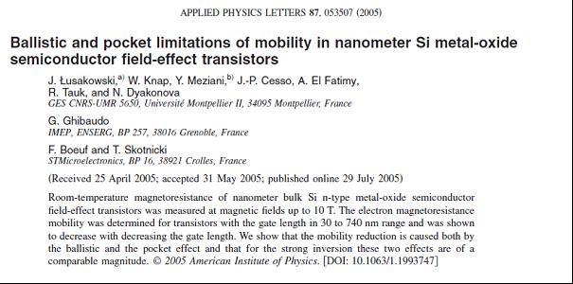

We have shown that this effect can be also seen/interpreted as a “reduction of the carrier mobility” – even if the mobility is not a well-defined value in the case of ballistic motion. The so called “ballistic mobility” was introduced and validity of the Mathiessen rule (“inverse of total mobility equals to sum of inverse mobilities of all independent scattering mechanisms”) was verified experimentally. Example of the experimental results is given in the figure below. One can observe a strong reduction of mobility when the device length becomes smaller than 200 nm.

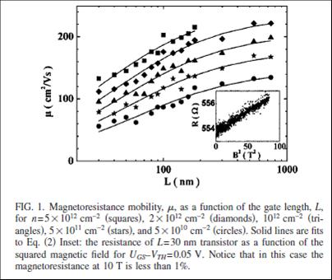

By the high field magnetoresistance measurements completed by theoretical analysis we have shown that ballistic effects play an important role for modern Si transistors shorter than 100 nm and are responsible for at least 30 percent “mobility reduction” at 30 nm channel length. We would like to mention that from experimental point of view mobility determination was a challenging task. This because the room temperature magneto-resistance of Silicon devices changes only ~1% even in fields as high as 10 T (see inset- figure above). We used a superconducting magnet with special electrical/thermal/mechanical isolations allowing high stability room temperature measurements.

The figure below presents the relative contribution of ballistic and impurity scattering (pocket) effects for transistors of 30 nm length. One can see that the ballistic effects give the contribution that is comparable with the impurity/pocket mobility limitation.

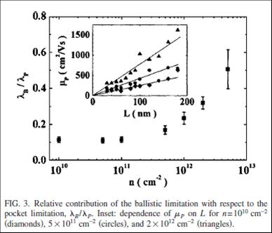

This project allowed to give better understanding of the physics of ballistic effects and to determine the physical limits of performance of next generation nanometre MOSFETs.

***3.3.3. Terahertz detection and imaging by Field Effect Transistors.***

Research on the THz detection related to plasma effects in the Silicon nanotransistors led us to discovery that these transistors can efficiently work at room temperature and that they have responsivity that is one of the highest between all existing room temperature detectors. The results on the Terahertz Plasma Excitations in FETs and their applications for Terahertz technologies led to many conference and journal publications and were recognized by many (>30) invited and tutorial papers. Below there are few highlights.

The first room temperature broadband THz detection by nanometre Si MOSFETs have already showed the great potential of Silicon devices.

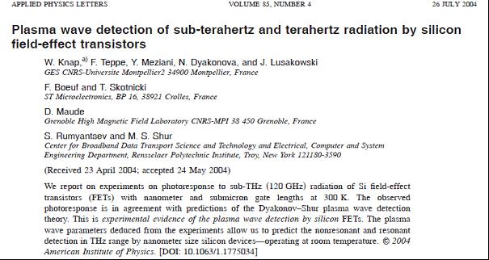

 The key parameter that determines the performance of the transistors is so called Noise equivalent power. It was found in the range of 10-10 W/Hz – this mean very close to the best room temperature THz detectors – see figure below.

Together with an industrial partner **STMicroelectronics, CEA-LETI, and New TeraHertz Technology- Italy,** we studied the possibilities to make an array of detectors that can be used as focal plane arrays for future THz cameras working in 0.3-1.0 THz range.

After the first successful demonstration of the single pixel operation this project is continued and supported by **NANO2012, Ph.D. - thesis convention and other bilateral contracts.**

Also GaN/AlGaN transistors are considered as potential THz detectors – this work is continued in collaboration with III-V Labs and IEMN Lille – ANR project TERAGAN.

**Below there is a list of a few the most important industry related contracts:**

Schlumberger Industrie –«Capteurs de gaz a semi-conducteurs» (1995-1997).

European IP PullNano IST « PULLing the limits of NANOCmos electronics» (2006-2009).

Nano 2008 (2005-2008) and Nano 2012 ( 2009- 2012) «Terahertz nanotransistors» with STMicroelectronics.

ANR TeraGaN “Terahertz GaN transistors ”with II-V Labs (2007-2010).

Contrat Collaboration de Recherche “Terahertz FET for security applications ”Entreprise NTT, Turin, Italy (2008-2010).

CANON France – Terahertz Communication with Field Effect Transistors (2013-2016).

DGA/SAGEM/LETI – Terahertz vision with Field Effect Transistors Arrays (2014-2017).

**Most important achievement in the field of technology transfer is creation of Spin-off Company T-Waves Technologies.**

***T-Waves Technology start- up company was created in October 2014 – I am scientific Director of this company. This company has already 5 employees and get support of most of national (OSEO) and regional agencies (Languedoc-Roussilon Region). This company uses CNRS Patents – made by our group on THz detectors and sources.***

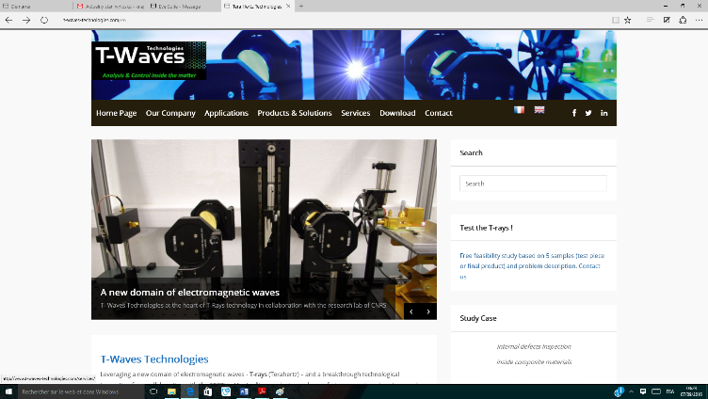**T-Waves Technologies**

[**www.t-waves-technologies.com**](http://www.t-waves-technologies.com)is the fruit of a technological partnership started in 2012 with the Charles Coulomb laboratory (L2C), a mixed CNRS-University of Montpellier unit. The field of Terahertz electromagnetic waves (100 GHz-10THz) is at the heart of this collaboration.

Based on the internationally-recognised research and several patents, T-Waves Technologies aims to design and develop components, mainly terahertz sensors and sources, and measuring and imaging systems in the terahertz field. The exceptional capabilities of these waves that are both penetrating and endowed with spectroscopic sensitivity, make our systems particularly relevant for inspecting defects and characterising physico-chemical properties at the heart of the material.

**T-Waves Technologies**  provides its customers with skills of our **experts in the field of terahertz domain** both in the technological area and the light-matter interaction.

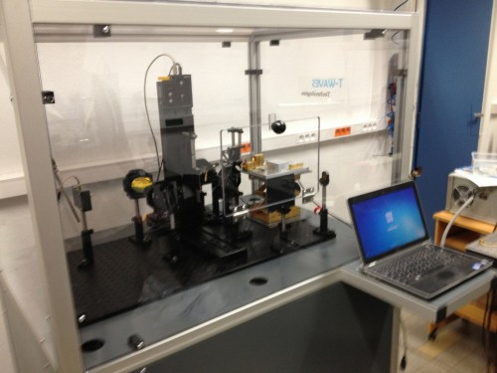

**Terahertz 2D Imaging system developed by T-Waves**

**T-Waves Technologies** has been awarded both institutional and professional distinctions during its incubation period:

2012: Winner of the innovative company contest – “emerging” category - organised by the Ministry of Research and Oseo.

2013: Winner of the Innovation Trophy at the ENOVA international opto-electronics salon in Paris.

2014: Winner of the innovative company contest – “creation/development” category - organised by the French Ministry of Research and BPI France.

***Currently in T-Waves technology we develop THz camera based on the concept of Field Effect Transistor Detectors – discovered by THz team of L2C laboratory and company provides employment for 9 engineers, Ph.D. students and technicians. It has the clients between Renault, DGA, and others important French Enterprises and Institutions.***

Project related with Terahertz Nanonelectronics was supported by ANR project TERANOVA 2005-2007 and TERAGAN 2008-2010 (running). It is important to mention the collaboration with industry. The most important there were the collaborations with STMicroelectronics program NANO2008 (2005-2009) as well as the European Project PULLNANO. Also at the end of 2008 the new collaborative projects related to THz imaging systems (with LETI–Grenoble and the Italian Society – New Terahertz Technology (NTT)) started. Also STMicroelectronics will continue to support our activity through the NANO 2012 program. International projects like PICS with Niznij Novgorod-Russia, PHC GILIBERT with Lithuania, PHC SAKURA with Japan, GDR-E and GDR-I allowed establishing good network of international collaborations. Recently new international laboratory LIA –TERAMIR was created (2014-2017) to join efforts of groups from France, Poland and Russia in the domain of plasma physics of new Graphene and Graphene like systems.